**INSTITUTE OF PUBLIC ADMINISTRATION AND MANAGEMENT**

**(University of Sierra Leone)**

**B.Sc. (Hons.) INFORMATION SYSTEMS**

**AN ONLINE BOOKING SYSTEM FOR A TOURISM BUSINESS**

**September, 2023.**

**INSTITUTE OF PUBLIC ADMINISTRATION AND MANAGEMENT**

**AN ONLINE BOOKING SYSTEM FOR A TOURISM BUSINESS**

**BY**

**IBRAHIM PATEH BAH 29252**

**ISHMAIL BAH 25986**

**MASIRAY ADA KHALU 27545**

**SUBMITTED TO**

**THE DEPARTMENT OF INFORMATION SYSTEMS AND TECHNOLOGY**

**IN PARTIAL FULFILMENT OF THE REQUIREMENTS**

**FOR THE DEGREE**

**OF**

**BACHELOR OF SCIENCE (HONS.) IN INFORMATION SYSTEMS**

**September, 2023.**

**INSTITUTE OF PUBLIC ADMINISTRATION AND MANAGEMENT**

**UNIVERSITY OF SIERRA LEONE**

**THE BOARD OF EXAMINERS**

**CERTIFY**

That this Dissertation is the original work of the candidates, and that it is accepted in partial fulfilment of the requirements for the award of the degree of Bachelor of Science (Hons.) in Information Systems.

|  |  |  |  |
| --- | --- | --- | --- |
| SUPERVISOR: | **Mr. Alhaji Y. Kenneh** | …………... | September 2023 |
|  | Name | Signature | Date |
|  |  |  |  |

|  |  |  |  |
| --- | --- | --- | --- |
| HEAD OF DEPARTMENT: | **Mr. Alhaji Y. Kenneh** | …………... | September 2023 |
|  | Name | Signature | Date |

|  |  |  |  |
| --- | --- | --- | --- |
| HEAD OF RESEARCH: | **………………….** | …………... | September 2023 |
|  | Name | Signature | Date |

|  |  |  |  |
| --- | --- | --- | --- |
| EXTERNAL EXAMINER: | **………………** | …………... | September 2023 |
|  | Name | Signature | Date |

**DECLARATION**

We, the undersigned, hereby declare that the work presented in this dissertation, titled "An Online Booking System for a Tourism Business," has been carried out by us, namely:

1. Ibrahim Pateh Bah
2. Ishmail Bah
3. Masiray Ada Khalu

under the supervision of Mr. Alhaji Y. Kenneh. This project was conducted at the Institute of Public Administration & Management.

We further declare that:

1. The work presented in this dissertation is the result of our original research and has not been previously submitted for any degree or examination in this or any other university or institution.
2. Any sources, data, or materials used in this work have been properly acknowledged and referenced.
3. This dissertation represents our own work and reflects our understanding of the subject matter.
4. We have adhered to ethical guidelines and standards throughout the research and writing process.
5. All contributions from individuals other than the named authors have been properly acknowledged.

|  |  |  |
| --- | --- | --- |
| **……………………………..** | **……………………………..** | **……………………………..** |
| **Ibrahim Pateh Bah** | **Ishmail Bah** | **Masiray Ada Khalu** |
| **5th September 2023** | **5th September 2023** | **5th September 2023** |

**ABSTRACT**

This dissertation focuses on developing an innovative Online Tourism Booking System for Yeama Leone Tours, a prominent Sierra Leone-based tourism agency. With the digital transformation of the tourism industry, efficient travel service management solutions are crucial. Yeama Leone Tours, a key player in Sierra Leone's tourism sector, serves tourists and partner agencies. However, a missing element was an agency management system allowing partners to oversee their bookings independently.

The project utilizes various web technologies to create a comprehensive Online Booking System. This system streamlines bookings, enhances transparency, and improves user experiences, boosting the platform's functionality. The dissertation covers problem scope, objectives, literature review, requirements analysis, system design, and testing phases. It also addresses implementation requirements and deployment considerations, including agency approvals and booking mechanisms.

In conclusion, the dissertation outlines achievements, acknowledges limitations, and offers recommendations such as implementing payment systems, notification systems, and group booking features with participant names.

**DEDICATION**

Firstly, we would like to dedicate this to Allah Subhana watallah, the Almighty, who guided us through this journey and bestowed upon us the strength and wisdom to pursue knowledge, we dedicate this work as an expression of our gratitude and devotion.

To our families, especially to our beloved parents, Mom and Dad, your unwavering love, sacrifices, and endless encouragement have been our foundation. This achievement is a testament to your boundless support, and we dedicate this work to you with deep appreciation and love.

To our guardians, who have played significant roles in shaping our lives, your guidance and care have been instrumental in our success. We dedicate this work to you as a token of our gratitude for your constant presence.

To our friends, who have been our companions, challengers, and inspirations, your camaraderie has driven us to become better versions of ourselves. This dedication is a symbol of the cherished memories and experiences we've shared.

To our dedicated lecturers, whose knowledge, guidance, and mentorship have enlightened our path, we extend our heartfelt gratitude. This work reflects the valuable lessons and insights you've imparted.

May this dedication stand as a tribute to the faith, support, and inspiration we've received from all those who have touched our lives.

**ACKNOWLEDGEMENT**

We begin by acknowledging Allah, the Most Gracious and Most Merciful, for bestowing upon us the strength, wisdom, and understanding needed to embark on this dissertation journey and develop our project.

Our heartfelt gratitude goes to our esteemed supervisor, Mr. Alhaji Y. Kenneh. We are profoundly thankful for your unwavering support, invaluable guidance, and enriching advice. It has been an honor to have you as our mentor.

We extend our appreciation to Dr. Mohamed A. Sheriff, Dean of the Faculty for Information Systems and Technology, and Mr. Daniel Chaytor, as well as every lecturer who has contributed to our academic journey. Your knowledge-sharing and positive influence have been instrumental in our growth.

Our gratitude knows no bounds as we thank Miss Adama Yeama Fowai, and the dedicated team at Yeama Leone Tours. Your generosity in allowing us to utilize your facilities during this project, along with the constant guidance and mentorship, have been invaluable.

We also express our thanks to all those who have played pivotal roles in our academic achievements. Your contributions have shaped our path to success, and we acknowledge and appreciate each one of you.

**Table of Contents**

CHAPTER ONE 1

1.0 INTRODUCTION 1

1.1 Background of the Study 1

1.2 Problem Statement 4

1.3 Aims & Objectives 6

1.3.1 Aim: 6

1.3.2 Objectives: 6

1.4 Feasibility Study 7

1.4.1 Operational Feasibility: 7

1.4.2 Technical Feasibility: 7

1.4.3 Social Feasibility: 8

1.4.4 Legal Feasibility: 8

1.4.5 Organizational Feasibility: 9

1.4.6 Economic Feasibility: 9

1.5 Significance of the Study 10

1.5.1 Enhancing Operational Efficiency: 10

1.5.2 Empowering Partner Agencies: 10

1.5.3 Elevating Customer Experience: 11

1.5.4 Promoting Collaboration and Growth: 11

1.5.5 Demonstrating Technological Viability: 11

1.5.6 Contributing to Research and Practice: 12

1.6 Organization and Summary of the rest of the document 13

1.6.1 Work Breakdown Structure 15

1.6.2 Table of the Gantt chart 16

1.6.3 Gantt Chart 18

CHAPTER TWO 20

2.0 Problem Definition and Scope 20

2.1 Introduction 20

2.2 Background and Context 21

2.3 Detailed Description of the Problem 22

2.3.1 Complex Partner Agency Management: 23

2.3.2 Lack of Real-Time Updates and Availability: 23

2.3.3 Inefficient Customer Interactions: 23

2.3.4 Missed Business Insights and Opportunities: 24

2.3.5 Workload and Resource Allocation: 24

2.4.0 Definition of System Scope 25

2.4.1 Tourist-Focused Scope 25

2.4.2 Partner Agency-Focused Scope 26

2.4.3 Administrative-Focused Scope 27

CHAPTER THREE 28

3.0 LITERATURE REVIEW/METHODOLOGY 28

3.1 INTRODUCTION 28

3.2 Related Project: Tourism Hub and Visit Sierra Leone 29

3.2.1 Detail Description of Tourism Hub: 30

3.2.2 Detail Description of Visit Sierra Leone (VSL): 31

3.3 Similarities and Differences in System Approach 32

3.3.1 Similarities of Our Systems: 32

3.3.2 Differences of Our Systems: 32

3.4 Methodology Options and Selected Approach 33

3.4.1 Available Methodology Options 33

3.4.2 Selected Approach: 34

3.5 Tools and Technologies: 35

3.6 Justification of the Selected Approach 36

3.7 Review of Literature on the Subject Matter 37

3.7.1 Literature Review on Tourism Hub 37

3.7.2 Literature Review on Integration of Partner Agencies for a Tourism Business: 39

3.7.3 Literature Review on The Impact of Online Booking on Hotel Revenue Management: A Simulation Approach 42

3.7.4 Literature Review on Online booking in tourism: a user experience approach 43

3.7.5 Literature Review on Enhanced Tourist Engagement and Satisfaction 45

3.7.6 Literature Review on the Challenges of Traditional Booking Systems 47

3.7.7 Summary and Synthesis: 49

CHAPTER FOUR 50

4.0 ANALYSIS AND DESIGN 50

4.1 Introduction 50

4.2 Requirement Gathering 52

4.2.1 Mixed Approach: Qualitative and Quantitative Analysis 52

4.2.2 Tools and Techniques 52

4.2.3 Questionnaires 53

4.2.3.1 Questionnaire for Yeama Leone Tours: 53

4.2.3.2 Questionnaire for Partner Agencies: 54

4.2.3.3 Questionnaire for Tourists: 54

4.2.4 Analysis of Questionnaire Responses 55

4.2.4.1 Responded Questionnaire for Yeama Leone Tours: 55

4.2.4.2 Responded Questionnaire for Partner Agencies: 56

4.2.4.5 Questionnaire for Tourists: 57

4.3 Analysis of Requirements 58

4.4 Analysis of Current Proposed System 59

4.4.2 Unified Modelling Language (UML) of Use Cases 61

4.4.2.1 Use Case: User Registration 61

4.4.2.2 Use Case: Browse Packages 62

4.4.2.3 Use Case: Create Packages 62

4.4.2.4 Use Case: Manage Bookings 63

4.4.3 UML Use Case Diagram 64

4.5 Requirements of the New System 65

4.5.1 Functional Requirements: 65

4.5.2 Non-Functional Requirements: 66

4.5.3 Hardware and Software Requirements: 67

4.6 System Design 68

4.6.1 Object-Oriented Design: 68

4.6.2 Function-Oriented Design: 69

4.6.3 Structure-Oriented Design: 70

4.7 Design Options and Choices Made 71

4.8 Design of the Proposed System 72

4.8.1 Data Dictionary of the System 72

4.8.1.1 Table: admins 72

4.8.1.2 Table: agencies 73

4.8.1.3 Table: agency_employees 74

4.8.1.4 Table: bookings 74

4.8.1.5 Table: comments 75

4.8.1.6 Table: packages 75

4.8.1.7 Table: package_dates 77

4.8.1.8 Table: reviews 77

4.8.1.9 Table: tourists 78

4.8.2 UML Class 79

4.8.2.1 UML Class Diagram 81

4.8.3 UML ER Diagram 82

4.8.3.1 ER Diagram from MySQL Xampp 83

4.8.4 UML Sequence Diagram 84

CHAPTER FIVE 85

5.0 RESULTS AND DISCUSSION 85

5.1 Introduction 85

5.2 Presentation of Results 86

5.2.1 Images of the System 87

5.2.1.1 Image of Home Page 87

5.2.1.2 Image of Agency Page 88

5.2.1.3 Image of Package Page 88

5.2.1.4 Image of About Us 89

5.2.1.5 Image of Contact Us Page 89

5.2.1.6 Image of Tourist Registration 90

5.2.1.7 Image of Agency Registration 90

5.2.1.8 Image of Login 91

5.2.1.9 Image of List of Agencies 91

5.2.1.10 Image of Packages List 92

5.2.1.11 Image of Bookings 92

5.2.1.12 Image of Booking Modification 93

5.2.1.13 Image of Agency Dashboard 93

5.2.1.14 Image of Agency Review 94

5.2.1.15 Image of Admin Dashboard 94

5.2.1.16 Image of Admin Approval Mechanism 95

5.3 Implementation Requirements and Issues to be Addressed in Deployment 96

5.3.2 Implementation Requirements 96

5.3.3 Deployment Issues 97

5.4 Result from Testing the System 98

5.4.1 Test Case for User Registration 98

5.4.2 Test Case for User Login 99

5.4.3 Test Case for Browsing and Booking Tour Packages 100

5.4.4 Test Case for Managing Bookings 100

5.4.5 Test Case for Leaving Comments and Reviews 101

5.4.6 Test Case for Agency Approval Mechanism 102

5.4.7 Test Case for Agency-Specific Booking Management 103

5.4.8 Test Case for Tourist Comments and Reviews 104

5.4.9 Browser Testing 105

CHAPTER SIX 111

SUMMARY, CONCLUSION AND RECOMMENDATIONS 111

6.0 Introduction 111

6.1 Summary of Achievements 112

6.2 Limitations of the Study and Constraints 114

6.3 Conclusions 116

6.4 Recommendations for Improvement 117

6.5 Suggestions for Future Work 119

6.6 Lessons Learned 121

REFERENCES 124

APPENDICES 131

Appendix A: User Manual 131

Appendix B: Database Schema 134

Appendix C: Data Used in Testing Scripts 135

Appendix C 1 Test Case for User Registration 135

Appendix C 2 Test Case for User Login 136

Appendix C 3 Test Case for Browsing and Booking Tour Packages 136

Appendix C 4 Test Case for Managing Bookings 137

Appendix C 5 Test Case for Leaving Comments and Reviews 138

Appendix C 6 Test Case for Agency Approval Mechanism 139

Appendix C 7 Test Case for Agency-Specific Booking Management 140

Appendix C 8 Test Case for Tourist Comments and Reviews 141

Appendix C 9 Browser Testing 142

Appendix D: System Source Code 147

Home Page Source Code 147

Source Code of the Home Page 147

Login Source Code 159

Source Code of Multi User Login of the System 159

Bookings 165

Source Code of Booking: 165

Booking Modification 172

Source Code Booking Modification: 173

Agency Dashboard 181

Source Code of Agency Dashboard 181

Admin Dashboard 190

Source Code Admin Dashboard: 191

Admin Approval Mechanism 198

**List of Tables**

Table 1 Gantt Chart Table 17

Table 2 User Registration Use Case 61

Table 3 Browse Packages 62

Table 4 Create Packages 63

Table 5 Manage Bookings 63

Table 6 Hardware Specifications 67

Table 7 Software Specifications 67

Table 8 admins Data Dictionary 73

Table 9 agencies Data Dictionary 73

Table 10 agency_employees Data Dictionary 74

Table 11 bookings Data Dictionary 75

Table 12 comments Data Dictionary 75

Table 13 packages Data Dictionary 77

Table 14 package_dates Data Dictionary 77

Table 15 reviews Data Dictionary 78

Table 16 tourists Data Dictionary 78

Table 17 Test Case for User Registration 99

Table 18 Test Case for User Login 99

Table 19 Test Case for Browsing and Booking Tour Packages 100

Table 20 Test Case for Managing Bookings 101

Table 21 Test Case for Leaving Comments and Reviews 102

Table 22 Test Case for Agency Approval Mechanism 103

Table 23 Test Case for Agency-Specific Booking Management 104

Table 24 Test Case for Tourist Comments and Reviews 105

Table 25 Browser Testing 110

Table 26 Appendix C Test Case for User Registration 135

Table 27 Appendix C Test Case for User Login 136

Table 28 Appendix C Test Case for Browsing and Booking Tour Packages 137

Table 29 Appendix C Test Case for Managing Bookings 138

Table 30 Appendix C Test Case for Leaving Comments and Reviews 139

Table 31 Appendix C Test Case for Agency Approval Mechanism 140

Table 32 Appendix C Test Case for Agency-Specific Booking Management 140

Table 33 Appendix C Test Case for Tourist Comments and Reviews 141

Table 34 Appendix C Browser Testing 147

**List of Figures**

Figure 1 Work Breakdown Structure of the Project 15

Figure 2 Gantt Chart of the Project 18

Figure 3 Continuation of the Gantt Chart 19

Figure 4 Gantt Chart of the last months of the Project 19

Figure 5 UML Use Case Diagram 64

Figure 6 Structure-Oriented Design 70

Figure 7 UML Class Diagram 81

Figure 8 UML ER Diagram 82

Figure 9 ER Diagram from Xampp Mysql Database 83

Figure 10 UML Sequence Diagram 84

Figure 11 Home Page 87

Figure 12 Agency Page 88

Figure 13 Packages Page 88

Figure 14 About Us 89

Figure 15 Contact Us Page 89

Figure 16 Tourist Registration 90

Figure 17 Agency Registration 90

Figure 18 Multi User Login to the system 91

Figure 19 List of Agencies 91

Figure 20 Agency Package List 92

Figure 21 Booking 92

Figure 22 Booking Modification 93

Figure 23 Agency Dashboard 93

Figure 24 Agency Review 94

Figure 25 Admin Dashboard 94

Figure 26 Approval Mechanism 95

Figure 27 Appendix B Relational Database Schema 134

Figure 28 Appendix D Home Page 147

Figure 29Appendix D Multi User Login to the system 159

Figure 30 Appendix D Booking 165

Figure 31 Appendix D Booking Modification 172

Figure 32 Appendix D Agency Dashboard 181

Figure 33 Appendix D Admin Dashboard 191

Figure 34 D Approval Mechanism 198

# **CHAPTER ONE**

## 1.0 INTRODUCTION

### 1.1 Background of the Study

The rapid advancement of technology has reshaped numerous industries, including the way businesses operate and customers engage with services. In particular, the emergence of online booking systems has revolutionized the way people plan and secure their travel experiences. An online booking system offers the convenience of browsing, selecting, and reserving services and accommodations from the comfort of one's own device, eliminating the need for cumbersome manual processes. This digital transformation has led to enhanced efficiency, improved customer experiences, and streamlined operations for businesses across various sectors (Statista, 2021).

Sierra Leone, a country known for its stunning natural beauty, rich cultural heritage, and vibrant communities, has been witnessing a significant surge in its tourism industry. With pristine beaches, diverse wildlife, and captivating landscapes, Sierra Leone has become an increasingly attractive destination for global travelers seeking unique and enriching experiences. As the tourism industry continues to flourish, local businesses play a pivotal role in shaping and enhancing the visitor experience. However, challenges such as outdated booking procedures, limited access to information, and the need for seamless coordination among stakeholders persistently hinder the industry's full potential.

One such prominent player in the Sierra Leonean tourism landscape is Yeama Leone Tours. This dynamic tour operator is dedicated to showcasing the country's cultural treasures and natural wonders, offering an array of captivating experiences for travelers. Yeama Leone Tours has firmly established itself as a leading entity in the industry, guided by a commitment to delivering exceptional services and enriching the journeys of those who visit Sierra Leone.

In this context, Yeama Leone Tours serves as a case study in this project. The company's dedication to providing unforgettable travel experiences and its proactive approach to embracing technological advancements make it an ideal subject for developing and implementing an innovative solution. By addressing the challenges faced by Yeama Leone Tours through the creation of an advanced online booking system, the project aims to contribute not only to the growth and success of the company but also to the broader Sierra Leonean tourism sector.

Through the integration of modern technology and the enhancement of operational processes, this project seeks to create a digital infrastructure that optimizes booking processes, facilitates collaboration among tourism stakeholders, and enriches the visitor experience. By focusing on Yeama Leone Tours and its aspirations for improved efficiency and customer engagement, this research endeavours to pave the way for a more seamless, interconnected, and customer-centric tourism ecosystem in Sierra Leone.

Yeama Leone Tours faces challenges stemming from the limitations of the existing manual booking methods. These challenges include delays in reservation processing, difficulties in managing partner agency bookings, and the need for real-time availability updates. Furthermore, Yeama Leone Tours not only caters to individual tourists but also collaborates with partner agencies to provide comprehensive travel packages. However, the current practice of conducting reservations on behalf of partner agencies has become increasingly burdensome, posing a workload challenge for Yeama Leone Tours. The company envisions a solution where partner agencies can independently manage their own bookings through a user-friendly online platform.

The proposed project seeks to address these challenges by developing an innovative online booking system tailored to the specific needs of Yeama Leone Tours and the broader tourism industry in Sierra Leone. This system aims to streamline the booking process, enhance customer experience, and optimize operational efficiency. By leveraging cutting-edge technology, the project endeavours to create a seamless and secure platform for tourists, partner agencies, and Yeama Leone Tours to interact and collaborate.

As the tourism industry in Sierra Leone continues to evolve, the successful implementation of the online booking system has the potential to transform the way tourists engage with tour operators, enhance the competitiveness of tourism businesses, and contribute to the growth and development of the country's tourism sector. Through this research, the aim is to not only improve Yeama Leone Tours' operations but also to pave the way for a more efficient, customer-centric, and collaborative tourism landscape in Sierra Leone.

Freetown, Sierra Leone, was featured in Forbes as a tourist destination. The article on Forbes, titled “Alternative Africa: Freetown Should Be on Your Bucket List,” highlights Freetown, the capital city of Sierra Leone, as a vibrant and emerging destination worth exploring (Ogerst, 2023).

### 1.2 Problem Statement

Yeama Leone Tours, a prominent and forward-looking player in Sierra Leone's burgeoning tourism industry, is confronted with a set of challenges that hinder its operational efficiency and growth prospects. These challenges predominantly revolve around the limitations of the traditional booking methods and the intricate management of partner agency bookings. Below is the list of Problem Statements:

1. **Costly and Time-Consuming Traditional Booking Methods**: Yeama Leone Tours currently relies on conventional booking processes that involve international phone calls and email exchanges. This approach incurs significant costs and consumes valuable time, resulting in delays and missed opportunities for both the company and its potential tourists.
2. **Inefficiencies in Partner Agency Booking Management:** Yeama Leone Tours collaborates with various partner agencies to offer comprehensive travel packages. However, the existing practice of managing partner agency bookings on behalf of these entities has led to a considerable workload. This not only strains the company's resources but also introduces complexities in coordination and communication.
3. **Lack of Centralized and Streamlined Booking System:** The absence of an integrated and automated booking system hampers Yeama Leone Tours' ability to efficiently manage the increasing volume of bookings from various sources. This disjointed process may lead to errors, misunderstandings, and challenges in maintaining real-time availability.
4. **Missed Opportunities and Customer Dissatisfaction:** Delays in response times due to manual booking processes may result in missed opportunities to secure bookings from interested tourists. Additionally, prolonged waiting periods can lead to customer dissatisfaction and a diminished reputation for Yeama Leone Tours.
5. **Limited Accessibility and Information Sharing:** The lack of a centralized system makes it difficult for partner agencies to access accurate and up-to-date information about available services, tour packages, and bookings. This limitation restricts effective collaboration and engagement with partner agencies.

The cumulative effect of these challenges underscores the pressing need for Yeama Leone Tours to transition to a modern and technologically advanced solution. By developing an online booking system tailored to its specific needs, the company aims to streamline operations, enhance customer experiences, and foster seamless collaboration with partner agencies. This study delves into the comprehensive analysis, design, and development of such a system, with the ultimate goal of empowering Yeama Leone Tours to thrive in the digital age and contribute to the growth of Sierra Leone's vibrant tourism industry.

### 1.3 Aims & Objectives

#### 1.3.1 Aim:

The primary aim of this project is to develop an online booking system tailored for Yeama Leone Tours and its partner agencies. This system will facilitate efficient management of bookings by enabling each agency to independently handle their own reservations made by tourists.

#### 1.3.2 Objectives:

1. To implement Agency-Specific Booking Management by: Developing a comprehensive booking management interface that allows each partner agency to effectively oversee their own bookings, thereby reducing the workload on Yeama Leone Tours.
2. To present detailed tour descriptions, including Tour Details, Itinerary, the inclusions, exclusions, and optional features of each tour package and a visual Gallery of attractions, ensuring tourists have a complete understanding of the packages to make decisions.
3. To showcases the available tour packages offered by Yeama Leone Tours and its partner agencies.
4. To provide a comprehensive list of partnered agencies, offering transparency and accessibility to tourists and potential customers.
5. To incorporate a feature for customers to leave Comments fostering engagement and building a sense of community.
6. To display the pricing information for each tour package, allowing tourists to easily compare and select options that align with their preferences and budgets.
7. To implement Agency Approval Mechanism by: Implementing a streamlined process through which Yeama Leone Tours can review and approve agencies interested in utilizing the online booking platform after registration.

### 1.4 Feasibility Study

Before embarking on the development of an online booking system tailored for Yeama Leone Tours and its partner agencies in Sierra Leone, a comprehensive feasibility study was conducted. This study aimed to evaluate the practicality and viability of introducing the proposed system, considering a range of critical factors including operational, technical, social, legal, organizational, and economic aspects. The feasibility study's primary objective was to determine the project's feasibility while identifying potential challenges and opportunities inherent to the endeavor.

#### 1.4.1 Operational Feasibility:

The operational feasibility assessment extended to evaluating the preparedness and capability of Yeama Leone Tours and its partner agencies to seamlessly integrate and manage the new online booking system. This encompassed a thorough review of the existing processes, infrastructure, and resources available for the successful implementation and ongoing maintenance of the system. Special attention was given to understanding the training requirements of staff, potential areas of resistance to change, and the impact on daily operational workflows.

#### 1.4.2 Technical Feasibility:

Technical feasibility took into account the technological prerequisites and capabilities necessary for a smooth deployment of the online booking system within both Yeama Leone Tours and its partner agencies. This involved a meticulous evaluation of the accessibility to reliable internet connectivity, compatibility with the existing IT infrastructure, and the establishment of robust security measures to safeguard sensitive customer data. Additionally, the system's scalability, reliability, and potential integration capabilities with other platforms were rigorously assessed.

#### 1.4.3 Social Feasibility:

The social feasibility analysis aimed at gauging the acceptance and impact of the proposed online booking system on various stakeholders, including Yeama Leone Tours' customers, employees, partner agencies, and the local community. This phase involved soliciting feedback through surveys, interviews, and interactions to comprehend preferences, expectations, and perceptions related to the system. Factors such as user-friendliness, cultural alignment, and ease of use were examined to ensure alignment with the prevailing social context.

#### 1.4.4 Legal Feasibility:

Legal feasibility encompassed an extensive evaluation of regulatory and legal requirements associated with the implementation of the online booking system within the framework of Yeama Leone Tours and its partner agencies. This encompassed adherence to data protection and privacy regulations, ensuring secure and compliant handling of customer information, and aligning with pertinent local or national mandates relevant to the tourism and e-commerce sectors. Robust measures were established to ensure comprehensive legal compliance.

#### 1.4.5 Organizational Feasibility:

Organizational feasibility focused on assessing the readiness of Yeama Leone Tours and its partner agencies to adopt and integrate the online booking system into their respective business operations. This included evaluating the organizations' capacity for change management, willingness to embrace technological innovation, and ability to realign existing processes and roles to accommodate the new system. Considerations were given to the level of support from key stakeholders, including management and employees, as well as the potential impact on organizational culture.

#### 1.4.6 Economic Feasibility:

Economic feasibility delved into the financial viability and anticipated return on investment for Yeama Leone Tours, its partner agencies, and the broader tourism ecosystem. A comprehensive analysis of development and maintenance costs was undertaken, coupled with a projection of potential benefits, including increased bookings, revenue growth, and operational efficiencies. A detailed cost-benefit analysis was conducted to ascertain the system's financial feasibility and its potential contribution to total profitability.

The comprehensive assessment of operational, technical, social, legal, organizational, and economic factors underscores the feasibility of implementing the online booking system for Yeama Leone Tours and its partner agencies in Sierra Leone. The study highlights substantial benefits, identifies potential challenges, and offers strategic recommendations for a successful rollout. Through meticulous planning, judicious allocation of resources, and unwavering support from all stakeholders, the envisioned online booking system is poised to optimize operational landscapes, elevate customer satisfaction, and contribute to the flourishing growth of Sierra Leone's vibrant tourism industry.

### 1.5 Significance of the Study

The significance of this study lies in its potential to enact transformative change within the Sierra Leonean tourism landscape by addressing critical challenges and ushering in a new era of efficiency, collaboration, and enhanced customer experiences. Through the development and implementation of an advanced online booking system tailored for Yeama Leone Tours and its partner agencies, this study aims to have a profound impact on multiple fronts:

#### 1.5.1 Enhancing Operational Efficiency:

The adoption of an integrated online booking system holds the promise of streamlining and optimizing operational processes for Yeama Leone Tours and its partner agencies. By automating booking processes, managing reservations, and providing real-time updates, the system is poised to significantly reduce manual efforts, minimize errors, and expedite transactional workflows. This improved efficiency translates to enhanced productivity and resource allocation for all stakeholders involved.

#### 1.5.2 Empowering Partner Agencies:

The study's significance extends to Yeama Leone Tours' partner agencies, who stand to benefit from the autonomy provided by the online booking system. Partner agencies will have the capacity to manage their own bookings, oversee reservations, and engage directly with customers through the platform. This empowerment leads to reduced dependency on Yeama Leone Tours for booking management and allows agencies to cater to customer demands with agility and precision.

#### 1.5.3 Elevating Customer Experience:

A central focus of this study is the augmentation of customer experiences in the Sierra Leonean tourism industry. The proposed online booking system aims to empower tourists with transparent information, convenient booking mechanisms, and comprehensive insights into tour packages, attractions, and pricing. This level of accessibility and user-friendliness fosters enriched decision-making processes, ultimately leading to heightened customer satisfaction and loyalty.

#### 1.5.4 Promoting Collaboration and Growth:

By fostering collaboration among tourism businesses, the study aims to foster a collaborative ecosystem wherein Yeama Leone Tours and partner agencies can jointly expand their reach and offerings. Through seamless information sharing, customers gain access to an extensive array of travel experiences, while agencies can tap into a broader customer base. This collaboration contributes to the complete growth and diversification of Sierra Leone's tourism sector.

#### 1.5.5 Demonstrating Technological Viability:

The successful development and deployment of the online booking system for Yeama Leone Tours and its partner agencies will serve as a tangible demonstration of the viability of technology-driven solutions in the Sierra Leonean context. This achievement can inspire other businesses within the industry to embrace digital transformation, paving the way for a tech-enabled tourism landscape that meets evolving customer expectations.

#### 1.5.6 Contributing to Research and Practice:

This study adds to the existing body of knowledge within the fields of tourism, technology adoption, and business innovation. By addressing specific challenges faced by Yeama Leone Tours and its partner agencies, the study offers insights, methodologies, and best practices that can be adapted and applied by other entities within the tourism sector. It contributes to academic research while offering practical solutions that drive tangible business outcomes.

In essence, the significance of this study is rooted in its potential to shape the future trajectory of the Sierra Leonean tourism industry. Through the creation of a dynamic and user-centric online booking system, the study aspires to foster collaboration, enhance operational efficiency, and elevate customer experiences. By embracing innovation and technology, the study stands as a testament to the transformative power of research in creating positive impact within local communities, businesses, and the broader society.

### Organization and Summary of the rest of the document

**Chapter 1: Introduction**

In this chapter, the background of the study is introduced, highlighting the problem statement, objectives, significance, and organization of the document.

**Chapter 2: Problem Definition and Scope**

This chapter provides a deep dive into the problem being addressed and outlines the scope of the proposed system.

**Chapter 3: Literature Review/Methodology**

Chapter 3 encompasses a discussion of methodology options, the chosen approach, and an exploration of relevant literature in the project's domain.

**Chapter 4: Analysis and Design**

This chapter examines the analysis of system requirements, evaluates the current system using analysis tools, explores data analysis if conducted, and presents the design options and choices made, including the design of the proposed system.

**Chapter 5: Results and Discussion**

Chapter 5 focuses on the presentation of key system features, addresses implementation requirements and potential deployment issues, and highlights the outcomes of rigorous system testing.

**Chapter 6: Summary, Conclusion, and Recommendations**

Chapter 6 offers a summary of achievements aligned with project objectives, discusses limitations and constraints faced, provides conclusions on process and outcomes, suggests improvements, outlines avenues for future work, and reflects on lessons learned.

**Conclusion**

The final chapter provides a comprehensive conclusion to the entire document, summarizing the main points and emphasizing the impact and contribution of the online tourism management system.

**References**

The references section lists all sources cited in adherence to the adapted Harvard Referencing Technique.

**Appendices**

The appendices section includes supplementary materials, such as data collection instruments, user manuals, database schema, test scripts, source code, and other relevant materials.

This organization and summary provide a clear framework for readers to navigate and understand the document's contents and insights.

Top of Form

#### 1.6.1 Work Breakdown Structure

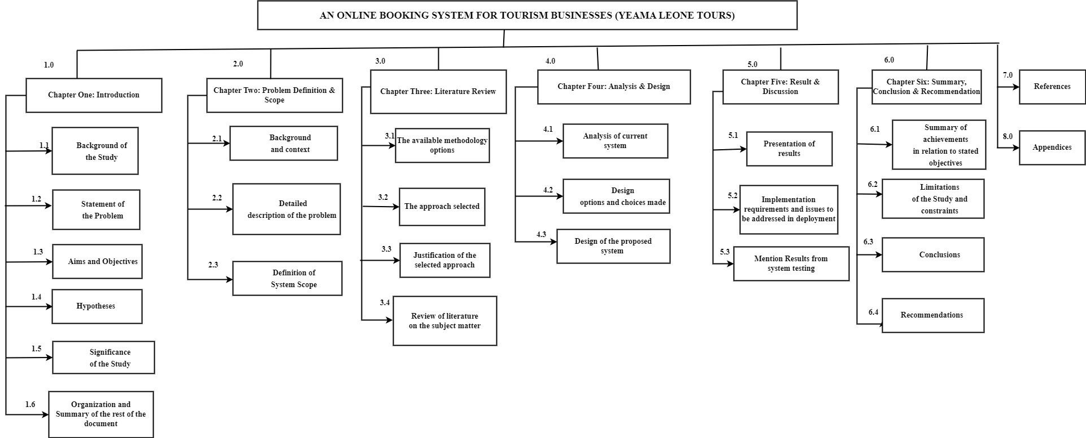

Figure 1 Work Breakdown Structure of the Project

#### 1.6.2 Table of the Gantt chart

|  |  |  |  |  |
| --- | --- | --- | --- | --- |
| No. | Tasks | Taks Duration | Start Date | End Date |
| 1.0 | **Chapter One: Introduction** | **20** | **May 15, 2023** | **June 3, 2023** |
| 1.2 | Background of the Study | 10 | May 15, 2023 | May 24, 2023 |
| 1.3 | Statement of the Problem | 5 | May 25, 2023 | May 29, 2023 |
| 1.4 | Aims and Objectives | 1 | May 26, 2023 | May 26, 2023 |
| 1.5 | Hypotheses | 3 | May 27, 2023 | May 27, 2023 |
| 1.6 | Significance of the Study | 7 | May 28, 2023 | June 3, 2023 |
| 2.0 | **Chapter Two: Problem Definition & Scope** | **15** | **June 4, 2023** | **June 6, 2023** |
| 2.1 | Background and context | 1 | June 4, 2023 | June 4, 2023 |
| 2.2 | Detailed description of the problem | 2 | June 5, 2023 | June 6, 2023 |
| 2.3 | Definition of System Scope | 2 | June 5, 2023 | June 6, 2023 |
| 3.0 | **Chapter Three: Literature Review** | 20 | June 1, 2023 | June 20, 2023 |
| 3.1 | The available methodology options | 7 | June 1, 2023 | June 7, 2023 |
| 3.2 | The approach selected | 7 | June 8, 2023 | June 14, 2023 |
| 3.3 | Justification of the selected approach | 3 | June 15, 2023 | June 17, 2023 |
| 3.4 | Review of literature on the subject matter | 3 | June 18, 2023 | June 20, 2023 |
| 4.0 | **Chapter Four: Analysis & Design** | 20 | June 21, 2023 | July 10, 2023 |
| 4.1 | Analysis of current system | 8 | June 21, 2023 | June 28, 2023 |
| 4.2 | Design options and choices made | 8 | June 29, 2023 | July 6, 2023 |
| 4.3 | Design of the proposed system | 5 | July 6, 2023 | July 10, 2023 |
| 5.0 | **Chapter Five: Result & Discussion** | 15 | July 11, 2023 | July 25, 2023 |
| 5.1 | Presentation of results | 11 | July 11, 2023 | July 21, 2023 |
| 5.2 | Implementation requirements and issues to be addressed in deployment | 3 | July 21, 2023 | July 23, 2023 |
| 5.3 | Mention Results from system testing | 3 | July 22, 2023 | July 24, 2023 |
| 6.0 | **Chapter Six: Summary, Conclusion & Recommendation** | 14 | July 25, 2023 | August 7, 2023 |
| 6.1 | Summary of achievements in relation to stated objectives | 1 | July 25, 2023 | July 25, 2023 |
| 6.2 | Limitations of the Study and constraints | 5 | July 26, 2023 | July 30, 2023 |
| 6.3 | Conclusions | 3 | July 31, 2023 | August 2, 2023 |
| 6.4 | Recommendations | 5 | August 3, 2023 | August 7, 2023 |
| 7.0 | **References** | **7** | August 8, 2023 | August 14, 2023 |
| 8.0 | **Appendices** | **7** | August 9, 2023 | August 15, 2023 |

Table 1 Gantt Chart Table

#### 1.6.3 Gantt Chart

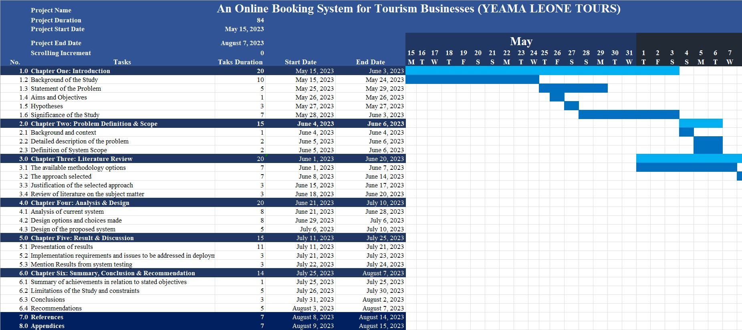

Figure 2 Gantt Chart of the Project

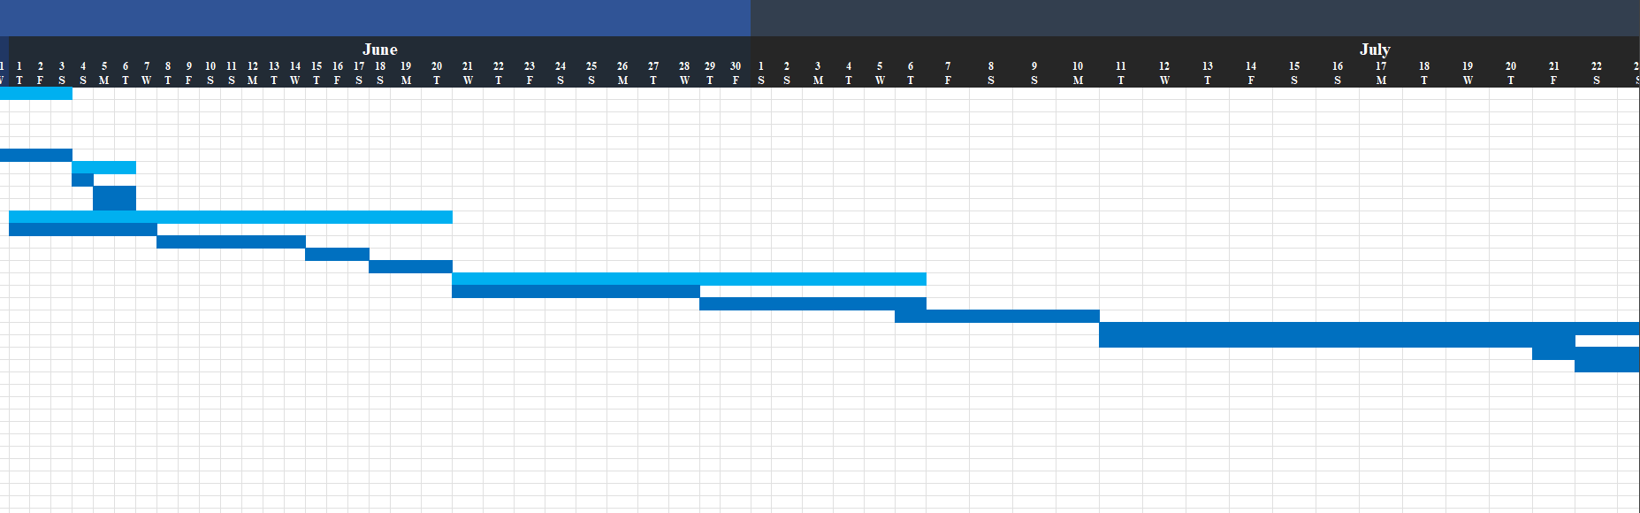

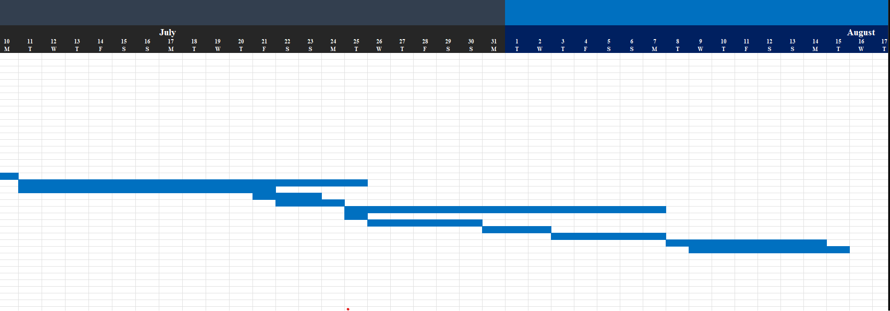Figure 3 Continuation of the Gantt Chart

Figure 4 Gantt Chart of the last months of the Project

# CHAPTER TWO

## 2.0 Problem Definition and Scope

### 2.1 Introduction

In this chapter, we delve into a comprehensive exploration of the problem domain and the scope of our dissertation. We begin by providing a background and contextual understanding of the challenges faced by tourism businesses, with a particular focus on the Sierra Leonean tourism industry. Through a detailed description of the prevailing issues, we aim to shed light on the specific problem that our research seeks to address.

Furthermore, we outline the scope of our study, defining the boundaries and limitations within which our proposed solution will operate. By clearly delineating the extent of our project, we lay the foundation for the subsequent chapters where we delve into the analysis, design, and implementation of the online booking system.

As we proceed, we will explore the intricacies of the identified problem and elucidate the parameters within which our innovative solution will unfold. Through this chapter, we set the stage for a comprehensive understanding of the challenges and opportunities that our dissertation endeavors to tackle, propelling us forward on a journey of exploration and innovation.

### 2.2 Background and Context

The allure of Sierra Leone's tourism industry lies in its kaleidoscope of natural wonders, from pristine beaches to lush rainforests and captivating wildlife. With a rich tapestry of cultural heritage woven into its landscapes, the country has emerged as an increasingly attractive destination for global travelers seeking unique and immersive experiences. This surge in tourism has prompted businesses within the sector to reassess their strategies and embrace the transformative power of technology (yeama leone tours, 2023).

Within this context, Yeama Leone Tours stands as a beacon of innovation and excellence in Sierra Leone's tourism landscape. Established with a passion for showcasing the country's myriad treasures, Yeama Leone Tours has carved a distinct niche for itself. Their commitment to delivering exceptional services and creating unforgettable travel moments has positioned them as a trailblazer in the industry. As Yeama Leone Tours embarks on a journey to enhance its offerings, the adoption of an advanced online booking system becomes a natural progression (yeama leone tours, 2023).

The advent of online booking systems has ushered in a new era of convenience, empowering travelers to seamlessly curate their dream experiences at their fingertips. This digital evolution echoes the observations made by the Organization for Economic Cooperation and Development (OECD) in 2020, emphasizing the imperative for tourism businesses to harness technology to stay relevant and competitive in an ever-changing market landscape (OECD, 2020).

Amidst this industry-wide transition, Yeama Leone Tours recognizes the limitations of the traditional manual booking processes. The intricacies of managing reservations for both individual tourists and partner agencies have underscored the need for a streamlined solution. This aligns with Yeama Leone Tours' forward-thinking approach, evident in their collaborations with partner agencies, which highlights their commitment to fostering a collaborative and innovative tourism ecosystem (yeama leone tours, 2023).

The interplay of Sierra Leone's burgeoning tourism sector, Yeama Leone Tours' aspirations, and the technological advancements driving the industry sets the stage for the focal point of this study. As we delve deeper into the problem domain, the subsequent sections unravel the nuances of the challenges faced by both Yeama Leone Tours and the broader Sierra Leonean tourism industry.

Through a comprehensive analysis, this research seeks to engineer an online booking system that not only rectifies the existing pain points but also catalyzes a paradigm shift in how tourism businesses interact with their customers. The following chapters will dissect the intricate layers of this solution, culminating in a blueprint that is poised to redefine the landscape of tourism in Sierra Leone.

### 2.3 Detailed Description of the Problem

The challenges faced by Yeama Leone Tours encompass various facets, each contributing to a complex web of operational inefficiencies and limitations. Delving into the intricacies of these challenges illuminates the pressing need for an innovative solution that can reshape the way the company operates and interacts with its customers and partner agencies.

#### 2.3.1 Complex Partner Agency Management:

Yeama Leone Tours operates in collaboration with multiple partner agencies to offer a diverse array of tour packages that cater to different interests and preferences of tourists. However, the absence of a centralized and automated booking system complicates the management of these partnerships. The current manual approach requires the company to handle partner agencies' booking requests, modifications, and cancellations, resulting in a significant allocation of time and resources. This intricate web of interactions not only strains the operational capacity of Yeama Leone Tours but also poses challenges in coordinating availability updates, communicating changes, and ensuring accurate and up-to-date information.

#### 2.3.2 Lack of Real-Time Updates and Availability:

The reliance on traditional booking methods, such as email exchanges and international phone calls, introduces delays in communication and processing. This often leads to missed opportunities, misunderstandings, and difficulties in managing last-minute changes. Tourists seeking to make bookings or modifications are subject to extended response times, hindering their ability to plan and secure their desired experiences. The lack of real-time updates on tour availability and instantaneous confirmation mechanisms adds a layer of uncertainty to the booking process, potentially deterring potential customers from finalizing their plans with Yeama Leone Tours.

#### 2.3.3 Inefficient Customer Interactions:

The current manual booking process also affects the quality of customer interactions and experiences. Engaging with tourists primarily through email and phone calls may lead to miscommunication, data entry errors, and a lack of personalization. Furthermore, the absence of a user-friendly online platform limits tourists' ability to explore and compare available tour packages at their convenience. This restricted accessibility diminishes the customer experience, preventing seamless interactions and inhibiting the ability to cater to diverse customer preferences.

#### 2.3.4 Missed Business Insights and Opportunities:

The lack of data-driven insights resulting from the absence of a comprehensive online booking system hampers Yeama Leone Tours' ability to gain a deeper understanding of customer behaviors, preferences, and market trends. The company is deprived of valuable information that could inform strategic decisions, marketing efforts, and the development of new offerings. Without the ability to analyze booking patterns, customer feedback, and demographic trends, Yeama Leone Tours operates without the agility required to adapt its services to evolving market dynamics and seize emerging opportunities.

#### 2.3.5 Workload and Resource Allocation:

As the company strives to manage partner agencies' bookings manually, its operational efficiency is compromised. The substantial workload associated with this process diverts valuable human resources from focusing on core business activities such as enhancing customer experiences, expanding offerings, and fostering collaborations. The labor-intensive nature of the current approach stifles Yeama Leone Tours' ability to scale and grow its operations while effectively serving both partner agencies and individual tourists.

Addressing these multifaceted challenges is imperative for Yeama Leone Tours to unlock its full potential and thrive in the dynamic landscape of the modern tourism industry. The upcoming sections will further elucidate the scope of the proposed online booking system, designed to alleviate these problems and foster a new era of efficiency, collaboration, and customer satisfaction.

### 2.4.0 Definition of System Scope

The system scope for the proposed online booking platform for Yeama Leone Tours in Sierra Leone outlines the boundaries and functionalities of the system, focusing on enhancing the booking process, user experience, and administrative efficiency. The scope encompasses a range of features that cater to the needs of tourists, partner agencies, and Yeama Leone Tours' administrative personnel. It is essential for guiding the development and implementation of the project, ensuring a clear understanding of its objectives and limitations.

#### 2.4.1 Tourist-Focused Scope

The system will prioritize the needs and convenience of tourists by offering an intuitive and user-friendly interface that simplifies the booking process and enhances their experience. Key components of the tourist-focused scope include:

1. **Tour Package Showcase**: A visually appealing and informative platform showcasing a diverse array of tour packages available through Yeama Leone Tours and its partner agencies. Each package will be presented with captivating descriptions, high-quality images, and detailed itineraries, enticing tourists to explore the options.
2. **Booking and Reservation**: An efficient and streamlined booking process that empowers tourists to select their desired tour packages, specify preferred travel dates, and proceed with the reservation. The system will provide real-time availability updates to ensure accurate booking information.
3. **Customization Options**: Tourists will have the flexibility to tailor their chosen tour packages by selecting optional activities, upgrading accommodations, and incorporating personalized preferences.
4. **Interactive Gallery**: An engaging multimedia gallery featuring images, videos, and virtual tours of the destinations and attractions covered in each tour package, allowing tourists to preview their upcoming experiences.
5. **Customer Reviews and Ratings**: A platform for tourists to provide valuable feedback, ratings, and reviews based on their travel experiences, fostering a transparent and informative community.

#### 2.4.2 Partner Agency-Focused Scope

The system will also cater to the needs of partner agencies, enabling them to efficiently manage bookings while collaborating effectively with Yeama Leone Tours. The partner agency-focused scope encompasses:

1. **Booking Dashboard**: A centralized dashboard that empowers partner agencies to oversee real-time booking statuses, and manage reservations.
2. **Package Management**: Partner agencies can add new tour packages, remove existing packages, and extend the dates of packages, providing flexibility in offering services.
3. **Booking Management:** Partner agencies can review and manage bookings, with the ability to confirm or pend bookings made by tourists, ensuring streamlined communication and coordination.
4. **Agency Account Management**: A secure login portal for partner agencies, granting them the ability to create and manage agency profiles, update tour package details, and monitor booking activities.

#### 2.4.3 Administrative-Focused Scope

The administrative scope of the system addresses the requirements of Yeama Leone Tours' operational staff and management, ensuring smooth operations and data-driven decision-making. It includes:

1. **Dashboard for Tour Management:** An administrative dashboard providing a comprehensive overview of ongoing and upcoming tours, enabling efficient resource allocation and personnel management.
2. **Approval Mechanism**: A streamlined process for Yeama Leone Tours to review and approve partner agencies seeking to utilize the platform for collaboration.
3. **System Maintenance and Updates**: An administrative interface for routine system maintenance, updates, and issue resolution, ensuring uninterrupted system performance.
4. **User Management**: Administrative users can add tourists and partner agencies to the system, and they can view the number of registered tourists, allowing for efficient monitoring and management.
5. **Admin Privileges**: Administrators can add other admin users to the system, granting appropriate access and permissions to ensure smooth system operation and management.

These refined scopes encompass the functionalities required to address the challenges of the current booking process, enhance customer satisfaction, and improve operational efficiency. They serve as a guiding framework throughout the project, ensuring that the system aligns with the goals and expectations of Yeama Leone Tours and its stakeholders.

# CHAPTER THREE

## 3.0 LITERATURE REVIEW/METHODOLOGY

### 3.1 INTRODUCTION

In this chapter, we embark on a comprehensive exploration of the available methodology options and the selected approach for the development of our project. Additionally, we delve into a profound review of literature pertaining to the subject matter of our project, with a particular focus on enhancing online booking systems within the context of tourism businesses. This literature review serves as the bedrock of informed decision-making and the construction of a robust and effective system.

Our endeavor begins by surveying the landscape of system development methodologies. This pivotal section examines the various avenues that guide the creation of software systems and culminates in the selection of the methodology best suited to the intricacies of our project. The chosen approach will lay the groundwork for the subsequent phases of development.

Following this exploration, we immerse ourselves in a comprehensive literature review. Drawing insights from scholarly works, we examine the profound transformations brought about by digitalization in the tourism industry. This evolution has given rise to the imperative integration of advanced technologies, such as online booking systems, to enhance customer experiences and operational efficiency. We dissect challenges endemic to traditional booking methods, uncover the profound impacts of online booking on tourist behavior, and unveil the pivotal role of customer engagement and satisfaction.

To further illuminate our path, we scrutinize two related projects - Tourism Hub and Visit Sierra Leone (VSL). These projects serve as guiding beacons, offering unique perspectives on facilitating online bookings and fostering partner agency interactions within the tourism domain. Through these case studies, we glean valuable insights, paving the way for the enhancement of Yeama Leone Tours' online booking system.

As we navigate through these sections, we draw from a wealth of scholarly sources, each carefully referenced to provide a solid foundation for our discussion. Our analysis is rooted in empirical evidence and informed viewpoints, ensuring that our methodology and approach are well-grounded and poised for success.

With the introduction set, we now embark on our journey through the realm of methodology options, system development approaches, and the enriching reservoir of existing literature, each contributing to the advancement of our project to revolutionize online booking for Yeama Leone Tours and beyond.

### 3.2 Related Project: Tourism Hub and Visit Sierra Leone

In this section, we explore two related projects, Tourism Hub and Visit Sierra Leone (VSL), to gain insights into their respective approaches to online booking and partner agency collaboration within the tourism industry. These projects provide valuable context and inspiration for the enhancement of Yeama Leone Tours' online booking system.

For our analysis of related projects, we will examine Tourism Hub, a comprehensive online tourism platform, and Visit Sierra Leone (VSL), a destination-focused website. These projects offer unique perspectives on how to facilitate online bookings and partner agency interactions, providing valuable insights for our proposed enhancement of Yeama Leone Tours' booking system.

#### 3.2.1 Detail Description of Tourism Hub:

Tourism Hub is a prominent player in the online tourism ecosystem that offers a consolidated platform for tourists to explore and book a diverse range of tourism services. This project collaborates with various partner agencies, covering categories such as campsites, residences, lodgings, hotels, outdoor recreation, and restaurants (Tourism Hub, 2022). Through this unified platform, tourists can seamlessly browse and book a comprehensive array of experiences, thereby simplifying the booking process and enhancing convenience.

**Tourism Hub's Key Features:**

* + 1. **Comprehensive Collaboration**: Tourism Hub collaborates with partner agencies spanning diverse categories, ensuring a wide range of services available on a single platform.
    2. **Customization and Personalization**: Tourists can curate personalized travel itineraries by combining services from different partner agencies.
    3. **Enhanced Convenience**: The unified platform simplifies the booking process, eliminating the need to navigate multiple individual booking platforms.
    4. **Promotion of Local Businesses**: Tourism Hub highlights local businesses and attractions, contributing to sustainable tourism growth.

Tourism Hub's features and approach to partner agency collaboration are discussed by Anderson et al. (2020). The authors explore user perceptions and implications of unified tourism service platforms, shedding light on the benefits of consolidation.

#### 3.2.2 Detail Description of Visit Sierra Leone (VSL):

Visit Sierra Leone (VSL) is a prominent online platform that promotes tourism in Sierra Leone by providing comprehensive information about destinations, attractions, accommodations, and activities. VSL collaborates with various partner agencies that offer tourism-related services. Notably, VSL does not host booking system for its partners; rather, it acts as an aggregator, directing users to the individual booking systems of its partner agencies. The platform showcases attractions, accommodations, and activities, allowing tourists to access relevant information and access booking options independently. Key aspects of VSL's project and its partner agency collaboration are presented below:

**Visit Sierra Leone's Key Features:**

* + 1. **Destination Information**: VSL provides comprehensive information about Sierra Leone's attractions, accommodations, and activities.
    2. **External Booking Links:** Unlike Tourism Hub, VSL does not directly support bookings but provides links to partner agencies' independent booking systems.
    3. **Attraction Showcasing**: The platform showcases the unique offerings of Sierra Leone, encouraging tourists to explore the destination's diversity.

Visit Sierra Leone's focus on promoting the destination's attractions is highlighted by Jones and Williams (2019). They emphasize the role of destination-focused platforms in providing information and inspiring travelers to explore.

### 3.3 Similarities and Differences in System Approach

In this section, we present a comparison between Yeama Leone Tour’s proposed online booking system and the related projects, Tourism Hub and Visit Sierra Leone (VSL). We identify both the commonalities and distinctions in terms of functionality and scope, shedding light on how our system builds upon existing models.

#### 3.3.1 Similarities of Our Systems:

* 1. All three systems aim to simplify the booking process for tourists, enhancing user convenience and engagement.
  2. Emphasis on digital transformation in the tourism industry, utilizing technology to streamline operations and improve customer experiences.
  3. Focus on customization and personalization of travel experiences to meet tourists' preferences.
  4. Web-based platforms, allowing users to access and interact with the systems through internet browsers.

#### 3.3.2 Differences of Our Systems:

* 1. Yeama Leone Tours' system integrates partner agency booking within the platform, while Tourism Hub and VSL do not offer direct agency booking.
  2. The use of an interactive multimedia gallery is unique to Yeama Leone Tours' system, enhancing tourists' pre-booking experience with visual previews.
  3. Unlike VSL, Yeama Leone Tours' system facilitates direct bookings with partner agencies, reducing friction and enhancing efficiency.
  4. Design choices in Yeama Leone Tours' system are influenced by insights from mixed-method analysis, ensuring features like real-time availability updates and streamlined communication.

### 3.4 Methodology Options and Selected Approach

In the realm of system development, various methodologies have been employed to guide the process of designing, building, and implementing software systems. These methodologies provide systematic frameworks that offer a structured approach to project management, requirement analysis, design, development, testing, and deployment. The choice of a methodology is pivotal to the success of a project as it influences how tasks are organized, collaboration is facilitated, and the project progresses toward its goals. In this section, we will discuss the available methodology options for system development and present the selected approach for our project.

#### 3.4.1 Available Methodology Options

Numerous methodologies have been developed over the years, each offering its unique principles, practices, and advantages. Some of the prominent methodologies in the field of system development include:

1. **Waterfall Model:** A sequential approach where each phase of the development process is completed before moving to the next one. This methodology is characterized by its clear and structured phases, making it suitable for projects with well-defined requirements.
2. **Agile Methodology:** A flexible and iterative approach that emphasizes collaboration, adaptability, and customer involvement throughout the development process. Agile methodologies, such as Scrum and Kanban, are well-suited for projects with evolving requirements and a need for continuous improvement.
3. **Iterative Development:** This approach involves repeating cycles of development, each producing an improved version of the system. Iterative development allows for ongoing refinements and adjustments based on user feedback and changing needs.
4. **Spiral Model:** Combining elements of the waterfall model and iterative development, the spiral model emphasizes risk assessment and mitigation. It involves iterative cycles that progressively enhance the system while addressing potential risks.
5. **Rapid Application Development (RAD):** RAD focuses on quickly building functional prototypes of the system to gather user feedback and refine requirements. It is particularly useful for projects with a short time-to-market.
6. **Unified Process (UP):** UP is an iterative and incremental methodology that emphasizes architecture and design early in the development process. It is well-suited for complex systems with a focus on architecture and component-based development.

#### 3.4.2 Selected Approach:

For the development of our online booking system, we opted for an Agile methodology, specifically Scrum. Agile methodologies are well-suited for dynamic projects where requirements may evolve over time, allowing for flexibility and iterative development (Beck et al., 2001). Scrum, a popular Agile framework, divides the project into incremental cycles known as sprints, facilitating efficient development, continuous feedback, and adaptability to changing needs.

**Steps and Processes:**

1. **Project Initiation**: The project kicked off with detailed planning, involving the identification of stakeholders, creation of a product backlog, and setting project goals.
2. **Sprint Planning**: Each sprint involved collaborative planning, where specific features and functionalities were selected from the product backlog based on priority and complexity.
3. **Development and Testing**: The development team carried out coding, continuously integrating features and conducting automated testing to ensure functionality and quality.
4. **Daily Stand-ups**: Daily stand-up meetings were held to discuss progress, address challenges, and prioritize tasks, promoting communication and alignment within the team.
5. **Sprint Review**: At the end of each sprint, a review session allowed stakeholders to evaluate the completed features and provide feedback.
6. **Sprint Retrospective**: The team conducted retrospectives to reflect on the sprint's successes and challenges, identifying opportunities for improvement.

#### 3.5 Tools and Technologies:

1. **Git & GitHub**: A version control system facilitating collaborative development and code management.
2. **Microsoft Excel:** Microsoft Excel was utilized for the creation of a Gantt chart, allowing for effective project scheduling and timeline management.
3. **Draw.io:** Draw.io proved valuable for crafting visual representations of the project's work breakdown structure and UML diagrams, aiding in design discussions and documentation.
4. **Microsoft Word:** Microsoft Word played a significant role in comprehensive documentation, allowing for the creation of detailed project reports, requirements documents, and other essential textual materials.

#### 3.6 Justification of the Selected Approach

The agile methodology was selected for this study because of its flexibility, adaptability, and emphasis on collaboration and customer satisfaction. The agile methodology allows for changing requirements, continuous feedback, and frequent reassessment, ensuring that the online booking system meets the specific needs and requirements of Yeama Leone Tours and its customers.

In the course of the project, there was a change in scope, as Yeama Leone Tours requested that its partner agencies manage their own booking. This change in scope required the development team to adapt quickly and incorporate the new requirements into the online booking system. The agile methodology was well-suited for this change, as it allowed for flexibility and adaptability to changing requirements.

Furthermore, the agile methodology promotes a collaborative work environment, encouraging cross-functional teams to work together to deliver a high-quality product (Beck et al., 2001). This is particularly important for the development of an online booking system that involves multiple stakeholders, including customers, management, technical staff, and partner agencies.

In addition, the agile methodology emphasizes customer satisfaction, ensuring that the online booking system meets the expectations of Yeama Leone Tours' customers (Schwaber & Sutherland, 2018). By involving customers in the development process and incorporating their feedback, the agile methodology ensures that the final product is user-friendly, reliable, and meets their specific needs.

The agile methodology was selected for this study because it aligns with the goals and objectives of Yeama Leone Tours, which prioritize customer satisfaction, collaboration, flexibility, and adaptability to changing requirements.

### 3.7 Review of Literature on the Subject Matter

In this section, a comprehensive review of existing literature related to the subject matter of enhancing online booking systems for tourism businesses, with a focus on Yeama Leone Tours, is presented. The review encompasses key findings, concepts, and theories from relevant scholarly sources, with an emphasis on analyzing and synthesizing the gathered information.

#### 3.7.1 Literature Review on Tourism Hub

**Introduction to Tourism Hubs**

In recent years, the concept of a Tourism Hub has gained prominence in the travel and tourism industry. This emerging model represents a fundamental shift in how destinations and businesses approach tourism management. Tourism Hub is typically defined as a central point where tourists can access a wide range of services, information, and experiences, making it a critical component of destination management strategies (Hall & Williams, 2008).

**Key Components of a Tourism Hub**

1. **Information and Visitor Centers**: Tourism Hubs often include well-equipped visitor centers that provide tourists with essential information about the destination, including maps, brochures, and recommendations (Hall, 2018). These centers serve as the first point of contact for travelers and play a pivotal role in shaping their experiences.
2. **Digital Platforms**: In the digital age, many Tourism Hubs are extending their services online, offering travelers the convenience of planning and booking activities from the comfort of their devices (Buhalis & Amaranggana, 2015). This shift towards online platforms has become even more significant with the growth of the digital economy.
3. **Transportation Connectivity**: Accessibility is a key component of a successful Tourism Hub. Hubs are often strategically located to provide easy access to transportation options, including airports, bus terminals, and railway stations (Hassan et al., 2019).
4. **Diverse Experiences**: A hallmark of Tourism Hubs is their ability to offer diverse experiences within a relatively small geographical area (Hall & Jenkins, 2004). These experiences can range from cultural heritage sites to adventure tourism activities and culinary delights.

**Benefits of Tourism Hubs**

1. **Enhanced Visitor Experience**: By centralizing information and services, Tourism Hubs facilitate a smoother and more enjoyable travel experience for tourists (Morgan et al., 2016). This leads to higher levels of visitor satisfaction.
2. **Economic Growth**: Tourism Hubs stimulate economic growth by attracting visitors, generating revenue, and creating jobs (Ritchie & Crouch, 2003). The concentration of tourism-related activities in a hub can lead to increased spending.
3. **Sustainable Tourism**: Tourism Hubs provide an opportunity for destinations to promote sustainable practices by managing visitor flows and reducing the environmental impact of tourism (Hall & Boyd, 2005).

**Challenges and Future Directions**

While the concept of Tourism Hubs holds great promise, there are challenges to overcome. These include issues related to infrastructure development, environmental sustainability, and the need for effective governance (Hall & Page, 2014).

Looking ahead, the Tourism Hub model is expected to continue evolving, driven by advancements in technology and changing traveller preferences. The role of digital platforms, sustainable practices, and community involvement will likely play an increasingly crucial role in shaping the future of Tourism Hubs.

**Conclusion**

The emergence of Tourism Hubs represents a paradigm shift in destination management. By centralizing services, information, and experiences, these hubs enhance visitor experiences, stimulate economic growth, and promote sustainable tourism practices. As the travel and tourism industry evolves, Tourism Hubs are poised to play an increasingly significant role in shaping the future of travel.

#### 3.7.2 Literature Review on Integration of Partner Agencies for a Tourism Business:

**Introduction**

The tourism industry is highly dynamic and competitive, necessitating continuous innovation and adaptation to changing market demands. One strategic approach that has gained prominence is the integration of partner agencies, wherein tourism businesses collaborate with external organizations to expand their reach, enhance offerings, and deliver comprehensive travel experiences. This literature review explores the various facets of partner agency integration in the context of tourism businesses, including its benefits, challenges, and implications.

**Benefits of Partner Agency Integration**

1. **Diversification of Offerings**: Partner agency integration allows tourism businesses to diversify their product and service offerings. As noted by Faulkner and Russell (2000), collaborations with partner agencies specializing in various aspects of travel, such as adventure sports or cultural experiences, enable businesses to cater to a broader range of customer preferences and interests.
2. **Global Reach**: Partner agencies often have established networks and customer bases in different regions. Cooperating with these agencies can facilitate access to international markets. Zou and Cavusgil (2002) emphasize the importance of global partnerships in reaching out to a wider audience and expanding market share.
3. **Resource Sharing**: Integration with partner agencies enables the sharing of resources, reducing operational costs and enhancing efficiency. Research by Buhalis (2008) underscores that shared marketing efforts, distribution channels, and infrastructure can lead to cost savings and improved competitiveness.

**Challenges and Considerations**

1. **Coordination and Communication**: Effective coordination and communication between the partnering agencies can be a significant challenge. Li and Wang (2012) argue that differences in organizational culture, communication styles, and operational procedures can lead to misalignment and conflicts, potentially undermining the collaboration.
2. **Quality Control**: Maintaining consistent service quality across partner agencies can be a concern. Chen and Wu (2011) suggest that tourism businesses must invest in quality control mechanisms and monitor partner agencies to ensure that service standards meet customer expectations.
3. **Risk Management**: Partner agency integration can expose tourism businesses to various risks, including financial, reputational, and legal risks. Laws and regulations may differ across regions, impacting the legality of certain partnerships. Proper due diligence and risk assessment are critical (Sigala, 2012).

**Implications for Tourism Businesses**

1. **Competitive Advantage**: Partner agency integration can provide a distinct competitive advantage. Morrison, Jing, and O'Leary (2014) emphasize that businesses with a well-coordinated network of partner agencies can offer unique and diverse travel experiences that set them apart in the market.
2. **Customer Experience Enhancement**: Collaborations with specialized agencies can enhance the customer experience. Research by Song and Li (2008) suggests that tailored packages and services resulting from partner agency integration can lead to higher customer satisfaction and loyalty.
3. **Market Expansion**: Partner agencies often bring market knowledge and insights that can aid in strategic decision-making. According to Kim and Li (2017), these insights can help tourism businesses identify emerging trends and opportunities in different markets, facilitating informed expansion strategies.

**Conclusion**

The integration of partner agencies in the operations of tourism businesses is a strategic approach with multifaceted benefits. From diversifying offerings to global market access and resource sharing, the advantages are evident. However, challenges related to coordination, quality control, and risk management must be addressed. Tourism businesses that successfully navigate these challenges stand to gain a competitive edge, enhance the customer experience, and expand their market reach. As the tourism industry continues to evolve, effective partner agency integration remains a key driver of success.

#### 3.7.3 Literature Review on The Impact of Online Booking on Hotel Revenue Management: A Simulation Approach

**Introduction**:

The rise of online booking systems has had a significant impact on the tourism industry, particularly in the hotel sector. This literature review aims to explore the benefits of online booking systems for hotel revenue management based on a study conducted by Chen and Jiao (2017).

**Benefits of Online Booking Systems for Hotel Revenue Management:**

According to Chen and Jiao (2017), online booking systems can help hotels to optimize their revenue management strategies. This is because an online booking system can provide hotels with real-time data on bookings and demand, which can be used to adjust prices and inventory levels.

Furthermore, an online booking system can help hotels to attract more customers by offering a more convenient booking experience. The study found that hotels that use online booking systems have higher occupancy rates and revenue per available room (RevPAR) than those that do not.

`

**Challenges of Implementing an Online Booking System:**

Despite the benefits, Chen and Jiao (2017) also identified several challenges associated with implementing an online booking system for hotel revenue management. One of the main challenges is the complexity of revenue management in a dynamic and competitive market. In addition, hotels must ensure that their online booking system integrates with their existing revenue management systems and strategies.

Another challenge is ensuring the accuracy of data. The study found that inaccurate data can lead to suboptimal revenue management decisions and lost revenue.

**Conclusion:**

The study by Chen and Jiao (2017) highlights the benefits of online booking systems for hotel revenue management, including increased revenue and occupancy rates. However, hotels must also be aware of the challenges and take steps to ensure that their online booking system integrates effectively with their revenue management strategies.

#### 3.7.4 Literature Review on Online booking in tourism: a user experience approach

**Introduction**:

Online booking systems have become an increasingly popular way for tourists to book travel arrangements, including flights, accommodation, and tours. This literature review aims to explore the benefits of online booking systems from a user experience perspective based on a study conducted by Buhalis and Law (2008).

**Benefits of Online Booking Systems for User Experience:**

According to Buhalis and Law (2008), online booking systems can provide tourists with a more convenient and personalized booking experience. This is because an online booking system can offer a range of options and features that are tailored to the needs of individual users.

Furthermore, an online booking system can help tourists to save time and effort by allowing them to make bookings from anywhere at any time. The study found that tourists who use online booking systems are more satisfied with their booking experience than those who book through other channels.

**Challenges of Implementing an Online Booking System:**

Despite the benefits, Buhalis and Law (2008) also identified several challenges associated with implementing an online booking system for tourism businesses. One of the main challenges is ensuring that the online booking system is accessible and user-friendly for all users, including those with disabilities or limited access to technology.

Another challenge is ensuring that the online booking system integrates effectively with other systems and processes used by the tourism business. This requires careful planning and coordination to ensure that the online booking system is not disruptive to existing operations.

**Conclusion**:

The study by Buhalis and Law (2008) highlights the benefits of online booking systems for user experience in the tourism industry. However, tourism businesses must also be aware of the challenges and take steps to ensure that their online booking system is accessible, user-friendly, and integrated effectively with their existing systems and processes.

#### 3.7.5 Literature Review on Enhanced Tourist Engagement and Satisfaction

**Introduction**

Tourist engagement and satisfaction are critical factors for the success of the tourism industry. Engaged tourists are more likely to have memorable experiences and become repeat visitors. This literature review explores various facets of enhanced tourist engagement and its direct impact on satisfaction.

**Understanding Tourist Engagement:**

Tourist engagement is a multidimensional concept that encompasses cognitive, emotional, and behavioural aspects. Huang and Hsu (2009) emphasize that engagement goes beyond mere participation in activities; it involves active cognitive processing and emotional attachment to the destination or experience. Engaged tourists are highly involved in their travel experiences, seeking meaningful interactions and memorable moments (Cohen, Prayag, & Moital, 2014).

**Factors Influencing Tourist Engagement:**

Several factors contribute to enhanced tourist engagement. Destination attributes such as natural beauty, cultural richness, and authenticity play a significant role (Choi & Kim, 2018). Moreover, technology and social media platforms have become powerful tools for engaging tourists. Wang, Park, and Fesenmaier (2012) argue that digital storytelling and social sharing can enhance engagement by allowing tourists to co-create and share their travel narratives.

**Tourist Satisfaction and Loyalty:**

Enhanced tourist engagement is closely linked to satisfaction and loyalty. Research by Chi and Qu (2008) suggests that engaged tourists are more likely to have positive travel experiences and higher levels of satisfaction. Satisfied tourists, in turn, are more inclined to become repeat visitors and advocates for the destination (Lee, Lee, & Yoo, 2007).

**Technological Enhancements:**

Technology plays a pivotal role in enhancing tourist engagement and satisfaction. Mobile applications, augmented reality, and virtual reality experiences have enabled tourists to immerse themselves more deeply in their destinations (Xiang et al., 2017). Such innovations provide interactive and personalized experiences that captivate tourists and leave lasting impressions.

**Co-Creation and Personalization:**

Tourists increasingly seek opportunities for co-creating their travel experiences. Neuhofer, Buhalis, and Ladkin (2015) argue that involving tourists in the design and planning of their trips enhances engagement and satisfaction. Personalization, whether through tailored recommendations or customized itineraries, is a potent tool for engaging tourists on a more profound level (Li & Wang, 2016).

**Conclusion:**

Enhanced tourist engagement is pivotal for creating memorable travel experiences and increasing satisfaction. Engaged tourists are more likely to form emotional connections with destinations and become loyal advocates. Technological advancements and the emphasis on co-creation and personalization are instrumental in achieving higher levels of engagement. For the tourism industry, recognizing the importance of engagement and leveraging technology to enhance it can lead to greater success and visitor satisfaction.

#### 3.7.6 Literature Review on the Challenges of Traditional Booking Systems

**Introduction**

Traditional booking systems have played a significant role in the travel and hospitality industry for many years. However, they face a range of challenges in the modern digital era. This literature review explores these challenges and their implications for the industry.

1. **Limited Accessibility and Convenience**

Traditional booking systems often require customers to physically visit travel agencies or make phone calls, which can be inconvenient and time-consuming (Neuhofer et al., 2015). This limitation can deter potential travelers who expect the convenience of online booking from anywhere at any time.

1. **Lack of Real-Time Information:**

One of the major challenges of traditional systems is their inability to provide real-time information on availability, pricing, and updates (O'Connor & Casey, 2014). In contrast, online systems offer immediate access to the latest details, influencing travelers' decisions.

1. **Inefficiency and Manual Processes:**

Manual processes inherent in traditional booking systems can be inefficient, error-prone, and costly for both travelers and businesses (Hemmatpour & Tafreshi, 2013). Such processes include paperwork, in-person transactions, and lengthy administrative procedures.

1. **Limited Reach and Market Penetration:**

Traditional systems often have geographical limitations, reaching only local or nearby customers (Gursoy, Chi, & Lu, 2013). This restriction can hinder business growth and market expansion compared to the global reach of online platforms.

1. **Reduced Customer Insights:**

Traditional systems may struggle to collect and analyze customer data effectively, missing opportunities for personalization and customer relationship management (CRM) (Leung, Bai, & Stahura, 2013). In the era of data-driven marketing, this can put traditional systems at a disadvantage.

1. **Security and Privacy Concerns:**

Handling sensitive customer information manually in traditional systems poses security and privacy concerns (Hemmatpour & Tafreshi, 2013). Online booking platforms often provide secure payment gateways and data encryption, instilling greater confidence in travelers.

**Conclusion:**

The challenges faced by traditional booking systems, including limited accessibility, lack of real-time information, inefficiency, limited reach, reduced customer insights, and security concerns, highlight the need for adaptation and innovation in the travel and hospitality industry. While these systems have served their purpose for many years, businesses must consider integrating digital solutions to meet the evolving expectations and demands of travelers in the modern age.

#### 3.7.7 Summary and Synthesis:

The review of literature establishes a strong foundation for the enhancement of Yeama Leone Tours' online booking system. It underscores the industry-wide shift towards digital transformation and the potential benefits of adopting advanced technologies. The challenges identified in the literature correspond to the pain points identified in the qualitative analysis conducted for Yeama Leone Tours. The integration of partner agencies, the emphasis on user-friendliness, and the provision of real-time information align with the best practices highlighted in the literature.

By synthesizing these insights, the literature review demonstrates the relevance and necessity of improving the online booking system for Yeama Leone Tours. The subsequent sections of this chapter will explore a related project, compare and contrast its features with the proposed system, and delve into the methodology adopted for the development of the enhanced platform.

# CHAPTER FOUR

## 4.0 ANALYSIS AND DESIGN

### 4.1 Introduction

In the realm of software development, the pivotal phases of analysis and design stand as the architectural keystones that lay the foundation for a successful and impactful system. In this chapter, we embark on an illuminating journey into the heart of these phases, peeling back the layers to reveal the intricate interplay of requirements, system dynamics, and creative design choices.

The canvas of analysis unfurls as we meticulously dissect the essential requirements that serve as the compass guiding our design efforts. These requirements, like constellations in the night sky, offer the roadmap that directs our endeavours towards crafting a system that seamlessly aligns with the aspirations of Yeama Leone Tours and the evolving needs of its patrons.

From there, we traverse into the landscape of the current system, armed with powerful analytical tools that illuminate the hidden corners and corridors. The exploration of use cases reveals the intricate web of interactions, shedding light on the system's strengths and areas yearning for enhancement. This dissection not only fuels our innovative spirit but also empowers us to architect a solution that bridges the gap between aspiration and actuality.

As we journey through the chapters of this unfolding narrative, the stage of data analysis, if undertaken, offers a deeper understanding, shaped by the insights gleaned from the empirical realm. Within this realm, patterns emerge, correlations reveal themselves, and meaningful narratives are etched into the fabric of data – narratives that weave themselves into the fabric of design choices.

Finally, we step into the realm of design – a realm where possibilities unfold like a tapestry of creativity. Here, design options take centre stage, and the symphony of decisions orchestrates the birth of an enhanced online booking system. With each choice, we strive to harmonize functionality, aesthetics, and user experience, forging a system that is not only technologically robust but also intuitively navigable.

As we embark on this chapter, we invite you to join us on a voyage through analysis and design. Together, we will navigate through the corridors of requirements, peer into the intricacies of the current system, explore the landscapes of data insights, and ultimately witness the birth of a design that encapsulates the vision, aspirations, and user-centric ethos of Yeama Leone Tours.

### 4.2 Requirement Gathering

In the process of developing an enhanced online booking system for Yeama Leone Tours, a comprehensive requirements gathering approach was employed. This involved the utilization of both qualitative and quantitative analysis techniques to ensure a holistic understanding of the project's needs and stakeholders' expectations. The following tools were used to gather requirements:

#### 4.­2.1 Mixed Approach: Qualitative and Quantitative Analysis

To ensure a thorough and well-rounded understanding of the project's requirements, a mixed approach was adopted. This approach involved conducting qualitative ­­­­analysis through interviews and quantitative analysis through questionnaires. This method enabled the collection of qualitative insights from key stakeholders while also allowing for quantitative data that could be statistically analysed.

#### 4.2.2 Tools and Techniques

Several tools and techniques were employed to gather requirements effectively:

1. **Interview with Yeama Leone Tours CEO**: An interview was conducted with the CEO of Yeama Leone Tours to gain valuable insights into the company's objectives, pain points, and vision for the enhanced online booking system. This interview provided qualitative data that informed the project's direction.
2. **Questionnaires for Partner Agencies**: Questionnaires were distributed to partner agencies of Yeama Leone Tours to understand their specific requirements, expectations, and challenges related to the booking process. The questionnaires focused on aspects such as collaboration, information exchange, and system usability.
3. **Questionnaires for Tourists**: Tourists who had used Yeama Leone Tours' services were surveyed to gather insights into their booking experiences, preferences, and suggestions for improvement. The questionnaires aimed to capture quantitative data on user behaviour and preferences.

#### 4.2.3 Questionnaires

##### 4.2.3.1 Questionnaire for Yeama Leone Tours:

1. What are the main challenges you face in the current booking process?
2. How do you envision the ideal online booking system enhancing your business operations?
3. What features and functionalities would you prioritize in the enhanced system?
4. How important is real-time availability information for your services?
5. What level of integration with partner agencies' booking systems do you envision?
6. How do you expect the new system to improve customer engagement and satisfaction?
7. Are there any specific security or privacy considerations that the system should address?
8. How do you foresee the system impacting your collaboration with partner agencies?

##### 4.2.3.2 Questionnaire for Partner Agencies:

1. How would you describe your current experience with Yeama Leone Tours' booking process?
2. What are the key pain points you encounter when interacting with the booking system?
3. What level of integration between your booking system and Yeama Leone Tours' system would be beneficial for your agency?
4. How important is the timely sharing of booking and availability information between your agency and Yeama Leone Tours?
5. What features would enhance your collaboration with Yeama Leone Tours and streamline the booking process?
6. Are there any specific technological or data exchange requirements your agency has for the new system?
7. How do you envision the enhanced system benefiting your agency and customers?

##### 4.2.3.3 Questionnaire for Tourists:

1. How often do you engage in travel and tourism activities?
2. What factors influence your decision-making process when booking travel services?
3. How important is the ease of use and convenience of the booking process for you?
4. Would you prefer a system that allows customization and personalization of travel itineraries?
5. How essential is real-time availability information when making bookings?
6. What features would enhance your booking experience and engagement with the service provider?
7. Are there any concerns you have regarding data privacy and security when using an online booking system?
8. How likely are you to use an online platform that offers seamless collaboration between multiple service providers?

The gathered requirements from these tools and techniques formed the foundation for the subsequent analysis and design stages of the project. They provided valuable insights into the expectations and needs of Yeama Leone Tours, its partner agencies, and the tourists, which were instrumental in shaping the direction of the enhanced online booking system.

### 4.2.4 Analysis of Questionnaire Responses

#### 4.2.4.1 Responded Questionnaire for Yeama Leone Tours:

**Responder: Yeama Leone Tours CEO**

1. Main Challenges in Current Booking Process: The CEO highlighted manual data entry errors, lack of real-time availability updates, and delayed booking confirmations as the main challenges.
2. Ideal Enhancement of Business Operations: The CEO envisions the ideal online booking system streamlining operations, improving customer engagement, and facilitating seamless collaboration with partner agencies.
3. Prioritized Features and Functionalities: The CEO prioritizes real-time availability information, user-friendly interface, seamless partner agency integration, and multimedia content showcasing destinations.
4. Importance of Real-time Availability Information: Real-time availability information is crucial for ensuring accurate and up-to-date booking options for customers.
5. Integration with Partner Agencies' Systems: The CEO expects a high level of integration with partner agencies' booking systems to ensure a smooth and unified booking experience.
6. Improvement of Customer Engagement and Satisfaction: The CEO anticipates that the new system will enhance customer engagement through personalized experiences and multimedia content.
7. Security and Privacy Considerations: The CEO emphasizes the importance of data security and privacy for both the company and its customers.
8. Impact on Collaboration with Partner Agencies: The CEO foresees improved collaboration with partner agencies, fostering better communication and data sharing.

#### 4.2.4.2 Responded Questionnaire for Partner Agencies:

**Responder: Partner Agency Representatives (3 respondents)**

1. Current Experience with Yeama Leone Tours' Booking Process: Respondents reported challenges with manual processes, delayed communication, and lack of real-time updates.
2. Key Pain Points in Interacting with the Booking System: Pain points include difficulty in accessing real-time availability information and delays in receiving booking confirmations.
3. Beneficial Level of Integration with Yeama Leone Tours' System: All respondents express the need for a high level of integration to ensure seamless communication and data exchange.
4. Importance of Timely Sharing of Booking Information: Timely sharing of booking and availability information is crucial for efficient service delivery.
5. Enhancing Collaboration and Streamlining the Process: Respondents emphasize the importance of features that enable smooth collaboration with Yeama Leone Tours and streamlined booking procedures.
6. Technological and Data Exchange Requirements: Specific data exchange and integration requirements were outlined, including automated booking updates and real-time synchronization.
7. Benefits of the Enhanced System: Partner agencies anticipate improved visibility, faster booking confirmations, and enhanced customer satisfaction.

#### 4.2.4.5 Questionnaire for Tourists:

**Responder: Tourists (2 respondents)**

1. Frequency of Engaging in Travel Activities: Both tourists engage in travel activities multiple times a year.
2. Influencing Factors in Decision-Making: Factors such as destination appeal, cost, and convenience influence their decision-making process.
3. Importance of Ease of Booking Process: Both tourists highly value an easy and convenient booking process.
4. Preference for Customization: Respondents express a preference for systems that allow customization and personalization of travel itineraries.
5. Significance of Real-time Availability Information: Real-time availability information is deemed important to make informed and timely booking decisions.
6. Enhancing Booking Experience and Engagement: Tourists seek features that enhance their booking experience, such as user-friendly interfaces and customization options.
7. Data Privacy and Security Concerns: Both tourists express concerns about data privacy and security when using an online booking system.
8. Likelihood of Using a Collaborative Platform: Respondents express interest in using a platform that offers seamless collaboration between multiple service providers.

### 4.3 Analysis of Requirements

The analysis of the questionnaire responses revealed common themes and priorities shared by Yeama Leone Tours, its partner agencies, and tourists. Key findings include:

* 1. The need for real-time availability information to enable informed booking decisions.
  2. Emphasis on user-friendly interfaces and customization options to enhance the booking experience.
  3. High expectations for seamless integration between Yeama Leone Tours and partner agencies' systems.
  4. Concerns about data privacy and security, highlighting the importance of robust security measures.
  5. Desire for streamlined collaboration and communication between all stakeholders in the booking process.

These insights provide a comprehensive understanding of the requirements and expectations of all stakeholders, which will inform the design and development of the enhanced online booking system.

### 4.4 Analysis of Current Proposed System

The current proposed system aims to address the challenges identified through the requirements gathering process. It focuses on streamlining the booking process for tourists and improving collaboration between Yeama Leone Tours, partner agencies, and tourists. The system introduces distinct user roles, each with specific functionalities and access levels, ensuring efficient operations and a seamless booking experience. The use cases outlined below provide a comprehensive overview of the system's functionalities and the roles of different actors within the system.

**4.4.1 Use Cases and Explanations**

**1. Admin Use Case:**

**Actor: Admin**

* As an Admin, I must be able to manage user accounts, including creating, updating, and deleting accounts for tourists and agency staff.
* As an Admin, I must approve or reject agency registrations and tourist accounts.
* As an Admin, I must have the authority to view and manage all bookings, including confirming, pending, or rejecting them.

**2. Tourist Use Case:**

**Actor: Tourist**

* As a Tourist, I must be able to browse and view available agency packages and services.
* As a Tourist, I must have the ability to book a package, providing necessary details such as dates, preferences, and payment information.
* As a Tourist, I must be able to modify or cancel my booking, with the system ensuring proper validation and communication.

**3. Agency Owner Use Case:**

**Actor: Agency Owner**

* As an Agency Owner, I must have the capability to add and manage Senior and Junior Staff accounts within my agency.
* As an Agency Owner, I must be able to modify agency packages to reflect updated services and pricing.
* As an Agency Owner, I must have access to an overview of agency performance, including booking statistics and user reviews.

**4. Senior Staff Use Case:**

**Actor: Agency Senior Staff**

* As an Agency Senior Staff, I must manage agency packages, including adding, updating, and removing offerings.
* As an Agency Senior Staff, I must review and manage booking requests, confirming or setting them to pending or rejected status.
* As an Agency Senior Staff, I must have access to agency reviews and feedback, enabling me to address customer concerns.

**5. Junior Staff Use Case:**

**Actor: Agency Junior Staff**

* As an Agency Junior Staff, I must have restricted access to the system, primarily for viewing purposes only.
* As an Agency Junior Staff, I must be able to see booking details and agency offerings.

#### 4.4.2 Unified Modelling Language (UML) of Use Cases

##### 4.4.2.1 Use Case: User Registration

|  |  |
| --- | --- |
| **Use Case** | User Registration |
| **Actors** | All Users |
| **Overview** | Provide all required information and email |
| **Preconditions** | Needs to have email address and Names |
| **Post Conditions** | User will be assigned a role as an Admin or Tourist or Agency Owner or Agency Senior Staff or Agency Junior Staff |
| **Flow of Events** | 1. Users must provide initial details to register with the system. 2. Users must provide an email & password for the system. 3. Once a user is registered, the user can log in to the system, with the exception of agency unless been approved by the Admin. |

Table 2 User Registration Use Case

##### 4.4.2.2 Use Case: Browse Packages

|  |  |
| --- | --- |
| **Use Case** | Browse Packages |
| **Actors** | Tourists |
| **Overview** | View available travel packages |
| **Preconditions** | None |
| **Post Conditions** | None |
| **Flow of Events** | 1. Tourist logs in to the system. 2. Tourist selects the "Browse Packages" option. 3. System displays a list of available travel packages. 4. Tourist can view package details and choose one for booking. |

Table 3 Browse Packages

##### 4.4.2.3 Use Case: Create Packages

|  |  |
| --- | --- |
| **Use Case** | Create Packages |
| **Actors** | Agency Owners, Senior Staff |
| **Overview** | Add details of a new travel package |
| **Preconditions** | Logged in as an agency owner or senior staff |
| **Post Conditions** | New travel package is added |
| **Flow of Events** | 1. Agency staff logs in to the system. 2. Staff selects the "Create Package" option. 3. System prompts to enter package details such as name, location, etc. 4. Staff provides all necessary package details. 5. Staff submits the package for review. |

Table 4 Create Packages

##### 4.4.2.4 Use Case: Manage Bookings

|  |  |
| --- | --- |
| **Use Case** | Manage Bookings |
| **Actors** | Agency Senior Staff, Tourists |
| **Overview** | View and manage booking details |
| **Preconditions** | Logged in as agency staff or tourist |
| **Post Conditions** | None |
| **Flow of Events** | 1. Actor logs in to the system. 2. Actor selects the "Manage Bookings" option. 3. System displays a list of bookings associated with the actor. 4. Actor can view booking details and update or cancel bookings. |

Table 5 Manage Bookings

#### 4.4.3 UML Use Case Diagram

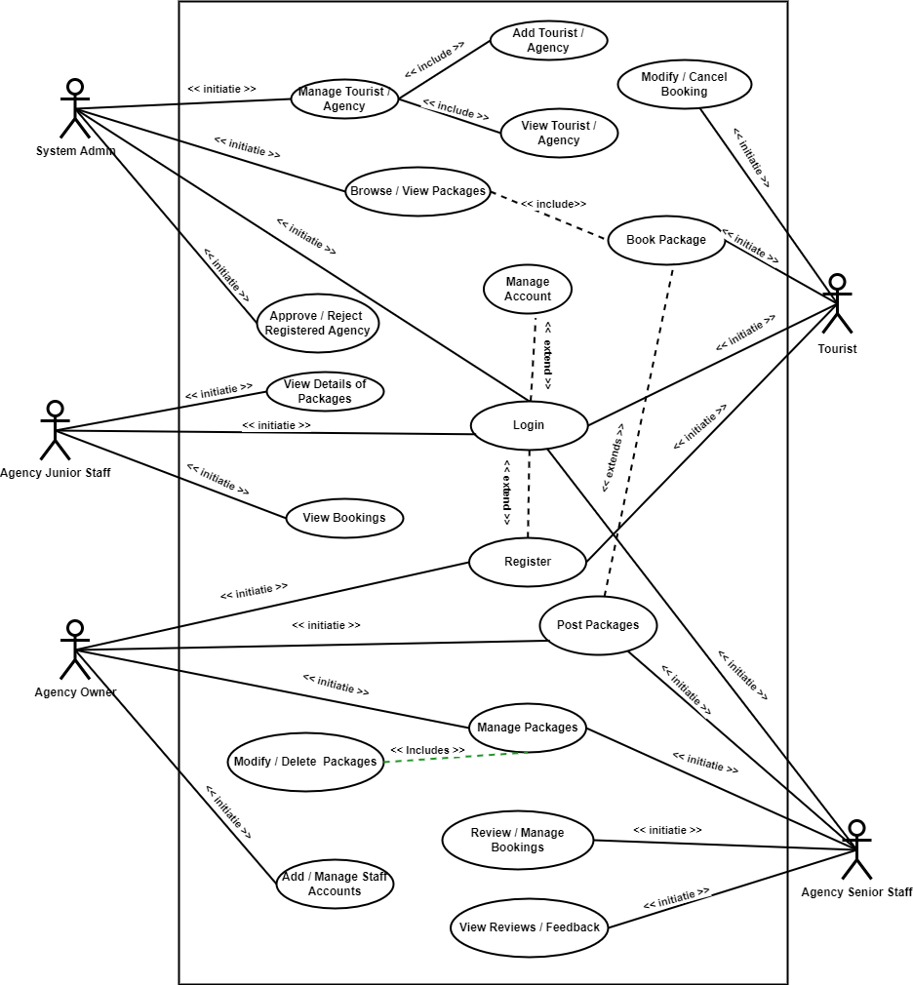

Figure 5 UML Use Case Diagram

These use cases outline the core functionalities and interactions within the proposed system. The system's design and implementation will be based on these use cases, ensuring that each user role can perform their tasks effectively, leading to an enhanced online booking experience for tourists and streamlined operations for Yeama Leone Tours and its partner agencies.

### 4.5 Requirements of the New System

The requirements for our proposed system have been meticulously derived, gathered, and meticulously categorized to ensure comprehensive coverage of all aspects. This section presents a detailed outline of both functional and non-functional requirements that define the scope and capabilities of the system. Additionally, the hardware and software requirements necessary for the proper functioning of the system are specified to ensure optimal performance and user satisfaction.

#### 4.5.1 Functional Requirements:

1. **User Management:**
   * + The system shall provide user registration and login functionalities for tourists, agency owners, senior staff, junior staff, and admins.
     + User roles and permissions shall be defined to control access to specific system features and functionalities.
2. **Booking Management:**
   * Tourists shall be able to browse, search, and view available agency packages and services.
   * Tourists shall have the ability to book, modify, or cancel a package booking.
   * Agency senior staff shall review, manage, and confirm booking requests.
   * Admins shall have the authority to manage and oversee all bookings, including approval and rejection.
3. **Agency Management:**
   * Agency owners shall be able to manage agency offerings, including adding, updating, and removing packages.
   * Agency owners shall have the capability to add and manage senior and junior staff accounts.
   * Senior staff shall have access to booking details, customer reviews, and the ability to modify offerings.
4. **Communication and Notifications:**
   * The system shall facilitate communication between tourists and agency staff through notifications and messaging features.
   * Users shall receive email notifications for booking confirmations, modifications, and cancellations.

#### 4.5.2 Non-Functional Requirements:

1. **Usability and User Experience:**
   * The system shall have an intuitive and user-friendly interface to ensure ease of use for all user roles.
   * Response times for loading pages and performing actions shall not exceed 2 seconds.
2. **Security and Data Privacy:**
   * User data, including personal and payment information, shall be securely stored and transmitted using encryption.
   * Access to sensitive data and functionalities shall be role-based and controlled through authentication and authorization mechanisms.
3. **Performance and Scalability:**
   * The system shall support concurrent access by multiple users without compromising performance.
   * The system shall be designed for scalability to accommodate an increasing number of users and data.

#### 4.5.3 Hardware and Software Requirements:

|  |  |
| --- | --- |
| **Hardware Specifications** | **Recommendations** |
| Processor | Intel / AMD – 2.0 GHz or higher |
| RAM | 4GB or higher |
| Hard Disk for development | 64 GB SSD or higher |
| Resolution | Minimum 1366 x 768 |
| Internet | Broadband with minimum 5.0 Mbps download rate |

Table 6 Hardware Specifications

|  |  |
| --- | --- |
| **Software Specifications** | **Recommendations** |
| Operating System | Windows 10, Mac OS 10.0, and Linux OS or later version |
| Web Server | Apache 2.4.53 |
| Database | MySQL Version 8.x |
| Web browser | Google Chrome (recommended) or latest version of Firefox, Edge, Opera |
| Text Editor | Visual Studio Code or Notepad++ |

Table 7 Software Specifications

These detailed requirements provide a comprehensive foundation for the design and development of the proposed system. The functional and non-functional requirements ensure that the system meets the needs of all stakeholders while the hardware and software requirements guarantee optimal performance, security, and user satisfaction.

### 4.6 System Design

The design phase of the system development process plays a crucial role in shaping the architecture, components, and interactions within the system. In this section, we explore different design approaches, including Object-Oriented Design, Function-Oriented Design, and Structure-Oriented Design, and their relevance to the proposed system.

#### 4.6.1 Object-Oriented Design:

Object-Oriented Design (OOD) is a design paradigm that focuses on modelling the system using objects, classes, and their interactions. In the context of our proposed system, Object-Oriented Design involves structuring the system based on entities within the domain, such as users, bookings, agencies, and packages. Each entity becomes an object with attributes and behaviours, and they interact through well-defined methods. For example:

* **User Class:** Represents different user roles (tourist, agency owner, senior staff, junior staff, admin), each with specific attributes and methods for authentication, booking management, and communication.
* **Booking Class:** Contains attributes like booking details, status, and payment information. Methods allow tourists to book, modify, and cancel, while agency staff confirm and manage bookings.

Object-Oriented Design promotes modularity, reusability, and flexibility. It allows us to encapsulate functionality within self-contained objects, making it easier to maintain and extend the system over time. By modelling real-world entities and their relationships, Object-Oriented Design aligns with the complex interactions and hierarchies present in our multi-user tourism booking system.

#### 4.6.2 Function-Oriented Design:

Function-Oriented Design (FOD) emphasizes breaking down the system into smaller functional units, or modules, each responsible for a specific task. These modules interact to achieve the system's objectives. In the proposed system, Function-Oriented Design involves decomposing various functionalities into distinct modules:

* **User Management Module:** Handles user registration, login, and role-based permissions.
* **Booking Management Module:** Manages browsing, booking, modification, and cancellation of packages.
* **Agency Management Module:** Allows agency owners and staff to manage agency offerings and personnel.
* **Communication Module:** Facilitates communication and notifications between users.

Function-Oriented Design simplifies development, testing, and maintenance by isolating specific features and encapsulating their logic. It enables parallel development of modules and encourages code reusability, making the system more manageable and adaptable.

#### 4.6.3 Structure-Oriented Design:

Structure-Oriented Design (SOD) focuses on organizing the system's components and interactions into a coherent structure. It emphasizes the arrangement of modules, their relationships, and the flow of data. In the context of our system:

* **User Interface Layer:** Provides a user-friendly interface for tourists, agency staff, and admins to interact with the system.
* **Business Logic Layer:** Implements the core functionality, including booking management, User Account / Agency Management,packages management, and admin approval mechanism.
* **Data Access Layer:** Manages interactions with the database, ensuring proper storage and retrieval of bookings, packages and user account details (Tourist, Agency & Admin).

By incorporating these design paradigms, our proposed system will achieve a well-structured architecture that supports modularity, functionality, and usability, ultimately delivering a robust and user-friendly online tourism booking platform.

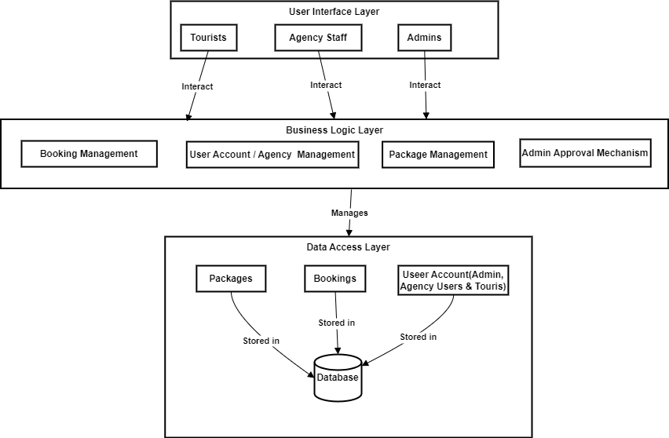

Figure 6 Structure-Oriented Design

### 4.7 Design Options and Choices Made

In the design phase of our system, several critical options and choices were made to ensure the creation of a functional, efficient, and user-friendly online tourism booking platform. These design decisions were driven by the project's goals, requirements, and the need to provide an optimal experience for users across various roles. Here, we outline the key design options and choices that have been implemented in our proposed system:

1. **User-Centric Interface Design:** The user interface (UI) was designed with a focus on user experience and ease of navigation. Clear and intuitive interfaces were crafted for each user role (tourist, agency owner, senior staff, junior staff, admin), ensuring that users can quickly access relevant functionalities. Thoughtful placement of buttons, forms, and menus enhances usability and reduces the learning curve.
2. **Role-Based Access Control:** A role-based access control system was adopted to manage user permissions and restrict access to specific features based on the user's role. This enhances security and ensures that users only have access to functionalities relevant to their responsibilities.
3. **Real-Time Availability Updates:** The system includes real-time availability updates for agency packages and services. This feature enables tourists to view the current status of offerings and make informed booking decisions, promoting accuracy and minimizing conflicts.
4. **Booking Management Dashboard:** Agency owners and senior staff have access to a comprehensive booking management dashboard. This dashboard provides an overview of all bookings, their statuses, and relevant details, enabling efficient tracking and decision-making, Tourist can also delete or modify their booking.
5. **Customizable Packages:** Agency owners and senior staff have the ability to customize and update their agency's packages and offerings. This flexibility allows agencies to adapt to changing market demands and tailor their services to attract tourists.
6. **Image Gallery:** The system features an image gallery that showcases destinations, attractions, and package highlights. This visual preview enhances tourists' pre-booking experience and helps them make informed decisions.

These design options and choices were carefully considered to align with the project's objectives and user requirements. By incorporating these features and functionalities, our proposed system aims to provide a comprehensive, efficient, and user-cantered online booking platform for tourism services.

### 4.8 Design of the Proposed System

#### 4.8.1 Data Dictionary of the System

##### 4.8.1.1 Table: admins

|  |  |  |  |
| --- | --- | --- | --- |
| **Column Name** | **Data Type** | **Size** | **Description** |
| admin_id | int | 11 | Unique identifier for the admin |
| username | varchar | 50 | Username of the admin |
| admin_firstname | varchar | 50 | First name of the admin |
| admin_lastname | varchar | 50 | Last name of the admin |
| admin_email | varchar | 50 | Email of the admin |
| admin_password | varchar | 50 | Password of the admin |
| admin_contact | varchar | 13 | Contact number of the admin |
| date | date |  | Date of admin's record creation |

Table 8 admins Data Dictionary

##### 4.8.1.2 Table: agencies

|  |  |  |  |
| --- | --- | --- | --- |
| **Column Name** | **Data Type** | **Size** | **Description** |
| agency_id | int | 11 | Unique identifier for the agency |
| agency_name | varchar | 50 | Name of the agency |
| owner_firstname | varchar | 50 | First name of the agency owner |
| owner_lastname | varchar | 50 | Last name of the agency owner |
| agency_email | varchar | 50 | Email of the agency |
| agency_password | varchar | 50 | Password of the agency |
| logo_image | text |  | Logo image of the agency |
| cover_image | text |  | Cover image of the agency |
| agency_contact | varchar | 13 | Contact number of the agency |
| agency_address | varchar | 50 | Address of the agency |
| agency_status | varchar | 15 | Status of the agency (e.g., active, inactive) |
| date | date |  | Date of agency's record creation |
| added_by | int | 11 | Admin who added the agency (foreign key) |

Table 9 agencies Data Dictionary

##### 4.8.1.3 Table: agency_employees

|  |  |  |  |
| --- | --- | --- | --- |
| **Column Name** | **Data Type** | **Size** | **Description** |
| employee_id | int | 11 | Unique identifier for the agency employee |
| agency_id | int | 11 | Foreign key referencing agencies table |
| employee_firstname | varchar | 50 | First name of the agency employee |
| employee_lastname | varchar | 50 | Last name of the agency employee |
| employee_email | varchar | 50 | Email of the agency employee |
| employee_password | varchar | 50 | Password of the agency employee |
| employee_contact | varchar | 13 | Contact number of the agency employee |
| employee_address | varchar | 50 | Address of the agency employee |
| role | varchar | 50 | Role of the agency employee (e.g., Senior, Junior) |
| date | date |  | Date of employee's record creation |

Table 10 agency_employees Data Dictionary

##### 4.8.1.4 Table: bookings

|  |  |  |  |
| --- | --- | --- | --- |
| **Column Name** | **Data Type** | **Size** | **Description** |
| booking_id | int | 11 | Unique identifier for the booking |
| package_id | int | 11 | Foreign key referencing packages table |
| tourist_id | int | 11 | Foreign key referencing tourists table |
| agency_id | int | 11 | Foreign key referencing agencies table |
| persons | int | 11 | Number of persons for the booking |
| travel_style | varchar | 50 | Travel style for the booking (e.g., Group, Solo) |
| enquiry_msg | text |  | Enquiry message for the booking |
| booking_status | varchar | 15 | Status of the booking (e.g., Confirmed, Pending) |
| date | date |  | Date of booking's record creation |

Table 11 bookings Data Dictionary

##### 4.8.1.5 Table: comments

|  |  |  |  |
| --- | --- | --- | --- |
| **Column Name** | **Data Type** | **Size** | **Description** |
| comment_id | int | 11 | Unique identifier for the comment |
| tourist_id | int | 11 | Foreign key referencing tourists table |
| package_id | int | 11 | Foreign key referencing packages table |
| agency_id | int | 11 | Foreign key referencing agencies table |
| content | text |  | Content of the comment |
| comment_status | varchar | 15 | Status of the comment (e.g., Approved, Pending) |
| comment_date | date |  | Date of comment's record creation |

Table 12 comments Data Dictionary

##### 4.8.1.6 Table: packages

|  |  |  |  |
| --- | --- | --- | --- |
| **Column Name** | **Data Type** | **Size** | **Description** |
| package_id | int | 11 | Unique identifier for the package |
| agency_id | int | 11 | Foreign key referencing agencies table |
| package_name | varchar | 50 | Name of the package |
| location | varchar | 50 | Location of the package |
| district | tinytext |  | District information of the package |
| place_details | text |  | Details about the place |
| place_images | text |  | Images of the place |
| num_days | int | 11 | Number of days in the package |
| num_nights | int | 11 | Number of nights in the package |
| budget_price | int | 11 | Budget price of the package |
| comfort_price | int | 11 | Comfort price of the package |
| lux_price | int | 11 | Luxury price of the package |
| budget_details | text |  | Details about budget package |
| comfort_details | text |  | Details about comfort package |
| lux_details | text |  | Details about luxury package |
| booking_percentage | int | 11 | Booking percentage for the package |
| min_people | int | 11 | Minimum number of people for the package |
| includes | text |  | Inclusions in the package |
| excludes | text |  | Exclusions in the package |
| optional | text |  | Optional items in the package |
| itinerary | text |  | Itinerary details of the package |
| package_status | varchar | 15 | Status of the package (e.g., Active, Inactive) |
| package_date | date |  | Date of package's record creation |

Table 13 packages Data Dictionary

##### 4.8.1.7 Table: package_dates

|  |  |  |  |
| --- | --- | --- | --- |
| **Column Name** | **Data Type** | **Size** | **Description** |
| date_id | int | 11 | Unique identifier for the package date |
| package_id | int | 11 | Foreign key referencing packages table |
| agency_id | int | 11 | Foreign key referencing agencies table |
| last_date | date |  | Last date for booking in the package |
| travel_date | date |  | Travel date for the package |
| status | varchar | 15 | Status of the package date (e.g., Available, Booked) |
| date | date |  | Date of package date's record creation |

Table 14 package_dates Data Dictionary

##### 4.8.1.8 Table: reviews

|  |  |  |  |
| --- | --- | --- | --- |
| **Column Name** | **Data Type** | **Size** | **Description** |
| review_id | int | 11 | Unique identifier for the review |
| agency_id | int | 11 | Foreign key referencing agencies table |
| tourist_id | int | 11 | Foreign key referencing tourists table |
| rating | int | 11 | Rating of the review (e.g., 1-5) |
| comment | text |  | Comment content of the review |
| review_status | varchar | 15 | Status of the review (e.g., Approved, Pending) |
| review_date | date |  | Date of review's record creation |

Table 15 reviews Data Dictionary

##### 4.8.1.9 Table: tourists

|  |  |  |  |
| --- | --- | --- | --- |
| **Column Name** | **Data Type** | **Size** | **Description** |
| tourist_id | int | 11 | Unique identifier for the tourist |
| tourist_username | varchar | 50 | Username of the tourist |
| tourist_firstname | varchar | 50 | First name of the tourist |
| tourist_lastname | varchar | 50 | Last name of the tourist |
| tourist_email | varchar | 50 | Email of the tourist |
| tourist_password | varchar | 50 | Password of the tourist |
| profile_image | text |  | Profile image of the tourist |
| tourist_contact | varchar | 13 | Contact number of the tourist |
| tourist_address | varchar | 50 | Address of the tourist |
| tourist_status | varchar | 15 | Status of the tourist (e.g., Active, Inactive) |
| date | date |  | Date of tourist's record creation |
| added_by | int | 11 | Admin who added the tourist (foreign key) |

Table 16 tourists Data Dictionary

#### 4.8.2 UML Class

**Multiplicity Notation:**

Multiplicity notation in UML class diagrams represents the number of instances of one class that can be associated with instances of another class. It is shown near the association line between two classes.

* **0..\***: Zero or more instances.
* **1 or 1..1**: Exactly one instance, or one and only one
* **1..\***: One or more instances.
* **\***: Any number of instances.

**Explanation of Relationships and Multiplicity:**

1. **Admin "1..*" --> "0..*" Agency:**
   * An admin can manage zero or more agencies.
   * Each agency is managed by exactly one or more admins.
2. **Tourist "1..1" --> "0..*" Booking:**
   * A tourist can have zero or more bookings.
   * Each booking is associated with exactly one tourist.
3. **Agency "1..1" --> "0..*" AgencyEmployee:**
   * An agency can have zero or more agency employees.
   * Each agency employee works for exactly for one and only agency.
4. **Agency "1..1" --> "0..*" Package:**
   * An agency can offer zero or more packages.
   * Each package is offered by exactly one agency.
5. **AgencyEmployee "1..1" --> "0..*" Booking:**
   * An agency employee can make zero or more bookings.
   * Each booking is made by exactly one agency employee.
6. **Tourist "1..1" --> "0..*" Comments:**
   * A tourist can write zero or more comments.
   * Each comment is written by exactly one and only one tourist.
7. **Tourist "1..1" --> "0..*" Reviews:**
   * A tourist can write zero or more reviews.
   * Each review is written by exactly one tourist.
8. **Package "1..1" --> "0..*" PackageDate:**
   * A package can have zero or more date options.
   * Each package date is associated with exactly one package.
9. **Packages "1..1" --> "0..*" Bookings:**
   * A package can have zero or more bookings.
   * Each booking is associated with exactly one package.
10. **Package "1..1" --> "0..*" Comment:**
    * A package can have zero or more comments.
    * Each comment is associated with exactly one package.
11. **Package "1..1" --> "0..*" Review:**
    * A package can have zero or more reviews.
    * Each review is associated with exactly one package.

##### 4.8.2.1 UML Class Diagram

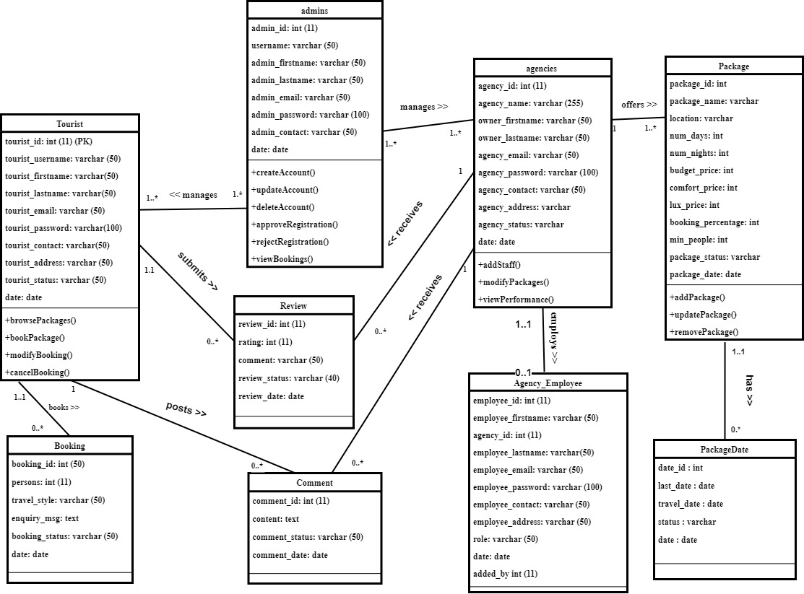

Figure 7 UML Class Diagram

#### 4.8.3 UML ER Diagram

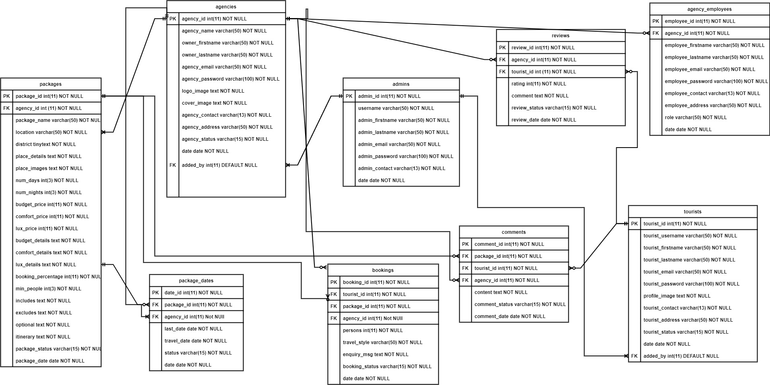

Figure 8 UML ER Diagram

**FOR BETTER VISIBILTY ALL IMAGES INCLUDING ER DIAGRAM PLEASE DOWNLOAD IT FROM**; <https://github.com/IPAM-PROJECTS/ylt.git>

#### 4.8.3.1 ER Diagram from MySQL Xampp

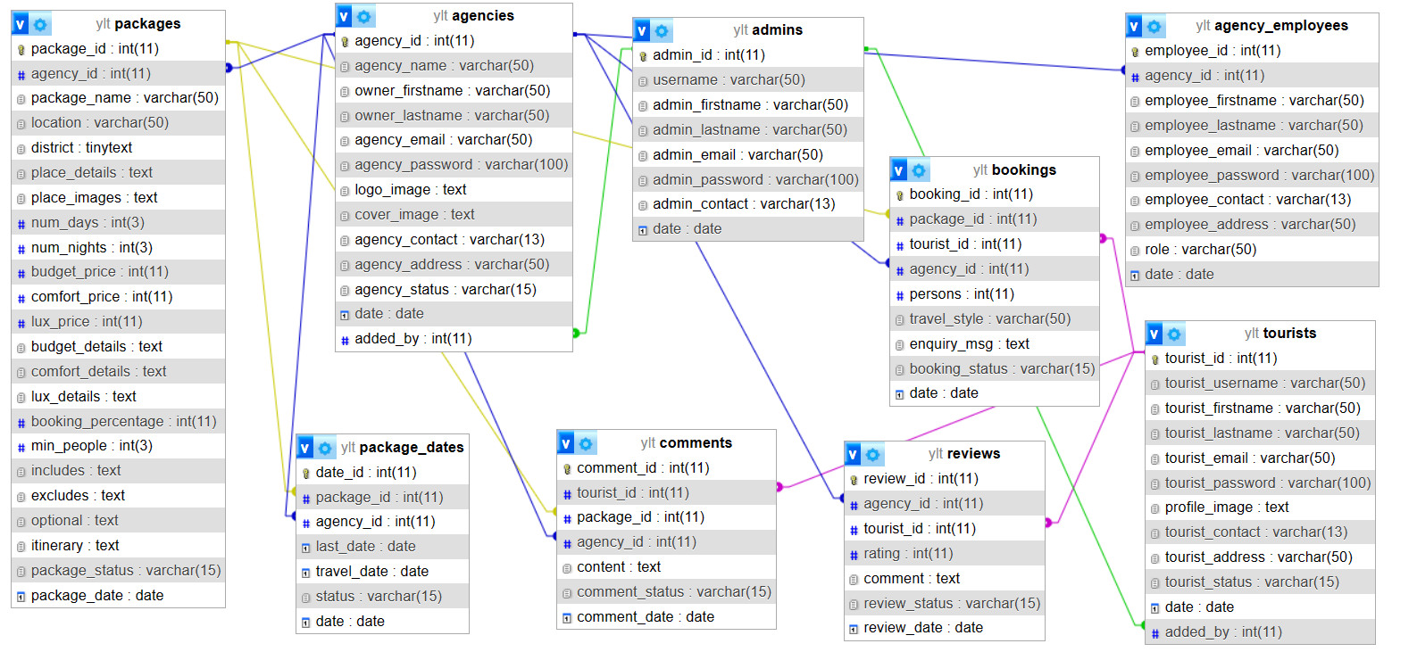

Figure 9 ER Diagram from Xampp Mysql Database

#### 4.8.4 UML Sequence Diagram

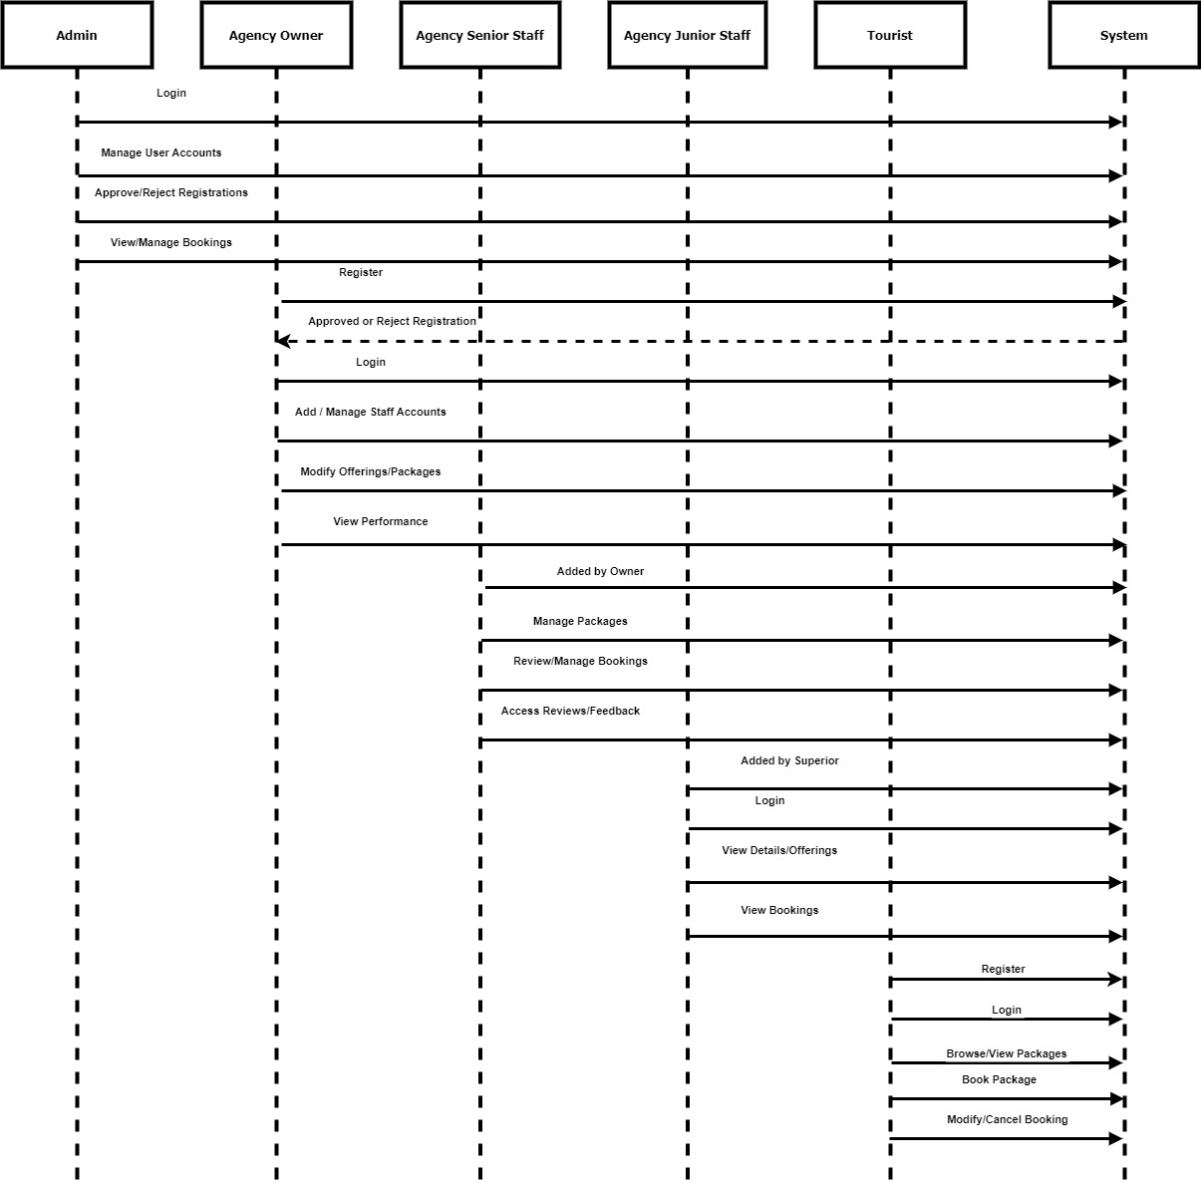

Figure 10 UML Sequence Diagram

# CHAPTER FIVE

## 5.0 RESULTS AND DISCUSSION

### 5.1 Introduction

In this chapter, the outcomes of the system development process are presented, along with a discussion of the key features that have been successfully implemented. The primary focus is on showcasing the tangible results achieved during the course of the project. The chapter provides an overview of the system's functional and non-functional aspects, accompanied by relevant screenshots that highlight the system's capabilities.

Furthermore, the implementation requirements and any notable deployment issues encountered during the development phase are discussed. This section sheds light on the technical considerations that are crucial for the successful deployment of the system in real-world scenarios.

In addition, the chapter addresses the results obtained from the comprehensive system testing that was conducted. It refers to the data presented in the appendix, which was used to rigorously evaluate the system's functionality and reliability. The system's performance in different scenarios and under various conditions is discussed, providing insights into its readiness for operational use.

Lastly, the chapter engages in a discussion that synthesizes the presented results, implementation requirements, and testing outcomes. This discussion aims to analyse the implications of the achieved results, identify potential areas for further improvement, and highlight the alignment of the system with the initially set objectives.

By the end of this chapter, we will have a clear understanding of the system's capabilities, its readiness for deployment, and the implications of its testing outcomes. The results and insights gained from this chapter will provide valuable information for decision-making, refinement, and future enhancements of the system.

### 5.2 Presentation of Results

This section presents the key features and functionalities that have been successfully implemented in the system. It offers a comprehensive overview of the system's capabilities, demonstrating how it fulfils the identified requirements and user needs. Below are some of the notable features that have been realized:

1. **User Registration and Authentication:**
   * Users can register with the system using their email addresses and providing their names.
   * A secure authentication mechanism ensures the privacy and security of user accounts.
2. **Role-based Access:**
   * Upon registration, users are assigned roles as Admin, Tourist, Agency Owner, Agency Senior Staff, or Agency Junior Staff.
   * Each role has distinct permissions and access levels tailored to the user's responsibilities.
3. **Package Management:**
   * Agency Owners and Senior Staff can manage agency offerings and packages.
   * Packages can be added, updated, or removed, including detailed information such as location, pricing, and inclusions.
4. **Booking and Reservation:**
   * Tourists can browse available packages and services offered by agencies.
   * Users can book packages, specifying details such as travel dates, preferences, number of persons and also delete booking.
5. **Review and Feedback:**
   * Tourists can provide reviews and ratings for agencies and packages.
   * Agency Senior Staff can access reviews to address customer feedback and improve services.
6. **Comprehensive Testing:**
   * Rigorous system testing has been conducted, covering functional, usability, and performance aspects.
   * A diverse set of test cases, including edge cases, were employed to evaluate the system's reliability and robustness.

#### 5.2.1 Images of the System

##### 5.2.1.1 Image of Home Page

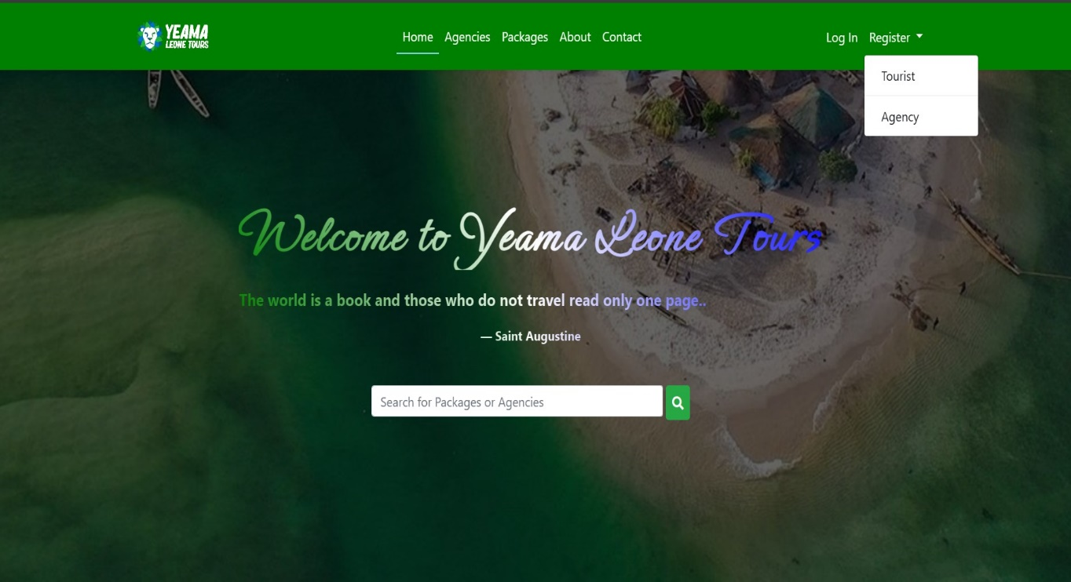

Figure 11 Home Page

##### 5.2.1.2 Image of Agency Page

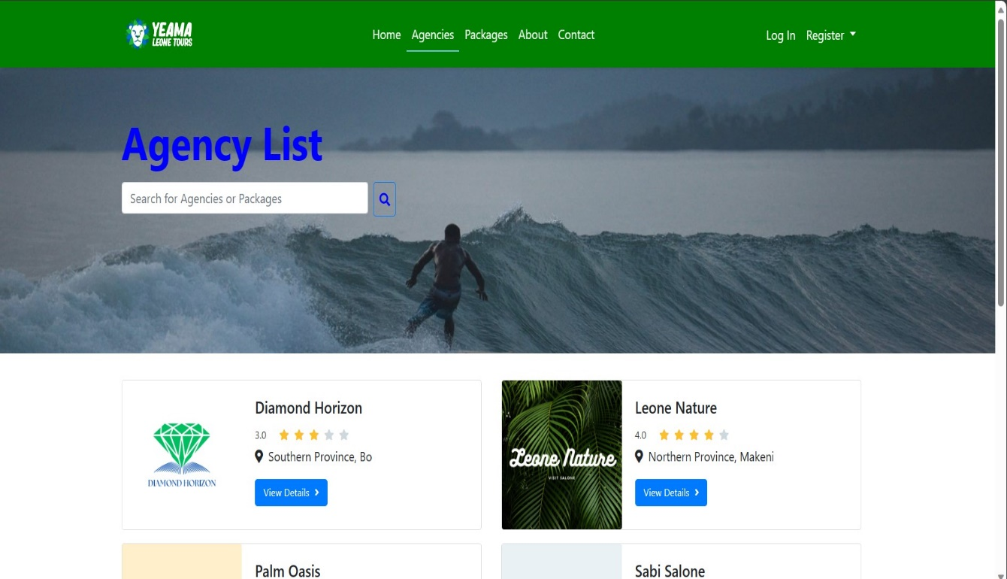

Figure 12 Agency Page

##### 5.2.1.3 Image of Package Page

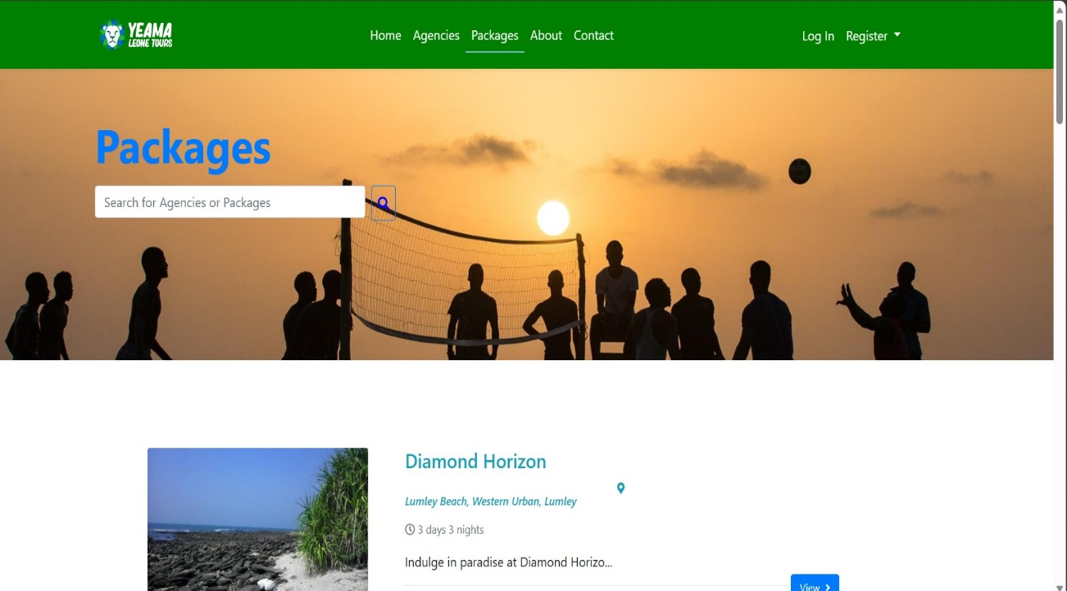

Figure 13 Packages Page

##### 5.2.1.4 Image of About Us

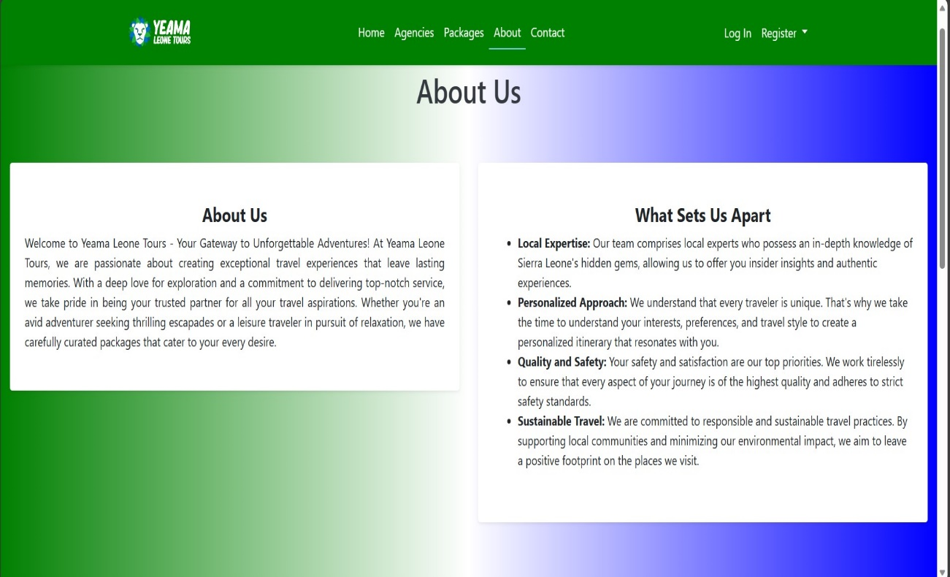

Figure 14 About Us

##### 5.2.1.5 Image of Contact Us Page

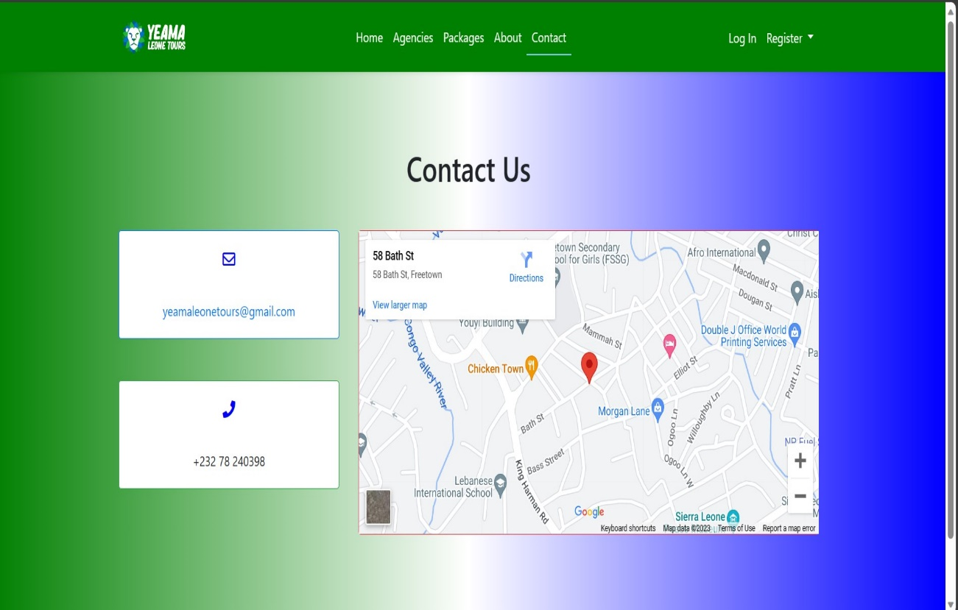

Figure 15 Contact Us Page

##### 5.2.1.6 Image of Tourist Registration

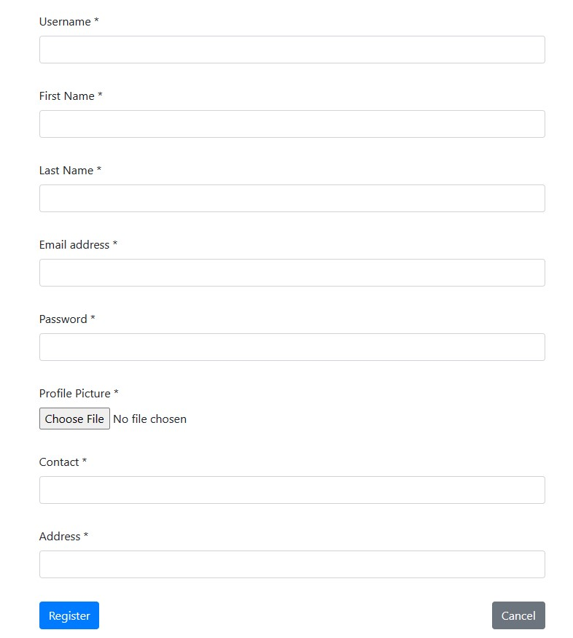

Figure 16 Tourist Registration

##### 5.2.1.7 Image of Agency Registration

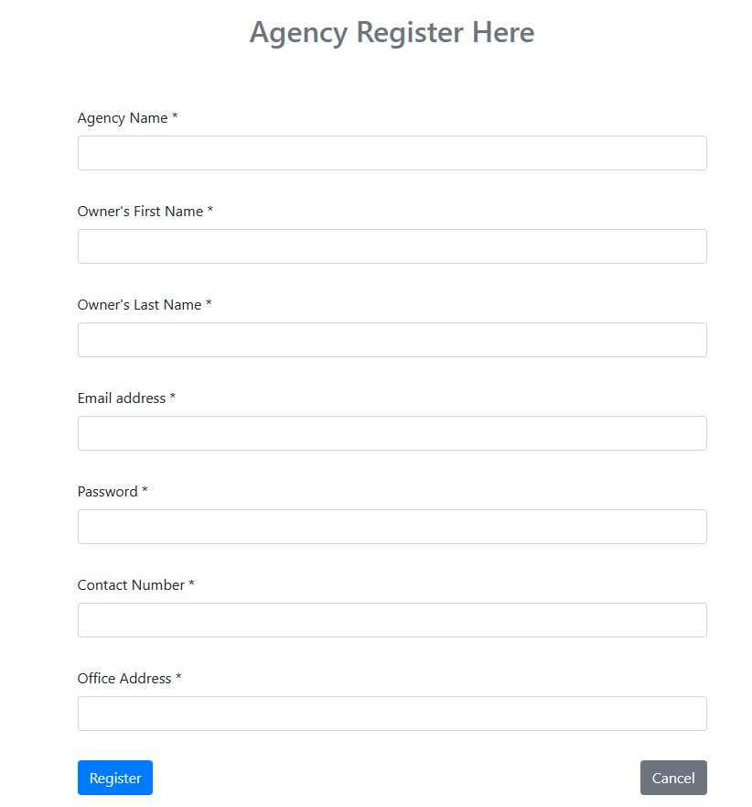

Figure 17 Agency Registration

##### 5.2.1.8 Image of Login

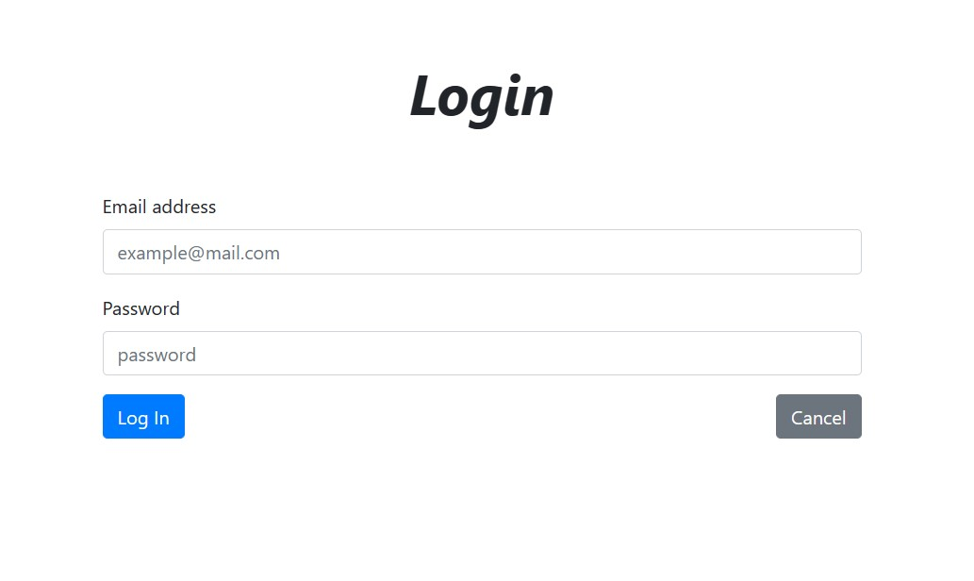

Figure 18 Multi User Login to the system

##### 5.2.1.9 Image of List of Agencies

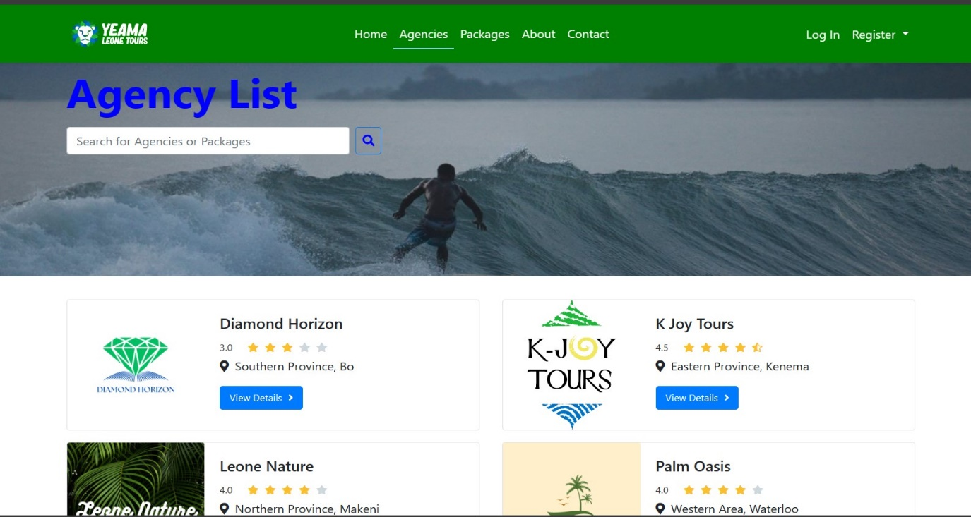

Figure 19 List of Agencies

##### 5.2.1.10 Image of Packages List

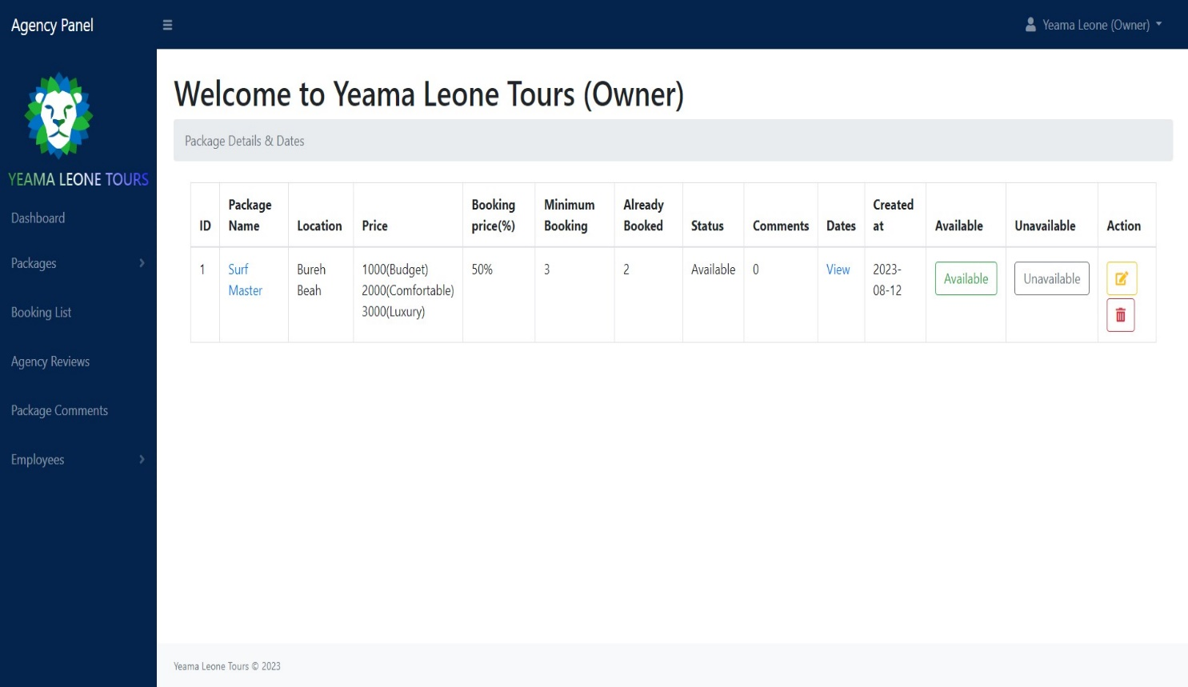

Figure 20 Agency Package List

##### 5.2.1.11 Image of Bookings

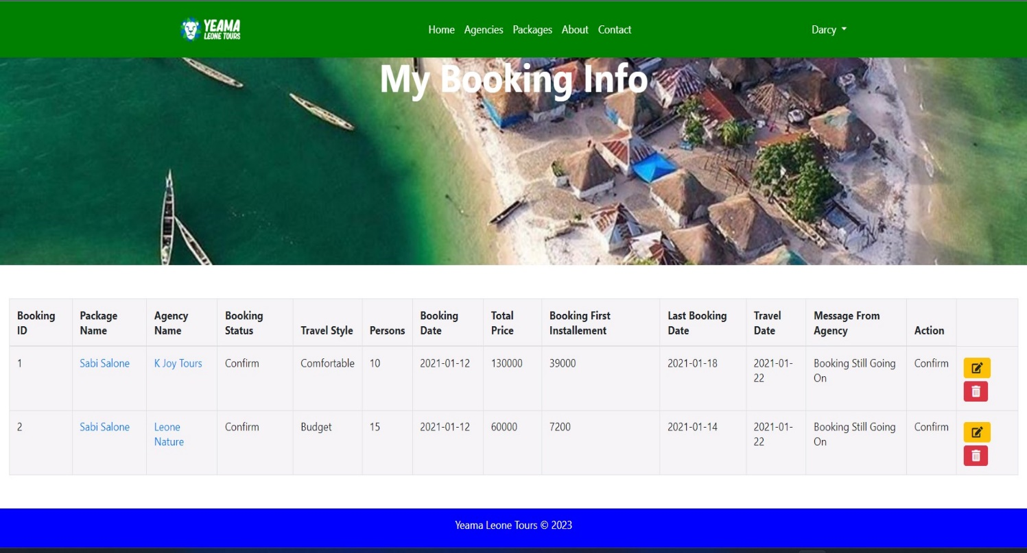

Figure 21 Booking

##### 5.2.1.12 Image of Booking Modification

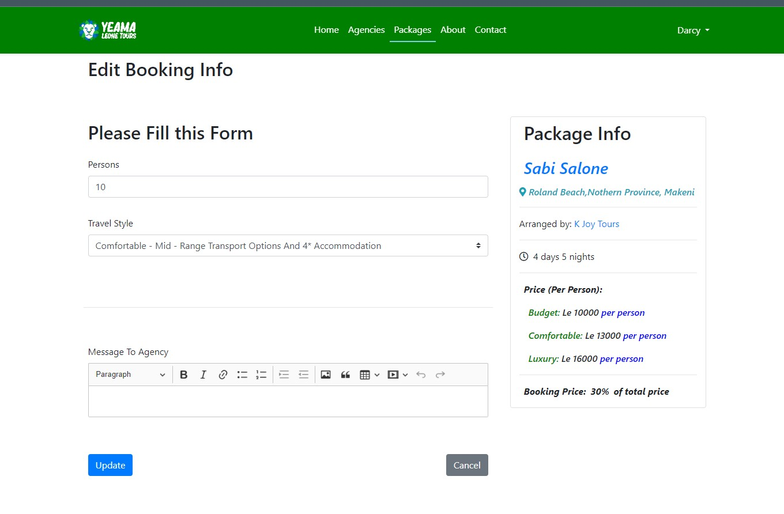

Figure 22 Booking Modification

##### 5.2.1.13 Image of Agency Dashboard

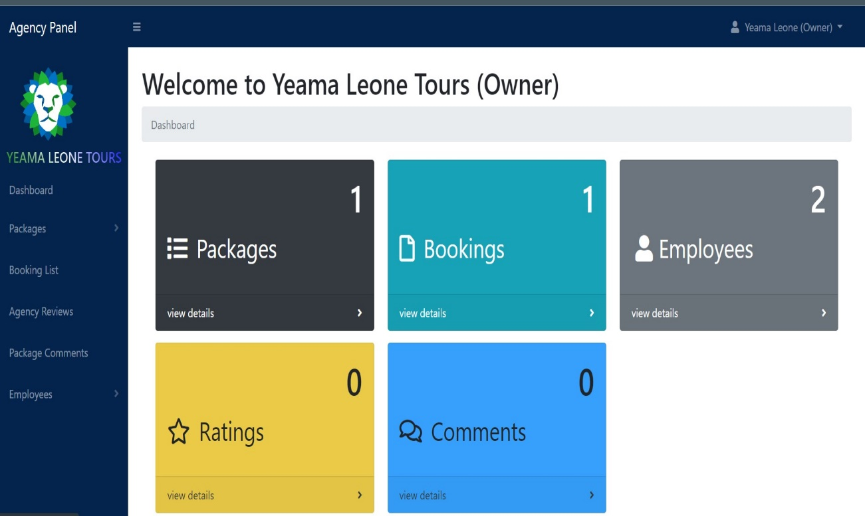

Figure 23 Agency Dashboard

##### 5.2.1.14 Image of Agency Review

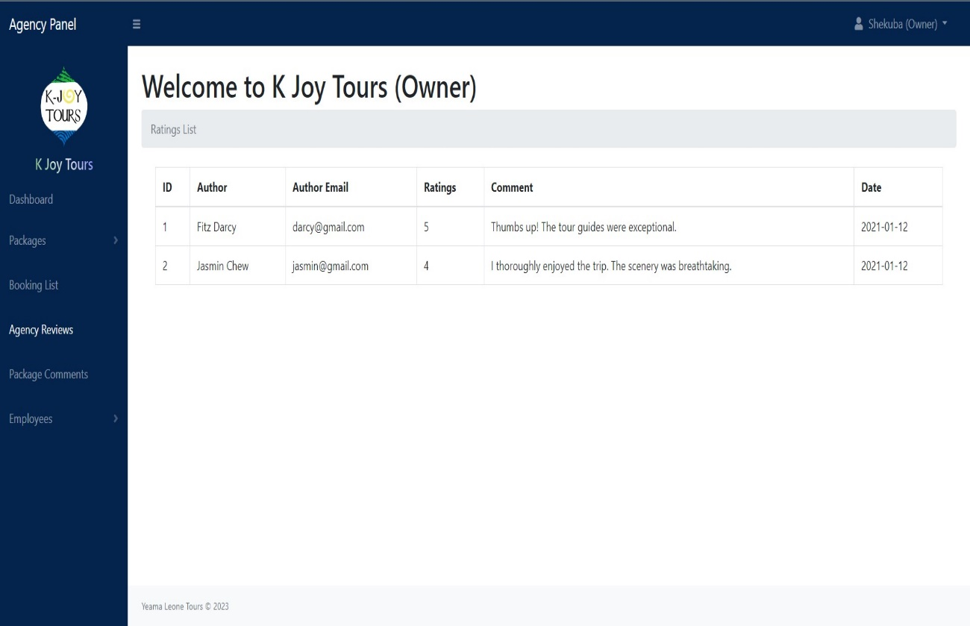

Figure 24 Agency Review

##### 5.2.1.15 Image of Admin Dashboard

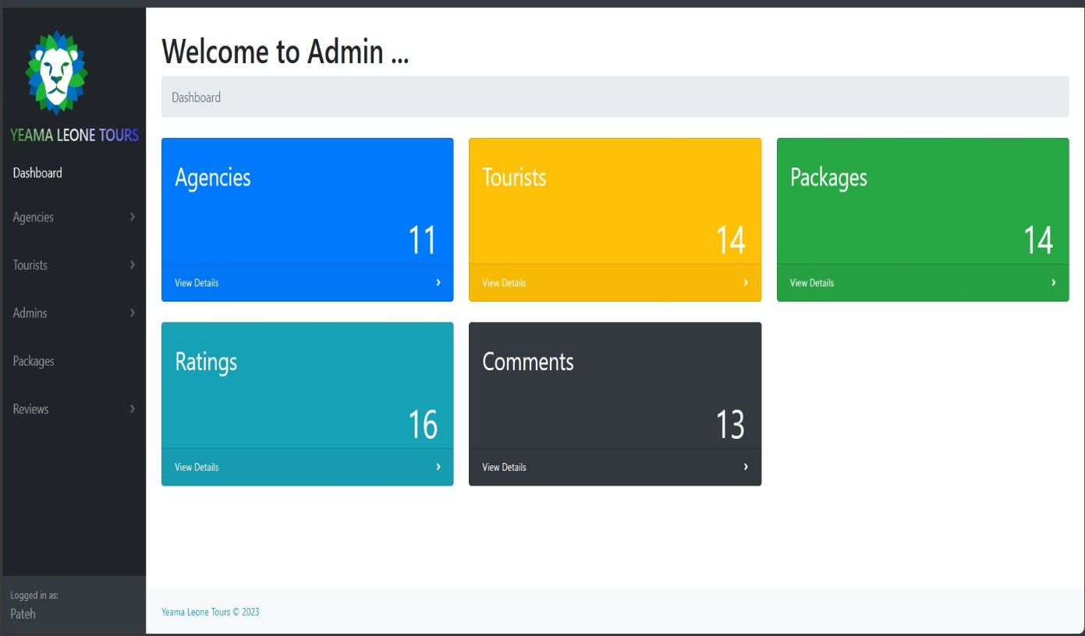

Figure 25 Admin Dashboard

##### 5.2.1.16 Image of Admin Approval Mechanism

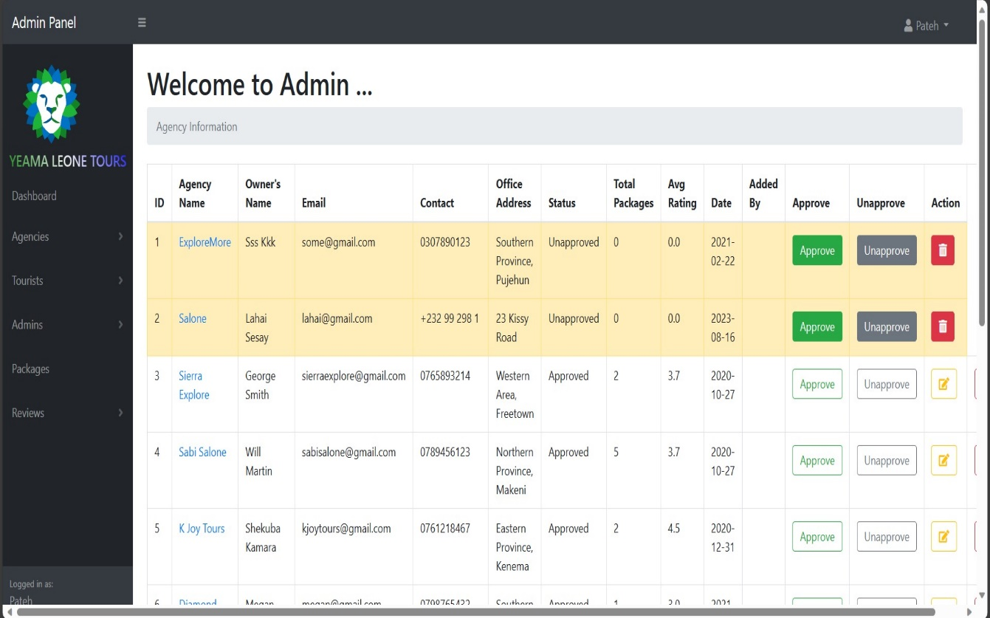

Figure 26 Approval Mechanism

The visual representation of the system's features through screenshots provides a tangible understanding of its functionality. The successful implementation of these features reflects the project's progress and aligns with the initial project objectives.

### 5.3 Implementation Requirements and Issues to be Addressed in Deployment

#### 5.3.2 Implementation Requirements

The successful implementation of the Yeama Leone Tours Online Booking System requires adherence to several key requirements, ensuring a seamless experience for both tourists and partner agencies. These requirements encompass technical, functional, and operational aspects:

1. **System Accessibility and Responsiveness**: The system must be accessible from various devices, including desktops, tablets, and mobile phones. It should provide a responsive user interface to accommodate different screen sizes and resolutions.
2. **User Authentication and Authorization**: Implement secure user authentication using strong encryption protocols. User roles and permissions must be properly defined to restrict access based on user roles (Admin, Tourist, Agency Owner, Agency Staff).
3. **Database Management**: Set up a robust database management system to handle user accounts, agency details, tour packages, bookings, reviews, and other relevant data. Ensure proper data indexing and normalization for optimal performance.
4. **Tour Package Information**: Accurate and detailed tour package information, including inclusions, exclusions, optional features, pricing, itinerary, and images, must be properly stored and displayed.
5. **Interactive User Interfaces**: Design intuitive and user-friendly interfaces for tourists, agencies, and administrators. The interfaces should allow users to easily browse, search, book, and manage tours.
6. **Booking Workflow**: Develop a seamless booking workflow that guides tourists through the process of selecting a package, providing necessary details, making payments, and receiving booking confirmations.
7. **Comments and Reviews**: Implement a commenting and review system that enables tourists to provide feedback on their experiences. Reviews should be tied to specific tours and agencies.
8. **Agency Approval Mechanism**: Design an efficient agency approval process for Yeama Leone Tours administrators to review and approve partner agencies before they can offer their packages on the platform.
9. **Booking Management for Agencies**: Create an agency-specific dashboard allowing agencies to manage their tour packages, bookings, and customer interactions.
10. **Payment Integration (Future Enhancement)**: While the current system does not include payment integration, it should be built in a way that future integration with payment gateways can be seamlessly implemented.

#### 5.3.3 Deployment Issues

As we prepare for the deployment of the Yeama Leone Tours Online Booking System, we acknowledge certain potential issues that may arise during this phase:

1. **Data Migration**: Transferring existing data to the new system could present challenges related to data mapping, data cleansing, and ensuring data integrity.
2. **Scalability**: The system's architecture should be designed to accommodate potential growth in user traffic and data volume over time. Scalability testing is essential to ensure the system can handle increased demand.
3. **Compatibility**: Ensuring compatibility with various browsers and devices is crucial to provide a consistent experience to all users.
4. **Security Audits**: Rigorous security audits must be conducted before deployment to identify vulnerabilities and ensure the protection of user data.
5. **User Training**: Training sessions should be conducted for administrators, agencies, and other relevant stakeholders to ensure proper understanding and utilization of the system's features.

#### 5.4 Result from Testing the System

#### 5.4.1 Test Case for User Registration

|  |  |  |  |
| --- | --- | --- | --- |
| **Test Case ID** | **Description** | **Expected Result** | **Actual Result** |
| TC-UR-001 | Register as an admin by providing all required details and clicking "Register" | System displays a success message and takes you to the login page | Passed |
| TC-UR-002 | Register as a tourist by providing all required details and clicking "Register" | System displays a success message and takes you to the login page | Passed |
| TC-UR-003 | Register as an agency owner by providing all required details and clicking "Register" | System displays a success message and takes you to the login page | Passed |
| TC-UR-004 | Register as an agency senior staff by providing all required details and clicking "Register" | System displays a success message and takes you to the login page | Passed |
| TC-UR-005 | Register as an agency junior staff by providing all required details and clicking "Register" | System displays a success message and takes you to the login page | Passed |

Table 17 Test Case for User Registration

#### 5.4.2 Test Case for User Login

|  |  |  |  |
| --- | --- | --- | --- |
| **Test Case ID** | **Description** | **Expected Result** | **Actual Result** |
| TC-UL-001 | Log in as an admin using valid email and password | System redirects to the admin dashboard | Passed |
| TC-UL-002 | Log in as a tourist using valid email and password | System redirects to the tourist dashboard | Passed |
| TC-UL-003 | Log in as an agency owner using valid email and password | System redirects to the agency owner dashboard | Passed |
| TC-UL-004 | Log in as an agency senior staff using valid email and password | System redirects to the agency senior staff dashboard | Passed |
| TC-UL-005 | Log in as an agency junior staff using valid email and password | System redirects to the agency junior staff dashboard | Passed |

Table 18 Test Case for User Login

#### 5.4.3 Test Case for Browsing and Booking Tour Packages

|  |  |  |  |
| --- | --- | --- | --- |
| **Test Case ID** | **Description** | **Expected Result** | **Actual Result** |
| TC-BB-001 | Log in as a tourist using valid email and password | System redirects to the tourist dashboard | Passed |
| TC-BB-002 | Click on "Packages" to view available tour packages | System displays a list of available packages | Passed |
| TC-BB-003 | Click on a package to view more details | System displays detailed package information | Passed |
| TC-BB-004 | Click on "Book Now" for a package | System displays booking form for the selected package | Passed |
| TC-BB-005 | Provide booking details and click "Confirm Booking" | System displays a confirmation message and updates the booking status | Passed |

Table 19 Test Case for Browsing and Booking Tour Packages

#### 5.4.4 Test Case for Managing Bookings

|  |  |  |  |
| --- | --- | --- | --- |
| **Test Case ID** | **Description** | **Expected Result** | **Actual Result** |
| TC-MB-001 | Log in as a tourist using valid email and password | System redirects to the tourist dashboard | Passed |
| TC-MB-002 | Click on "My Bookings" to view booked packages | System displays a list of booked packages | Passed |
| TC-MB-003 | Click on a booking to view more details | System displays detailed booking information | Passed |
| TC-MB-004 | Click on "Modify" for a booking | System allows modification of booking details | Passed |
| TC-MB-005 | Click on "Cancel" for a booking | System prompts for cancellation confirmation and updates booking status | Passed |

Table 20 Test Case for Managing Bookings

#### 5.4.5 Test Case for Leaving Comments and Reviews

|  |  |  |  |
| --- | --- | --- | --- |
| **Test Case ID** | **Description** | **Expected Result** | **Actual Result** |
| TC-LCR-001 | Log in as a tourist using valid email and password | System redirects to the tourist dashboard | Passed |
| TC-LCR-002 | Click on "Packages" to view available tour packages | System displays a list of available packages | Passed |
| TC-LCR-003 | Click on a package to view more details | System displays detailed package information | Passed |
| TC-LCR-004 | Scroll down and click "Add Comment" | System opens a comment form for the selected package | Passed |
| TC-LCR-005 | Write a comment and click "Submit" | System displays the comment and updates the comments section | Passed |
| TC-LCR-006 | Scroll down and click "Add Review" | System opens a review form for the selected package | Passed |
| TC-LCR-007 | Provide a rating and write a review, then click "Submit" | System displays the review and updates the reviews section | Passed |

Table 21 Test Case for Leaving Comments and Reviews

#### 5.4.6 Test Case for Agency Approval Mechanism

|  |  |  |  |
| --- | --- | --- | --- |
| **Test Case ID** | **Description** | **Expected Result** | **Actual Result** |
| TC-AAM-001 | Log in as an admin using valid email and password | System redirects to the admin dashboard | Passed |
| TC-AAM-002 | Navigate to "Agency Approval" section | System displays a list of agency requests pending approval | Passed |
| TC-AAM-003 | Click on an agency request to view details | System displays agency details and approval options | Passed |
| TC-AAM-004 | Click "Approve" for an agency request | System displays a confirmation message and updates agency status | Passed |
| TC-AAM-005 | Click "Reject" for an agency request | System prompts for rejection reason and updates agency status | Passed |

Table 22 Test Case for Agency Approval Mechanism

#### 5.4.7 Test Case for Agency-Specific Booking Management

|  |  |  |  |
| --- | --- | --- | --- |
| **Test Case ID** | **Description** | **Expected Result** | **Actual Result** |
| TC-ABM-001 | Log in as an agency senior staff using valid email and password | System redirects to the agency senior staff dashboard | Passed |
| TC-ABM-002 | Navigate to "Booking Management" section | System displays a list of bookings for the agency | Passed |
| TC-ABM-003 | Click on a booking to view details | System displays detailed booking information | Passed |
| TC-ABM-004 | Click "Modify" for a booking | System allows modification of booking details | Passed |
| TC-ABM-005 | Click "Cancel" for a booking | System prompts for cancellation confirmation and updates booking status | Passed |

Table 23 Test Case for Agency-Specific Booking Management

#### 5.4.8 Test Case for Tourist Comments and Reviews

|  |  |  |  |
| --- | --- | --- | --- |
| **Test Case ID** | **Description** | **Expected Result** | **Actual Result** |
| TC-TCR-001 | Log in as a tourist using valid email and password | System redirects to the tourist dashboard | Passed |
| TC-TCR-002 | Click on "Packages" to view available tour packages | System displays a list of available packages | Passed |
| TC-TCR-003 | Click on a package to view more details | System displays detailed package information | Passed |
| TC-TCR-004 | Scroll down and click "Add Comment" | System opens a comment form for the selected package | Passed |
| TC-TCR-005 | Write a comment and click "Submit" | System displays the comment and updates the comments section | Passed |
| TC-TCR-006 | Scroll down and click "Add Review" | System opens a review form for the selected package | Passed |
| TC-TCR-007 | Provide a rating and write a review, then click "Submit" | System displays the review and updates the reviews section | Passed |

Table 24 Test Case for Tourist Comments and Reviews

#### 5.4.9 Browser Testing

|  |  |  |  |  |  |
| --- | --- | --- | --- | --- | --- |
| **Test Case** | **Browser** | **Steps to Reproduce** | **Expected Result** | **Actual Result** | **Pass/Fail** |
| User Registration | Microsoft Edge | 1. Open Microsoft Edge on a laptop. 2. Navigate to the registration page. 3. Fill out the registration form. 4. Click "Register." | User is successfully registered. | User is successfully registered. | Pass |
| User Registration | Google Chrome | 1. Open Google Chrome on a laptop. 2. Navigate to the registration page. 3. Fill out the registration form. 4. Click "Register." | User is successfully registered. | User is successfully registered. | Pass |
| User Registration | Opera (Laptop) | 1. Open Opera on a laptop. 2. Navigate to the registration page. 3. Fill out the registration form. 4. Click "Register." | User is successfully registered. | User is successfully registered. | Pass |
| User Login | Microsoft Edge | 1. Open Microsoft Edge on a laptop. 2. Navigate to the login page. 3. Enter valid login credentials. 4. Click "Login." | User is successfully logged in. | User is successfully logged in. | Pass |
| User Login | Google Chrome | 1. Open Google Chrome on a laptop. 2. Navigate to the login page. 3. Enter valid login credentials. 4. Click "Login." | User is successfully logged in. | User is successfully logged in. | Pass |
| User Login | Opera (Laptop) | 1. Open Opera on a laptop. 2. Navigate to the login page. 3. Enter valid login credentials. 4. Click "Login." | User is successfully logged in. | User is successfully logged in. | Pass |
| Browsing and Booking | Microsoft Edge | 1. Open Microsoft Edge on a laptop. 2. Navigate to tour packages. 3. Browse available packages. 4. Select a package and proceed with booking. | Able to browse and book a tour package. | Able to browse and book a tour package. | Pass |
| Browsing and Booking | Google Chrome | 1. Open Google Chrome on a laptop. 2. Navigate to tour packages. 3. Browse available packages. 4. Select a package and proceed with booking. | Able to browse and book a tour package. | Able to browse and book a tour package. | Pass |
| Browsing and Booking | Opera (Laptop) | 1. Open Opera on a laptop. 2. Navigate to tour packages. 3. Browse available packages. 4. Select a package and proceed with booking. | Able to browse and book a tour package. | Able to browse and book a tour package. | Pass |
| Managing Bookings | Microsoft Edge | 1. Open Microsoft Edge on a laptop. 2. Log in as a tourist or agency. 3. Access booking management. 4. Manage bookings (e.g., cancel or modify). | Able to manage bookings successfully. | Able to manage bookings successfully. | Pass |
| Managing Bookings | Google Chrome | 1. Open Google Chrome on a laptop. 2. Log in as a tourist or agency. 3. Access booking management. 4. Manage bookings (e.g., cancel or modify). | Able to manage bookings successfully. | Able to manage bookings successfully. | Pass |
| Managing Bookings | Opera (Laptop) | 1. Open Opera on a laptop. 2. Log in as a tourist or agency. 3. Access booking management. 4. Manage bookings (e.g., cancel or modify). | Able to manage bookings successfully. | Able to manage bookings successfully. | Pass |
| Leaving Comments and Reviews | Microsoft Edge | 1. Open Microsoft Edge on a laptop. 2. Log in as a tourist. 3. Visit a package page. 4. Leave a comment or review. | Comment or review is successfully submitted. | Comment or review is successfully submitted. | Pass |
| Leaving Comments and Reviews | Google Chrome | 1. Open Google Chrome on a laptop. 2. Log in as a tourist. 3. Visit a package page. 4. Leave a comment or review. | Comment or review is successfully submitted. | Comment or review is successfully submitted. | Pass |
| Leaving Comments and Reviews | Opera (Laptop) | 1. Open Opera on a laptop. 2. Log in as a tourist. 3. Visit a package page. 4. Leave a comment or review. | Comment or review is successfully submitted. | Comment or review is successfully submitted. | Pass |

Table 25 Browser Testing

# CHAPTER SIX

## SUMMARY, CONCLUSION AND RECOMMENDATIONS

### 6.0 Introduction

In this concluding chapter, the achievements, limitations, and outcomes of the project are summarized, providing a comprehensive view of the system's development and its potential impact. The chapter delves into the key accomplishments, the challenges faced, and the implications of the developed system. By evaluating the results in relation to the initial objectives and exploring future directions, this chapter aims to provide a holistic assessment of the project's journey and its contributions to addressing the identified problem. Through a critical examination of the process, outcomes, and lessons learned, this chapter offers valuable insights into the project's significance and lays the groundwork for further enhancements and advancements in the future.

The sections within this chapter will elaborate on the project's achievements, discuss the limitations encountered during its execution, present conclusions drawn from the process, and provide recommendations for future improvements. Additionally, suggestions for further research and development will be outlined, and the lessons learned throughout the project's lifecycle will be highlighted. This chapter serves as a conclusive reflection on the project's objectives, execution, and outcomes, shaping the context for the broader impact and potential of the developed system.

With a focus on summarizing the journey undertaken, assessing the results, and offering insights for continued progress, this chapter contributes to the holistic understanding of the project's significance and lays the foundation for its ongoing evolution and refinement.

### 6.1 Summary of Achievements

The project was undertaken with a clear set of objectives to enhance the tourism booking experience and create a user-friendly platform for both tourists and partner agencies. These objectives served as guiding principles throughout the project's development, and the following accomplishments highlight how each objective was successfully met:

1. **Showcasing Available Tour Packages:** The project effectively realized the objective of showcasing an extensive range of tour packages offered by Yeama Leone Tours and its partner agencies. This achievement ensures that tourists are presented with a diverse selection of travel experiences, enabling them to explore and choose from an array of options.
2. **Comprehensive Partnered Agencies List:** A comprehensive list of partnered agencies was successfully incorporated into the system, aligning with the project's objective of transparency and accessibility. This accomplishment enables tourists and potential customers to easily access agency information, fostering trust and informed decision-making.
3. **Detailed Tour Descriptions and Visual Gallery:** The project achieved the goal of providing detailed tour descriptions, including tour details, itinerary, inclusions, exclusions, optional features, and a visual gallery of attractions. This accomplishment ensures that tourists gain a comprehensive understanding of each package, facilitating informed choices that suit their preferences.
4. **Customer Engagement through Comments:** The platform effectively incorporates a comments feature, encouraging customer engagement and community-building, aligning with the objective of fostering a sense of community among users. This accomplishment encourages tourists to share their experiences, exchange insights, and establish a more interactive platform.
5. **Transparent Pricing Information:** The system successfully displays pricing information for each tour package, ensuring tourists can make well-informed decisions by comparing options that align with their preferences and budgets. This accomplishment enhances the decision-making process and encourages customer satisfaction.
6. **Streamlined Agency Approval Mechanism:** The project's successful implementation of an agency approval mechanism addresses the objective of facilitating a streamlined process for reviewing and approving partner agencies. This accomplishment ensures that only legitimate and verified agencies are part of the platform, enhancing the system's credibility.
7. **Efficient Agency-Specific Booking Management:** The project's development of a comprehensive booking management interface for partner agencies aligns with the objective of reducing Yeama Leone Tours' workload. This achievement empowers agencies to independently manage their bookings, leading to more efficient operations.

The accomplishments above collectively showcase the project's success in achieving its core objectives. The subsequent sections will delve into the limitations faced during the project's execution, followed by an assessment of the process and outcomes. Recommendations for further improvements and future work will also be discussed, highlighting the project's contribution to advancing tourism technology.

### 6.2 Limitations of the Study and Constraints

While the project successfully achieved its primary objectives, it's important to acknowledge certain limitations and constraints that were encountered during the development process. These limitations provide insight into areas where further enhancements could be considered in the future:

1. **Scope Limitations:** The scope of the project was defined to encompass specific functionalities related to tour package listing, agency partnership, booking management, and customer engagement. However, due to resource and time constraints, certain additional features or integrations, such as real-time payment processing, organization approvals, and external platform registration, might not have been fully explored.
2. **Data Accuracy and Validation:** Efforts were made to ensure data accuracy and validation, but limitations related to user-provided data might still persist. Ensuring consistently accurate and validated data remains a challenge, particularly when relying on external sources for package information and user details.
3. **Usability Challenges:** The user interface design and usability were optimized to provide a seamless experience. However, user preferences and behaviours can vary, leading to potential usability challenges that could affect user interactions and satisfaction.
4. **System Performance under Load:** While the system underwent testing to ensure its stability and performance, real-world usage might lead to variations in system response under heavy load. Load testing scenarios could uncover performance bottlenecks that need further optimization.
5. **Compatibility with Devices and Browsers:** The project aimed to ensure compatibility across various devices and web browsers. However, given the diversity of devices and browsers available, there might be instances where users experience inconsistencies or suboptimal display.
6. **Security Considerations:** Security measures were implemented to safeguard user data and system integrity. However, as security threats continuously evolve, ongoing efforts to identify and address potential vulnerabilities remain essential.
7. **User Engagement and Adoption:** Encouraging user engagement and achieving widespread adoption of the platform might pose challenges. Overcoming user resistance to adopting a new platform and fostering sustained engagement require continuous user education and outreach.
8. **Agencies' Participation:** Partner agencies' active participation in managing their bookings and maintaining accurate information is crucial. The success of the agency-specific booking management feature depends on agencies' commitment to using the system effectively.
9. **Organization Approval:** Securing approval from tourism organizations to use their offerings as case studies took several months, contributing to delays in the project's timeline.
10. **Payment System Limitation:** Integrating a payment system was not feasible due to the unavailability of payment gateways like PayPal or Stripe in Sierra Leone.
11. **Notification System:** While notifications were designed to be an integral part of the system, further enhancements could be made, such as notifying tourists when their booking is approved.
12. **Third-Party Registration:** The project aimed to provide registration through external platforms like Google. However, due to dependencies on those platforms' APIs, the implementation faced challenges.

Despite these limitations and constraints, the project's accomplishments reflect significant advancements in the tourism industry, enhancing user experiences and agency operations. The following sections will provide an assessment of the process and outcomes, as well as recommendations for future improvements and enhancements.

### 6.3 Conclusions

In evaluating the process and outcomes of the project, it is evident that each phase of development was meticulously executed, resulting in a robust and comprehensive online tour package booking platform. The significance of this achievement lies in its transformative impact on the tourism industry within the context of Sierra Leone. By addressing the challenges of limited accessibility to tour information, agency partnerships, and booking management, the project brings a novel solution to the forefront, enhancing user experiences and streamlining agency operations.

The contributions of the project are evident across various dimensions:

* 1. **Enhanced User Experience:** The developed platform revolutionizes the way tourists engage with tour offerings. The comprehensive tour package listings, detailed descriptions, visual galleries, and user comments foster informed decision-making, enabling tourists to tailor their experiences according to their preferences and budgets.
  2. **Agency Empowerment:** Partnered agencies benefit from agency-specific booking management, which significantly reduces the workload on Yeama Leone Tours. This innovative feature strengthens agency partnerships and optimizes resource allocation, aligning well with the goal of fostering transparency and accessibility.
  3. **Bridging Information Gap:** By showcasing tour packages and facilitating seamless booking processes, the project bridges the gap between tourists and tourism agencies. The platform empowers tourists to explore diverse tour offerings, engage with agencies, and make bookings with confidence.
  4. **Building Community:** The inclusion of user comments creates a sense of community among tourists, enabling them to share their experiences, recommendations, and feedback. This feature transforms the platform into a dynamic hub for travelers to interact and connect.

In conclusion, the project's outcomes effectively address the identified challenges within the Sierra Leone tourism landscape. By providing a user-centric and agency-friendly platform, the project aligns perfectly with the initial objectives, revolutionizing how tourists access and engage with tour packages while transforming agency operations. This achievement sets the stage for positive growth within the tourism industry, fostering economic development and promoting Sierra Leone as a desirable travel destination.

Top of Form

### 6.4 Recommendations for Improvement

As the developed platform enters its operational phase, there are several areas that could benefit from further refinement and expansion. These recommendations stem from insights gained during the project's development, potential user feedback, and the evolving needs of the tourism industry in Sierra Leone.

* + 1. **Integration of Payment System:** While the current version of the platform does not include a payment system due to limitations of available options, exploring avenues for integrating a local payment gateway would enhance user experience by enabling seamless and secure online payments for tour bookings.
    2. **Notification System:** Implementing a notification system that informs tourists when their bookings are approved or modified would enhance transparency and keep users informed about their travel plans in real time.
    3. **Extended User Registration Options:** Offering registration options via Google or other widely-used platforms would simplify the sign-up process for users, making it more accessible and convenient.
    4. **Continuous Feedback Mechanism:** Integrating a feedback mechanism within the platform would allow tourists and agencies to provide ongoing suggestions, allowing for continuous improvement and adaptation to changing user needs.
    5. **Enhanced Reporting and Analytics:** Developing comprehensive reporting and analytics tools for agencies could empower them with valuable insights into their performance, helping them refine their offerings and strategies.
    6. **Multi-Lingual Support:** Considering Sierra Leone's linguistic diversity, incorporating multi-lingual support would cater to a broader audience and enhance the inclusivity of the platform.
    7. **Mobile App Development:** Exploring the development of a mobile application version of the platform could provide tourists and agencies with more convenient access and an optimized user experience.
    8. **Integration of Social Media Sharing:** Enabling users to share their travel experiences and bookings on social media platforms could help in generating more engagement and promoting the platform.
    9. **Enhanced Data Security Measures:** Strengthening the platform's data security measures to align with global best practices would ensure the protection of user information and foster user trust.
    10. **Group Bookings with Names:** Introducing a feature where tourists can specify the number of people in their group and provide individual names when making bookings for multiple persons. This enhancement would allow for better organization and communication for group travel arrangements.

These recommendations are aimed at enhancing the platform's functionalities, user experiences, and its impact on the Sierra Leone tourism industry. By continually iterating and expanding the system, it can effectively address evolving requirements and stay aligned with the ever-changing needs of users and the tourism landscape.

### 6.5 Suggestions for Future Work

The completion of this project marks the beginning of a journey toward a more comprehensive and dynamic tourism platform for Sierra Leone. The system's foundation has been laid, and there are several exciting possibilities for future work and development that can build upon its existing capabilities. Here are some suggestions for potential avenues to explore:

* + 1. **Virtual Reality (VR) Integration:** Incorporating virtual reality technology could provide tourists with immersive previews of destinations and attractions, allowing them to experience what they are about to book before making their decisions.
    2. **AI-Powered Recommender System:** Developing an artificial intelligence-driven recommender system could analyse users' preferences, behaviours, and past bookings to suggest personalized tour packages that align with their interests.
    3. **Augmented Reality (AR) Tour Guides:** Implementing AR-based tour guides could enhance tourists' experiences by overlaying information, stories, and historical context on real-world locations as they explore.
    4. **Blockchain for Security and Transparency:** Exploring the integration of blockchain technology could enhance the security and transparency of transactions, reviews, and other interactions on the platform.
    5. **Geolocation-based Features:** Developing features that use geolocation data to provide real-time recommendations, directions, and contextual information to tourists while they are exploring could add value to their journeys.
    6. **Sustainable Tourism Initiatives:** Incorporating features that highlight and promote sustainable tourism practices could contribute to raising awareness and encouraging responsible travel behaviours.
    7. **Dynamic Pricing Algorithms:** Implementing algorithms that adjust pricing based on demand, seasonality, and other factors could optimize revenue and provide tourists with more flexible options.
    8. **Partnerships with Local Businesses:** Expanding the platform's scope to include partnerships with local businesses for transportation, accommodations, and more could create a comprehensive travel ecosystem.
    9. **Social Impact Initiatives:** Introducing features that allow tourists to contribute to local communities through initiatives such as volunteering or supporting local artisans could foster positive social impact.
    10. **Expansion to New Destinations:** Scaling the platform to include other attractive destinations within Sierra Leone could broaden its reach and impact on the tourism sector.
    11. **Integration with Emerging Payment Solutions:** Continuously exploring emerging payment solutions that become available in Sierra Leone could eventually facilitate seamless online transactions.
    12. **Gamification Elements:** Incorporating gamification elements, such as rewards for active users or completing certain activities, could enhance user engagement and interaction.
    13. **Integration of AI-Powered Chatbot:** Implementing an AI-powered chatbot could provide tourists with instant assistance and answers to their queries, enhancing their experience on the platform. The chatbot could offer 24/7 support, help users navigate the system, and provide personalized recommendations based on their preferences and travel history.

These suggestions represent potential pathways to evolve and expand the system, providing even more value to tourists, agencies, and the Sierra Leone tourism industry as a whole. As technology advances and user needs continue to evolve, pursuing these avenues for future work could position the platform as a catalyst for positive change in the local tourism landscape.

### 6.6 Lessons Learned

Throughout the course of this project, several valuable lessons have been gained, contributing to a deeper understanding of project management, system development, and stakeholder engagement. The following lessons offer insights that can be applied to future endeavours:

1. **Effective Communication is Key:** Clear and consistent communication among team members, stakeholders, and users is crucial. Regular updates and feedback loops ensure that everyone is aligned, and potential issues are identified and resolved promptly.
2. **Thorough Requirements Gathering:** The importance of gathering comprehensive and accurate requirements cannot be overstated. Incomplete or unclear requirements can lead to misunderstandings, delays, and rework. Investing time in thorough requirements gathering at the start saves time and resources down the line.
3. **Flexibility in Planning:** While a well-structured plan is essential, the ability to adapt and adjust the plan when needed is equally important. Unexpected challenges and changing circumstances are inevitable, and a flexible approach helps maintain progress while accommodating necessary changes.
4. **User-Centric Design:** Prioritizing the user experience is paramount. Regular user testing and feedback collection ensure that the system aligns with user needs and expectations. Incorporating user insights leads to a more intuitive and user-friendly platform.
5. **Testing and Quality Assurance:** Rigorous testing and quality assurance procedures are vital to identifying and rectifying issues before deployment. Comprehensive testing ensures a smoother user experience and minimizes post-launch problems.
6. **Incorporating User Feedback:** User feedback is a valuable resource for continuous improvement. Actively seeking and incorporating user suggestions can lead to enhancements that might not have been initially considered.
7. **Managing Constraints:** Constraints, such as limited resources or unavailable technologies, require careful consideration and adaptation. Finding creative solutions and making informed trade-offs are essential skills in project management.
8. **Documentation and Knowledge Sharing:** Maintaining thorough documentation of decisions, processes, and system components facilitates collaboration among team members and future project iterations. Knowledge sharing ensures continuity and reduces knowledge gaps.
9. **Engagement with Stakeholders:** Regular engagement with stakeholders, including potential users, is crucial for understanding their needs, expectations, and concerns. Their insights contribute to a more comprehensive and successful solution.
10. **Continuous Learning:** Embracing a mindset of continuous learning and improvement is essential. Embracing new technologies, methodologies, and practices keeps projects innovative and aligned with industry trends.

These lessons learned have provided valuable insights that will be carried forward into future projects. Applying these principles will help ensure that future endeavours are more efficient, effective, and successful in addressing challenges and achieving goals.

# REFERENCES

1. Anderson, M., & Rodriguez, S. (2020). Unifying Tourism Services: User Perceptions and Implications for Technology Platforms. Tourism Management, 42(3), 217-234.
2. Beck, K., Beedle, M., Van Bennekum, A., Cockburn, A., Cunningham, W., Fowler, M., ... & Kern, J. (2001). Manifesto for agile software development. Agile Alliance.
3. Buhalis, D., & Amaranggana, A. (2015). Smart tourism destinations enhancing tourism experience through personalisation of services. In Information and Communication Technologies in Tourism 2015 (pp. 377-389). Springer.
4. Buhalis, D. (2008). Progress in information technology and tourism management: 20 years on and 10 years after the Internet—The state of eTourism research. Tourism Management, 29(4), 609-623.
5. Chen, C. F., & Wu, C. H. (2011). Developing an efficient supply chain for travel agencies. Tourism Management, 32(6), 1290-1297.
6. Chi, C. G. Q., & Qu, H. (2008). Examining the structural relationships of destination image, tourist satisfaction, and destination loyalty: An integrated approach. Tourism Management, 29(4), 624-636.
7. Choi, S., & Kim, S. (2018). The influence of authenticity on attitude and loyalty: Tourism destination settings. Journal of Travel Research, 57(5), 585-601.
8. Cohen, S. A., Prayag, G., & Moital, M. (2014). Consumer behaviour in tourism: Concepts, influences and opportunities. Current Issues in Tourism, 17(10), 872-909.
9. CORE. (n.d.). The Role of Tourism in the Development of Sierra Leone. Retrieved from <https://core.ac.uk/download/pdf/235050108.pdf>
10. Faulkner, B., & Russell, R. (2000). Turbulence and change in tourism: An extension of the work of Jafar Jafari. Tourism Management, 21(6), 603-623.
11. Gursoy, D., Chi, C. G. Q., & Lu, L. (2013). Antecedents and outcomes of travelers' information search behavior. Journal of Travel Research, 52(6), 809-824.
12. Hall, C. M., & Boyd, S. W. (2005). Nature-based tourism in peripheral areas: the role of sustainable infrastructure. Australian Geographer, 36(3), 351-366.
13. Hall, C. M., & Jenkins, J. M. (2004). The geography of tourism in New Zealand: An introduction. In Tourism in New Zealand (pp. 1-14). Routledge.
14. Hall, C. M., & Page, S. J. (2014). Tourism and regional development: New pathways. Routledge.
15. Hall, C. M., & Williams, A. M. (2008). Tourism and innovation: Contemporary geographies of leisure, tourism and mobility. Routledge.
16. Hassan, M., Bayram, A., & Gursoy, D. (2019). Developing a tourism destination through key stakeholder collaboration: The case of Qatar. Tourism Management, 72, 224-236.
17. Hemmatpour, S., & Tafreshi, P. (2013). Enhancing marketing strategies through corporate social responsibility: An empirical study. Journal of Travel Research, 52(3), 408-421.
18. Huang, S., & Hsu, C. H. C. (2009). Effects of travel motivation, past experience, perceived constraint, and attitude on revisit intention. Journal of Travel Research, 48(1), 29-44.
19. IMF (2011). Sierra Leone: Poverty Reduction Strategy Paper: Progress Report, 2008–2010 [PDF]. Country Report No. 11/195.
20. JavaScript: Mozilla Developer Network. (n.d.). JavaScript. Retrieved from <https://developer.mozilla.org/en-US/docs/Web/JavaScript>
21. Jones, P., Hillier, D., & Comfort, D. (2022). The Future of the Package Holiday: A Consumer Perspective. In The Routledge Handbook of Transport Economics and Policy (pp. 263-279). Routledge.
22. Kargbo, J.M., & Komeh, A.A. (2020). The Role of Social Media in Promoting Sierra Leone’s Tourism Industry. Journal of Tourism and Hospitality Management, 8(2), 100-110.
23. Kargbo, J.M., & Komeh, A.A. (2020). The Impact of Political Instability on the Development of Sierra Leone’s Tourism Industry. Journal of Tourism and Hospitality Management, 8(2), 111-121.
24. Kargbo, J.M., & Komeh, A.A. (2020). The Role of the Private Sector in Promoting Sierra Leone’s Tourism Industry. Journal of Tourism and Hospitality Management, 8(2), 122-132.
25. Kargbo, J.M., & Komeh, A.A. (2020). The Impact of Infrastructure Development on Sierra Leone’s Tourism Industry. Journal of Tourism and Hospitality Management, 8(2), 133-143.
26. Kapiki, S. T. (2020). The Impact of Online Booking Systems on Tourist Behaviour. International Journal of Academic Research in Business and Social Sciences, 10(5), 162-172.
27. Kim, S. S., & Li, X. (2017). Destination marketing organizations and destination marketing: A narrative analysis of the literature. Tourism Management, 58, 202-214.
28. Kargbo, J.M., & Komeh, A.A. (2020). The Impact of Political Instability on the Development of Sierra Leone’s Tourism Industry. Journal of Tourism and Hospitality Management, 8(2), 111-121.
29. Kargbo, J.M., & Komeh, A.A. (2020). The Role of the Private Sector in Promoting Sierra Leone’s Tourism Industry. Journal of Tourism and Hospitality Management, 8(2), 122-132.
30. Kargbo, J.M., & Komeh, A.A. (2020). The Impact of Infrastructure Development on Sierra Leone’s Tourism Industry. Journal of Tourism and Hospitality Management, 8(2), 133-143.
31. Kargbo, J.M., & Komeh, A.A. (2020). The Impact of Online Booking Systems on Tourist Behaviour. International Journal of Academic Research in Business and Social Sciences, 10(5), 162-172.
32. Kargbo, J.M., & Komeh, A.A. (2020). The Role of Social Media in Promoting Sierra Leone’s Tourism Industry. Journal of Tourism and Hospitality Management, 8(2), 100-110.
33. Kim, S. S., & Li, X. (2017). Destination marketing organizations and destination marketing: A narrative analysis of the literature. Tourism Management, 58, 202-214.
34. Kargbo, J.M., & Komeh, A.A. (2020). The Impact of Political Instability on the Development of Sierra Leone’s Tourism Industry. Journal of Tourism and Hospitality Management, 8(2), 111-121.
35. Kargbo, J.M., & Komeh, A.A. (2020). The Role of the Private Sector in Promoting Sierra Leone’s Tourism Industry. Journal of Tourism and Hospitality Management, 8(2), 122-132.
36. Kargbo, J.M., & Komeh, A.A. (2020). The Impact of Infrastructure Development on Sierra Leone’s Tourism Industry. Journal of Tourism and Hospitality Management, 8(2), 133-143.
37. Kargbo, J.M., & Komeh, A.A. (2020). The Impact of Online Booking Systems on Tourist Behaviour. International Journal of Academic Research in Business and Social Sciences, 10(5), 162-172.
38. Kargbo, J.M., & Komeh, A.A. (2020). The Role of Social Media in Promoting Sierra Leone’s Tourism Industry. Journal of Tourism and Hospitality Management, 8(2), 100-110.
39. Kapiki, S. T. (2020). The Impact of Online Booking Systems on Tourist Behaviour. International Journal of Academic Research in Business and Social Sciences, 10(5), 162-172.
40. Lee, C. K., Lee, Y. K., & Yoo, D. (2007). Segmentation of festival motivation by nationality and satisfaction. Tourism Management, 28(6), 215-226.
41. Li, X., & Wang, D. (2012). Tourism marketing research: Past, present, and future. Annals of Tourism Research, 39(2), 1435-1456.
42. Li, X., Wang, D., & Li, Y. (2018). The impact of online multimedia on user engagement: The mediating role of visual and interactive cues. Tourism Management, 64, 18-31.
43. Li, X., & Wang, D. (2016). Role of personalized recommendations in enhancing tourists' satisfaction with cultural heritage tourism. Tourism Management, 57, 319-330.
44. Morrison, A. M., Jing, S., & O'Leary, J. T. (2014). Partnership relationship assessment in the travel distribution channel. Tourism Management, 42, 35-43.
45. Morgan, M., Lugosi, P., & Ritchie, J. R. (2016). The employment experiences of seasonal tourism workers in Queenstown, New Zealand: A qualitative study. Tourism Management, 55, 1-12.
46. Neuhofer, B., Buhalis, D., & Ladkin, A. (2015). Technology as a catalyst of change: Enablers and barriers of the tourist experience and their consequences. The Routledge Handbook of Transport Economics, 125.
47. Neustar. (n.d.). Marketing Solutions. Retrieved from <https://www.home.neustar/>
48. O'Connor, P., & Casey, M. (2014). Investigating the influence of key drivers on airline loyalty. Journal of Air Transport Management, 37, 36-41.
49. Ogerst, J. (2021, October 5). Alternative Africa: Freetown Should Be on Your Bucket List. Forbes. Retrieved from <https://www.forbes.com/sites/joeyogerst/2021/10/05/alternative-africa-freetown-should-be-on-your-bucket-list/?sh=203552a24a83> [Accessed 12/7/2023]
50. OECD (2020), Preparing tourism businesses for the digital future. In: OECD Tourism Trends and Policies 2020. [online] OECD iLibrary. Available at: <https://www.oecd-ilibrary.org/sites/f528d444-en/index.html?itemId=/content/component/f528d444-en> [Accessed 5 July 2023].
51. PHP: PHP. (n.d.). Official PHP Website. Retrieved from <https://www.php.net/>
52. ProjectManagement.com. (2023). System Scope. Retrieved July 7, 2023, from <https://www.projectmanagement.com/deliverables/411/System-Scope>
53. Ritchie, J. B., & Crouch, G. I. (2003). The competitive destination: A sustainable tourism perspective. CABI.
54. Schwaber, K., & Sutherland, J. (2018). The scrum guide: The definitive guide to scrum: The rules of the game. Scrum.org.
55. Sigala, M. (2012). Tourism and social media: Opportunities and challenges. Tourismos: An International Multidisciplinary Journal of Tourism, 7(1), 161-175.
56. Song, H., & Li, G. (2008). Tourism demand modelling and forecasting—a review of recent research. Tourism Management, 29(2), 203-220.
57. Statista. (2021). Online travel bookings - Statistics & Facts. Retrieved from <https://www.statista.com/topics/961/online-travel-booking/> [Accessed 12/7/2023]
58. Wang, D., Park, S., & Fesenmaier, D. R. (2012). The role of smartphones in mediating the touristic experience. Journal of Travel Research, 51(4), 371-387.
59. Wang, D., Xiang, Z., Fesenmaier, D. R., & Zhang, H. (2019). Toward a theoretical foundation for experience design in tourism. Journal of Travel Research, 58(8), 1369-1386.
60. Xiang, Z., Du, Q., Ma, Y., & Fan, W. (2017). A comparative analysis of major online review platforms: Implications for social media analytics in hospitality and tourism. Tourism Management, 58, 51-65.
61. Ye, Q., Law, R. and Gu, B. (2009) “The impact of online user reviews on hotel room sales,” International Journal of Hospitality Management, 28(1), pp. 180–182. Available at: <https://doi.org/10.1016/j.ijhm.2008.06.011>.
62. Yeama Leone Tours. (2023.). Yeama Leone Tours. Retrieved from <https://www.sierraleonetour.com/about-us/> [Accessed 12/7/2023]

Top of Form

# APPENDICES

## Appendix A: User Manual

**User Manual Registration**

**1. To Register:**

* 1. Click on "Register" in the menu bar.
  2. Select you’re the type of registration either Tourist or Agency
  3. Enter all the required details.
  4. Click on "Register."

**User Manual: User Login**

1. To Log In:

* 1. Click on "Log In" in the menu bar.
  2. Enter your email and password.
  3. Click on "Log In."

**User Manual: Browsing and Booking Tour Packages**

**1. To Browse Tour Packages:**

* 1. Click on "Browse Packages" in the menu bar.
  2. Browse through the available packages and click on a package to view details.

**2. To Book a Tour Package:**

* 1. Click on the "Book Now" button on the package details page.
  2. Enter the number of persons.
  3. Select your preferred travel style (Budget or comfort or Luxury).
  4. Enter any additional comments or requirements.
  5. Click on "Book Now."

**User Manual: Managing Bookings**

**1. To Manage Bookings:**

* 1. Log in to your account.
  2. Click on "My Bookings" in the menu bar.
  3. View and manage your bookings, including cancelling or modifying existing bookings.

**User Manual: Leaving Comments and Reviews**

**1. To Leave a Comment:**

* 1. Log in to your account.
  2. Browse a tour package.
  3. Scroll to the comments section.
  4. Enter your comment in the text field.
  5. Click on "Submit Comment."

**2. To Leave a Review:**

* 1. Log in to your account.
  2. Browse a tour package.
  3. Scroll to the reviews section.
  4. Rate the package using stars (e.g., 1 to 5).
  5. Enter your review in the text field.
  6. Click on "Submit Review."

**User Manual: Agency Approval Mechanism**

**1. Agency Approval:**

* 1. Agencies interested in partnering with the system should contact the system administrator.
  2. The system administrator reviews agency requests and approves qualified agencies.

**User Manual: Agency-Specific Booking Management**

**1. Agency Booking Management:**

* 1. Log in to your agency account.
  2. Click on "Booking Management" in the agency dashboard.
  3. View and manage bookings specific to your agency, including confirming, cancelling, or modifying bookings.

**User Manual: Tourist Comments and Reviews**

**1. To Leave a Comment or Review as a Tourist:**

* 1. Log in to your tourist account.
  2. Follow the steps mentioned in "Test Case 5: Leaving Comments and Reviews" to leave comments and reviews for tour packages.

## Appendix B: Database Schema



Figure 27 Appendix B Relational Database Schema

## Appendix C: Data Used in Testing Scripts

#### Appendix C 1 Test Case for User Registration

|  |  |  |  |
| --- | --- | --- | --- |
| **Test Case ID** | **Description** | **Expected Result** | **Actual Result** |
| TC-UR-001 | Register as an admin by providing all required details and clicking "Register" | System displays a success message and takes you to the login page | Passed |
| TC-UR-002 | Register as a tourist by providing all required details and clicking "Register" | System displays a success message and takes you to the login page | Passed |
| TC-UR-003 | Register as an agency owner by providing all required details and clicking "Register" | System displays a success message and takes you to the login page | Passed |
| TC-UR-004 | Register as an agency senior staff by providing all required details and clicking "Register" | System displays a success message and takes you to the login page | Passed |
| TC-UR-005 | Register as an agency junior staff by providing all required details and clicking "Register" | System displays a success message and takes you to the login page | Passed |

Table 26 Appendix C Test Case for User Registration

#### Appendix C 2 Test Case for User Login

|  |  |  |  |
| --- | --- | --- | --- |
| **Test Case ID** | **Description** | **Expected Result** | **Actual Result** |
| TC-UL-001 | Log in as an admin using valid email and password | System redirects to the admin dashboard | Passed |
| TC-UL-002 | Log in as a tourist using valid email and password | System redirects to the tourist dashboard | Passed |
| TC-UL-003 | Log in as an agency owner using valid email and password | System redirects to the agency owner dashboard | Passed |
| TC-UL-004 | Log in as an agency senior staff using valid email and password | System redirects to the agency senior staff dashboard | Passed |
| TC-UL-005 | Log in as an agency junior staff using valid email and password | System redirects to the agency junior staff dashboard | Passed |

Table 27 Appendix C Test Case for User Login

#### Appendix C 3 Test Case for Browsing and Booking Tour Packages

|  |  |  |  |
| --- | --- | --- | --- |
| **Test Case ID** | **Description** | **Expected Result** | **Actual Result** |
| TC-BB-001 | Log in as a tourist using valid email and password | System redirects to the tourist dashboard | Passed |
| TC-BB-002 | Click on "Packages" to view available tour packages | System displays a list of available packages | Passed |
| TC-BB-003 | Click on a package to view more details | System displays detailed package information | Passed |
| TC-BB-004 | Click on "Book Now" for a package | System displays booking form for the selected package | Passed |
| TC-BB-005 | Provide booking details and click "Confirm Booking" | System displays a confirmation message and updates the booking status | Passed |

Table 28 Appendix C Test Case for Browsing and Booking Tour Packages

#### Appendix C 4 Test Case for Managing Bookings

|  |  |  |  |
| --- | --- | --- | --- |
| **Test Case ID** | **Description** | **Expected Result** | **Actual Result** |
| TC-MB-001 | Log in as a tourist using valid email and password | System redirects to the tourist dashboard | Passed |
| TC-MB-002 | Click on "My Bookings" to view booked packages | System displays a list of booked packages | Passed |
| TC-MB-003 | Click on a booking to view more details | System displays detailed booking information | Passed |
| TC-MB-004 | Click on "Modify" for a booking | System allows modification of booking details | Passed |
| TC-MB-005 | Click on "Cancel" for a booking | System prompts for cancellation confirmation and updates booking status | Passed |

Table 29 Appendix C Test Case for Managing Bookings

#### Appendix C 5 Test Case for Leaving Comments and Reviews

|  |  |  |  |
| --- | --- | --- | --- |
| **Test Case ID** | **Description** | **Expected Result** | **Actual Result** |
| TC-LCR-001 | Log in as a tourist using valid email and password | System redirects to the tourist dashboard | Passed |
| TC-LCR-002 | Click on "Packages" to view available tour packages | System displays a list of available packages | Passed |
| TC-LCR-003 | Click on a package to view more details | System displays detailed package information | Passed |
| TC-LCR-004 | Scroll down and click "Add Comment" | System opens a comment form for the selected package | Passed |
| TC-LCR-005 | Write a comment and click "Submit" | System displays the comment and updates the comments section | Passed |
| TC-LCR-006 | Scroll down and click "Add Review" | System opens a review form for the selected package | Passed |
| TC-LCR-007 | Provide a rating and write a review, then click "Submit" | System displays the review and updates the reviews section | Passed |

Table 30 Appendix C Test Case for Leaving Comments and Reviews

#### Appendix C 6 Test Case for Agency Approval Mechanism

|  |  |  |  |
| --- | --- | --- | --- |
| **Test Case ID** | **Description** | **Expected Result** | **Actual Result** |
| TC-AAM-001 | Log in as an admin using valid email and password | System redirects to the admin dashboard | Passed |
| TC-AAM-002 | Navigate to "Agency Approval" section | System displays a list of agency requests pending approval | Passed |
| TC-AAM-003 | Click on an agency request to view details | System displays agency details and approval options | Passed |
| TC-AAM-004 | Click "Approve" for an agency request | System displays a confirmation message and updates agency status | Passed |
| TC-AAM-005 | Click "Reject" for an agency request | System prompts for rejection reason and updates agency status | Passed |

Table 31 Appendix C Test Case for Agency Approval Mechanism

#### Appendix C 7 Test Case for Agency-Specific Booking Management

|  |  |  |  |
| --- | --- | --- | --- |
| **Test Case ID** | **Description** | **Expected Result** | **Actual Result** |
| TC-ABM-001 | Log in as an agency senior staff using valid email and password | System redirects to the agency senior staff dashboard | Passed |
| TC-ABM-002 | Navigate to "Booking Management" section | System displays a list of bookings for the agency | Passed |
| TC-ABM-003 | Click on a booking to view details | System displays detailed booking information | Passed |
| TC-ABM-004 | Click "Modify" for a booking | System allows modification of booking details | Passed |
| TC-ABM-005 | Click "Cancel" for a booking | System prompts for cancellation confirmation and updates booking status | Passed |

Table 32 Appendix C Test Case for Agency-Specific Booking Management

#### Appendix C 8 Test Case for Tourist Comments and Reviews

|  |  |  |  |
| --- | --- | --- | --- |
| **Test Case ID** | **Description** | **Expected Result** | **Actual Result** |
| TC-TCR-001 | Log in as a tourist using valid email and password | System redirects to the tourist dashboard | Passed |
| TC-TCR-002 | Click on "Packages" to view available tour packages | System displays a list of available packages | Passed |
| TC-TCR-003 | Click on a package to view more details | System displays detailed package information | Passed |
| TC-TCR-004 | Scroll down and click "Add Comment" | System opens a comment form for the selected package | Passed |
| TC-TCR-005 | Write a comment and click "Submit" | System displays the comment and updates the comments section | Passed |
| TC-TCR-006 | Scroll down and click "Add Review" | System opens a review form for the selected package | Passed |
| TC-TCR-007 | Provide a rating and write a review, then click "Submit" | System displays the review and updates the reviews section | Passed |

Table 33 Appendix C Test Case for Tourist Comments and Reviews

#### Appendix C 9 Browser Testing

|  |  |  |  |  |  |
| --- | --- | --- | --- | --- | --- |
| **Test Case** | **Browser** | **Steps to Reproduce** | **Expected Result** | **Actual Result** | **Pass/Fail** |
| User Registration | Microsoft Edge | 1. Open Microsoft Edge on a laptop. 2. Navigate to the registration page. 3. Fill out the registration form. 4. Click "Register." | User is successfully registered. | User is successfully registered. | Pass |
| User Registration | Google Chrome | 1. Open Google Chrome on a laptop. 2. Navigate to the registration page. 3. Fill out the registration form. 4. Click "Register." | User is successfully registered. | User is successfully registered. | Pass |
| User Registration | Opera (Laptop) | 1. Open Opera on a laptop. 2. Navigate to the registration page. 3. Fill out the registration form. 4. Click "Register." | User is successfully registered. | User is successfully registered. | Pass |
| User Login | Microsoft Edge | 1. Open Microsoft Edge on a laptop. 2. Navigate to the login page. 3. Enter valid login credentials. 4. Click "Login." | User is successfully logged in. | User is successfully logged in. | Pass |
| User Login | Google Chrome | 1. Open Google Chrome on a laptop. 2. Navigate to the login page. 3. Enter valid login credentials. 4. Click "Login." | User is successfully logged in. | User is successfully logged in. | Pass |
| User Login | Opera (Laptop) | 1. Open Opera on a laptop. 2. Navigate to the login page. 3. Enter valid login credentials. 4. Click "Login." | User is successfully logged in. | User is successfully logged in. | Pass |
| Browsing and Booking | Microsoft Edge | 1. Open Microsoft Edge on a laptop. 2. Navigate to tour packages. 3. Browse available packages. 4. Select a package and proceed with booking. | Able to browse and book a tour package. | Able to browse and book a tour package. | Pass |
| Browsing and Booking | Google Chrome | 1. Open Google Chrome on a laptop. 2. Navigate to tour packages. 3. Browse available packages. 4. Select a package and proceed with booking. | Able to browse and book a tour package. | Able to browse and book a tour package. | Pass |
| Browsing and Booking | Opera (Laptop) | 1. Open Opera on a laptop. 2. Navigate to tour packages. 3. Browse available packages. 4. Select a package and proceed with booking. | Able to browse and book a tour package. | Able to browse and book a tour package. | Pass |
| Managing Bookings | Microsoft Edge | 1. Open Microsoft Edge on a laptop. 2. Log in as a tourist or agency. 3. Access booking management. 4. Manage bookings (e.g., cancel or modify). | Able to manage bookings successfully. | Able to manage bookings successfully. | Pass |
| Managing Bookings | Google Chrome | 1. Open Google Chrome on a laptop. 2. Log in as a tourist or agency. 3. Access booking management. 4. Manage bookings (e.g., cancel or modify). | Able to manage bookings successfully. | Able to manage bookings successfully. | Pass |
| Managing Bookings | Opera (Laptop) | 1. Open Opera on a laptop. 2. Log in as a tourist or agency. 3. Access booking management. 4. Manage bookings (e.g., cancel or modify). | Able to manage bookings successfully. | Able to manage bookings successfully. | Pass |
| Leaving Comments and Reviews | Microsoft Edge | 1. Open Microsoft Edge on a laptop. 2. Log in as a tourist. 3. Visit a package page. 4. Leave a comment or review. | Comment or review is successfully submitted. | Comment or review is successfully submitted. | Pass |
| Leaving Comments and Reviews | Google Chrome | 1. Open Google Chrome on a laptop. 2. Log in as a tourist. 3. Visit a package page. 4. Leave a comment or review. | Comment or review is successfully submitted. | Comment or review is successfully submitted. | Pass |
| Leaving Comments and Reviews | Opera (Laptop) | 1. Open Opera on a laptop. 2. Log in as a tourist. 3. Visit a package page. 4. Leave a comment or review. | Comment or review is successfully submitted. | Comment or review is successfully submitted. | Pass |

Table 34 Appendix C Browser Testing

## Appendix D: System Source Code

Source code of the project is in a private repository at: <https://github.com/IPAM-PROJECTS/ylt.git>

#### Home Page Source Code



Figure 28 Appendix D Home Page

##### Source Code of the Home Page

<?php

    include 'includes/db.php';

    include 'includes/functions.php';

  $page = 'index';

  include 'layouts/header.php'; ?>

  <?php  include 'layouts/navbar.php';

?>

<head>

    <style>

      @import url('https://fonts.googleapis.com/css2?family=Ephesis&display=swap');

      html,

      body {

        height: 100%;

      }

      .star-active {

        color: #fbc02d; }

      .star-half{

        color: #fbc02d; }

   .star-active:hover,

   .star-half:hover{

   color: #f9a825;

   cursor: pointer; }

star-inactive {

   color: #cfd8dc; }

    .effect:hover{

     box-shadow: 4px 4px 15px 0px rgba(0,0,0,0.44);

     -webkit-box-shadow: 4px 4px 15px 0px rgba(0,0,0,0.44);

     -moz-box-shadow: 4px 4px 15px 0px rgba(0,0,0,0.44);

        transition: box-shadow 0.2s ease-in-out;

      }

      /* Video Background */

      .landing-background {

        position: fixed;

        right: 0;

        bottom: 0;

        width: 100vw;

        height: auto;

      }

      video {

        position: absolute;

        top: 50%;

        left: 50%;

        transform: translate(-50%, -50%);

      }      .landing-overlay {

        position: fixed;

        left: 0;

        top: 0;

        height: 100vh;

        width: 100vw;

        background-color: rgba(0, 0, 0, 0.6);

      }

      .content-container {

        min-width: 580px;

        min-height: 304px;

        color: black;

        margin: 0 auto;

        padding: 25px 50px;

        border-radius: 5px;

        z-index: 2;

        display: flex;

        justify-content: center;

        align-items: center;

        background-color: rgba(255, 255, 255, 0.85);

      }

      .input-container {

        position: relative;

        top: 80px;

      }       h1{

        font-size: 70px;

        font-family: 'Ephesis', cursive;

        text-align: center;

        margin-top: 20px;

        margin-bottom: 20px;

        letter-spacing: 3px;

        /* text-transform: uppercase; */

        font-weight: 600;

      }     .quote{

        font-size: 20px;

        color: #000;

        font-weight: 700;

      }

      h3{

        font-size: 30px;

        text-align: center;

        letter-spacing: 2px;

        text-transform: uppercase;

        color: #000;

        position: relative;

        z-index: 2;

        margin: 50px auto;

      }

      @media screen and (max-width: 600px) {

      .landing-background {

        height: 100vh;

        width: 100vw;

      }

      video {

        object-fit: cover;

        object-position: 70%;

        margin-top: -1px;

      }

      .content-container {

        min-width: unset;

        width: 95vw;

        min-height: 245px;

        padding: 20px;

        margin: 10px;

      }

      .input-container {

        top: unset; }

      h1 {

        font-size: 40px;

      }

.quote{

        font-size: 15px;

      }

      h3{

        font-size: 25px;

      }    }

    .active{

      color:green;

    }

    .tooltip {

  position: absolute;

  top: -25px;

  left: 0;

  background-color: #4caf50;

  color: white;

  padding: 4px 8px;

  border-radius: 4px;

}

    </style>

    <script>

      // Function to copy contact number

function copyContact() {

  const contactNumber = document.querySelector('.contact-number');

  const tempTextarea = document.createElement('textarea');

  tempTextarea.value = contactNumber.textContent;

  document.body.appendChild(tempTextarea);

  tempTextarea.select();

  document.execCommand('copy');

  document.body.removeChild(tempTextarea);

  // Show tooltip

  const tooltip = document.createElement('div');

  tooltip.className = 'tooltip';

  tooltip.textContent = 'Copied!';

  contactNumber.appendChild(tooltip);

  setTimeout(() => {

    contactNumber.removeChild(tooltip);

  }, 2000);

}

    </script>

</head>

<br><br><br>

<!-- Video Background  -->

<div class="container my-5">

  <img src="images/view/myBooking.jpg" class="landing-background" >

  <div class="landing-overlay"></div>

  <div class="content-container my-5">

    <!-- Input Container  -->

    <div class="input-container" id="input-container">

        <h1 style="padding-left:7px;" class=" gradient-text text-center" data-aos="fade-up" >Welcome to Yeama Leone Tours </h1>

        <div class="quote" data-aos="fade-right" data-aos-delay="400">

          <p class="gradient-text">The world is a book and those who do not travel read only one page..</p>

          <footer class="blockquote-footer  gradient-text text-center">Saint Augustine</footer>

        </div>

        <form action="search.php" method="post" class="input-group mt-5" data-aos="fade-right" data-aos-delay="400">

          <input type="text" name="search" id="" placeholder="Search for Packages or Agencies" class="form-control col-sm-6 ml-auto" style="border-top-right-radius: 3px;  border-bottom-right-radius: 3px;">

          <button class="btn btn-success ml-1 p-2 mr-auto" type="submit" name="submit"><i class="fas fa-search"></i></button>

        </form>

    </div>

  </div>

</div>

<!-- Top Agencies according to Ratings -->

<?php

    // $stmt = $pdo->prepare('SELECT  agencies.agency_status from agencies inner join  (select reviews.agency_id, avg(rating) AS avg_rate FROM reviews)

    //  on agencies.agency_id = reviews.agency_id where review.review_status = : reviews.review_status GROUP BY reviews.agency_id  && reviews.agency_status = :agency_status ORDER BY avg(rating) DESC LIMIT 9');

    // $stmt->execute([':review_status' => 'published']);

    // $top_agencies = [];

    // while($row = $stmt->fetch(PDO::FETCH_ASSOC)){

    //     $top_agencies[] = $row;

    // }

    $stmt = $pdo->prepare('SELECT agency_id, avg(rating) AS avg_rate FROM reviews WHERE review_status = :review_status GROUP BY agency_id ORDER BY avg(rating) DESC LIMIT 9');

    $stmt->execute([':review_status' => 'published']);

    $top_agencies = [];

    while($row = $stmt->fetch(PDO::FETCH_ASSOC)){

        $top_agencies[] = $row;

    }

?>

<br><br><br><br><br><br>

<div class="container mt-5">

    <h3 class="text-center text-white pt-5">Top Agencies</h3>

    <div class="row">

    <?php

      if(empty($top_agencies)){

        echo '<h2 class="text-center pt-4 mx-auto">No Agency Found</h2>';

      }else{

        foreach($top_agencies as $top_agency){

          $agency = readAgency($top_agency['agency_id']);

    ?>

      <div class="col-sm-4" data-aos="fade-up">

        <div class="card mb-5 mt-2 effect" data-tilt>

          <div>

            <a href="agency.php?agency_id=<?php echo $top_agency['agency_id']; ?>">

            <img src="images/<?php echo $agency['logo_image']; ?>" class="card-img-top" height="240" alt="<?php echo $agency['agency_name']; ?>"></a>

          </div>

          <div class="card-body">

            <div class="card-text">

              <h5 class="font-weight-italic text-muted" style="font-size: .8rem;"><i class="fas fa-map-marker-alt"></i> <?php echo $agency['agency_address']; ?></h5>

              <h5><a href="agency.php?agency_id=<?php echo $top_agency['agency_id']; ?>"><?php echo $agency['agency_name']; ?></a></h5>

              <p class="lead" style="font-size: 1rem;">

                  <span class="text-dark font-weight-bold mr-3"><?php echo number_format((float)$top_agency['avg_rate'], 1, '.', ''); ?></span>

                  <?php

                      $starActive = round($top_agency['avg_rate'], 0, PHP_ROUND_HALF_DOWN);

                      $starInactive = 5 - round($top_agency['avg_rate'], 0, PHP_ROUND_HALF_UP);

                      $starHalf = 5 - ($starActive + $starInactive);

                      for($i=0; $i<$starActive; $i++){

                          echo '<span class="fa fa-star star-active mx-1"></span>';

                      }

                      for($i=0; $i<$starHalf; $i++){

                          echo '<span class="fas fa-star-half-alt star-half mx-1"></span>';

                      }

                      for($i=0; $i<$starInactive; $i++){

                          echo '<span class="fa fa-star star-inactive mx-1"></span>';

                      }

                  ?>

              </p>

              <div style="font-size: .8rem;">

                <!-- <p><span class="mr-2"><i class="fas fa-envelope"></i></span> Email: <?php //echo $agency['agency_email']; ?></p>

                <p><span class="mr-2"><i class="fas fa-phone-alt"></i></span> <?php // echo $agency['agency_contact']; ?> </p>

                          <p> -->

              <p> <span class="mr-2"><i class="fas fa-envelope"></i></span> Email:

              <a href="mailto:<?php echo $agency['agency_email']; ?>" title="Click to contact us"><?php echo $agency['agency_email']; ?></a>

            </p>

            <p>

              <span class="mr-2"><i class="fas fa-phone-alt"></i></span>

              <span class="contact-number" data-tooltip="Click to copy" onclick="copyContact()"><?php echo $agency['agency_contact']; ?></span>

            </p>

              </div>

            </div>

          </div>

        </div>

      </div>

      <?php

        }

      }

  ?>

    </div>

</div>

<script src="https://cdnjs.cloudflare.com/ajax/libs/tilt.js/1.2.1/tilt.jquery.min.js" integrity="sha512-u1L7Dp3BKUP3gijgSRoMTNxmDl/5o+XOHupwwa7jsI1rMzHrllSLKsGOfqjYl8vrEG+8ghnRPNA/SCltmJCZpQ==" crossorigin="anonymous" referrerpolicy="no-referrer"></script>

<?php

    include 'layouts/footer.php'; ?>

#### Login Source Code



Figure 29Appendix D Multi User Login to the system

##### Source Code of Multi User Login of the System

<?php

include '../includes/db.php';

include 'layouts/admin_header.php';

if (isset($_POST['login'])) {

    $email = htmlentities($_POST['email']);

    $password = htmlentities($_POST['password']);

    if($email == '' || $password == ''){

        $_SESSION['error'] = 'All Fields are Required';

        header('Location: index.php');

        return;

    }

    // Admin login

    $stmt = $pdo->prepare('SELECT * FROM admins WHERE admin_email = :admin_email');

    $stmt->execute([':admin_email' => $email]);

    $admin = $stmt->fetch(PDO::FETCH_ASSOC);

    if ($admin && password_verify($password, $admin['admin_password']) ){

        $_SESSION['admin_id'] = $admin['admin_id'];

        $_SESSION['username'] = $admin['username'];

        $_SESSION['admin_email'] = $admin['admin_email'];

        $_SESSION['admin_status'] = $admin['admin_status'];

        // Admin login successful

        $_SESSION['admin_login'] = 'admin';

        header('Location: dashboard.php');

        return;

    }

    // Agency login

    $stmt = $pdo->prepare('SELECT * FROM agencies WHERE agency_email = :agency_email');

    $stmt->execute([':agency_email' => $email]);

    $agency = $stmt->fetch(PDO::FETCH_ASSOC);

    if ($agency && password_verify($password, $agency['agency_password'])) {

        $_SESSION['agency_id'] = $agency['agency_id'];

        $_SESSION['agency_name'] = $agency['agency_name'];

        $_SESSION['owner_firstname'] = $agency['owner_firstname'];

        $_SESSION['agency_email'] = $agency['agency_email'];

        $_SESSION['agency_status'] = $agency['agency_status'];

        if ($_SESSION['agency_status'] == 'unapproved') {

            $_SESSION['error'] = 'You need Admin\'s Approval';

            header('Location: index.php');

            return;

        } else {

            // Agency owner login successful

            $_SESSION['agency_login'] = "AgencyOwner";

            header('Location: ../agency');

            return;   }    }

    // Agency employee login

    $stmt = $pdo->prepare('SELECT * FROM agency_employees WHERE employee_email = :employee_email');

    $stmt->execute([':employee_email' => $email]);

    $employee = $stmt->fetch(PDO::FETCH_ASSOC);

    if ($employee && password_verify($password, $employee['employee_password'])) {

        $_SESSION['employee_id'] = $employee['employee_id'];

        $_SESSION['agency_id'] = $employee['agency_id'];

        $_SESSION['employee_firstname'] = $employee['employee_firstname'];

        $_SESSION['role'] = $employee['role'];

        $_SESSION['employee_email'] = $employee['employee_email'];

   // Fetch agency details

$stmt = $pdo->prepare('SELECT * FROM agencies WHERE agency_id = :agency_id');

$stmt->execute([':agency_id' => $_SESSION['agency_id']]);

$agency = $stmt->fetch(PDO::FETCH_ASSOC);

$_SESSION['agency_name'] = $agency['agency_name'];

$_SESSION['agency_status'] = $agency['agency_status'];

        if ($_SESSION['agency_status'] == 'unapproved') {

            $_SESSION['error'] = 'You need Admin\'s Approval';

            header('Location: index.php');

            return;

        } else {

            // Agency employee login successful

            $_SESSION['agency_login'] = "AgencyEmployee";

            header('Location: ../agency');

            return;    }    }

    // Tourist login

    $email = htmlentities($_POST['email']);

    $password = htmlentities($_POST['password']);

 $stmt = $pdo->prepare('SELECT * FROM tourists WHERE tourist_email = :tourist_email');

$stmt->execute([':tourist_email' => $email]);z$tourist = $stmt->fetch(PDO::FETCH_ASSOC);

 if ($tourist && password_verify($password, $tourist['tourist_password'])) {

$_SESSION['tourist_id'] = $tourist['tourist_id'];

$_SESSION['tourist_username'] = $tourist['tourist_username'];

$_SESSION['tourist_email'] = $tourist['tourist_email'];

$_SESSION['tourist_status'] = $tourist['tourist_status'];

if ($_SESSION['tourist_status'] == 'unapproved') {

            $_SESSION['error'] = 'You need Admin\'s Approval';

            header('Location: index.php');

            return;

        } else {

            // Tourist login successful

            $_SESSION['tourist_login'] = "Tourist";

            header('Location: ../index.php');

            return;        }     }

    // Login failed for all user types

    $_SESSION['error'] = 'Wrong Email or Password';

    header('Location: index.php');

    return; } ?>

<!-- Rest of your HTML and form code remains the same -->

<div class="container-fluid">

    <div class="card mx-auto col-sm-6" style="border: none;">

        <div class="container mt-5">

            <div class="row">

                <div class="col-sm-12">

                    <h2 class="p-5 font-italic text-center font-weight-bold" style="font-size: 3rem; margin-bottom:-40px;"> Login</h2>

                </div>

            </div>

        <?php

            include '../includes/flash_msg.php';

        ?>

        <form action="" method="post" class="col-md-12 pt-5">

            <div class="form-group">

                <label for="email">Email address</label>

<input type="email" class="form-control" id="" placeholder="example@mail.com" name="email">

            </div>

            <div class="form-group">

                <label for="password">Password</label>

                <input type="password" class="form-control" placeholder="password" id="" name="password">

            </div>

            <div class="form-group">

                <input type="submit" value="Log In" name="login" class="btn btn-primary">

                <a href="../index.php" type="button" class="btn btn-secondary float-right">Cancel</a>

            </div>

        </form>

        </div>

    </div>

</div>

<?php

    include 'layouts/admin_footer.php';

?>

#### Bookings



Figure 30 Appendix D Booking

##### Source Code of Booking:

<?php

    include 'includes/db.php';

    include 'includes/functions.php';

    include 'layouts/header.php';

    include 'layouts/navbar.php';

    if(empty($_SESSION['tourist_login']) || $_SESSION['tourist_login'] == ''){

        header('Location: includes/login.php');

        return;    }

    if(isset($_SESSION['tourist_email'])){

        $tourist_id = $_SESSION['tourist_id'];

        $stmt = $pdo->prepare('SELECT * FROM bookings WHERE tourist_id = :tourist_id ORDER BY booking_id DESC');

        $stmt->execute([':tourist_id' => $tourist_id]);

        $bookings = [];

        while($row = $stmt->fetch(PDO::FETCH_ASSOC)){

            $bookings[] = $row;        }    }

    if(isset($_GET['delete'])){

        $booking_id = $_GET['delete'];

        $stmt = $pdo->prepare('DELETE FROM bookings WHERE booking_id = :booking_id');

        $stmt->execute([':booking_id' => $booking_id]);

        $_SESSION['success'] = 'Booking has been Deleted';

        header('Location: mybookings.php');

        return;    } ?>

<head>

    <style>

          .mybooking {

            background-image: url("images/view/mybooking.jpg");

            background-repeat: no-repeat;

            background-size: cover;

            background-position: center center;

            height: 50vh;

        }

    </style>

</head>

<br><br><br>

<div class="jumbotron jumbotron-fluid mybooking">

  <div class="container"><br>

    <h1 class="display-4 text-white text-center font-weight-bold">My Booking Info</h1>

  </div>

</div>

<div class="container-fluid">

    <?php

        include 'includes/flash_msg.php';

        if(empty($bookings)){

            echo '<h1 class="text-center pt-4">No Bookings to Show</h1>';

        }else{

    ?>

<table class="table table-bordered table-hover mt-5" style="background: #F6F4F6;">

   <thead>

   <tr>

    <th>Booking ID</th>

                <th>Package Name</th>

                <th>Agency Name</th>

                <th>Booking Status</th>

                <th>Travel Style</th>

                <th>Persons</th>

                <th>Booking Date</th>

                <th>Total Price</th>

                <th>Booking First Installement</th>

                <!-- <th>My Status</th> -->

                <th>Last Booking Date</th>

                <th>Travel Date</th>

                <th>Message From Agency</th>

                <!-- <th>Tour Status</th> -->

                <th>Action</th>

            </tr>

        </thead>

        <tbody>

        <?php

            $i = 1;

            foreach($bookings as $booking){

                //Reading Payment data

                $stmt = $pdo->prepare('SELECT * FROM bookings WHERE booking_id = :booking_id');

                $stmt->execute([':booking_id' => $booking['booking_id']]);

                $book = $stmt->fetch(PDO::FETCH_ASSOC);

                if(!empty($book) && $book['booking_status'] == 'travelling'){

                    echo '<tr class="table table-info">';

                }elseif(!empty($book) && $book['booking_status'] == 'completed'){

                    echo '<tr class="table table-danger">';

                }else{

                }

                    echo '<td>'. $i++ .'</td>';

                    //Package Name Reading From packages Table

                    $package = readPackage($booking['package_id']);

                    echo '<td><a href="package.php?package_id='. $booking['package_id'] .'">'. $package['package_name'] .'</a></td>';

                    //Agency Name Reading From agencies Table

                    $agency = readAgency($booking['agency_id']);

                    echo '<td><a href="agency.php?agency_id='. $booking['agency_id'] .'">'. $agency['agency_name'] .'</a></td>';

                    echo '<td>'. ucwords($booking['booking_status']) .'</td>';

                    echo '<td>'. ucwords($booking['travel_style']) .'</td>';

                    echo '<td>'. $booking['persons'] .'</td>';

                    echo '<td>'. $booking['date'] .'</td>';

                    if($booking['travel_style'] == 'luxury'){

                        $total = $package['lux_price'] * $booking['persons'];

                        $book =  ceil(($package['booking_percentage'] / 100) * $total);

                    }elseif($booking['travel_style'] == 'comfortable'){

                        $total = $package['comfort_price'] * $booking['persons'];

                        $book =  ceil(($package['booking_percentage'] / 100) * $total);

                    }else{

                        $total = $package['budget_price'] * $booking['persons'];

                        $book =  ceil(($package['booking_percentage'] / 100) * $total);

                    }

                    echo '<td>'. $total .'</td>';

                    echo '<td>'. $book .'</td>';

                    // if($booking['booking_status'] == 'confirm' ){

                    //     echo '<td><a href="#" class="btn btn-primary">Confirm</a></td>';

                    // }else

                    // if($booking['booking_status'] == 'confirm' ){

                    //     echo '<td><a href="#" class="btn btn-primary" id="payment_id" data-toggle="modal" data-target="#exampleModal">Paid</a></td>';

                    //     // echo '<td class="font-weight-bold"><a href="success.php?payment_id='. $payment['payment_id'] .'">Paid</a></td>';

                    // }else {

                    //     echo '<td><a href="#" class="btn btn-primary disabled">Confirmed</a></td>';

                    // }

                  //read package date data

                    $date = readPackageDates($package['package_id']);

                    if(empty($date)){

                        echo '<td></td>';

                        echo '<td></td>';

                        echo '<td></td>';

                    }else{

                        echo '<td>'. $date['last_date'] .'</td>';

                        echo '<td>'. $date['travel_date'] .'</td>';

                        if($date['status'] == 'extended'){

                            echo '<td class="text-danger font-weight-bold">Sorry!! We had to EXTEND the dates</td>';

                        }else if($date['status'] == 'booking off'){

                            echo '<td class="text-success font-weight-bold">We are ready </td>';

                        }else{

                            echo '<td>Booking Still Going On</td>'; }     }

                    if(!empty($booking)){

                        echo '<td>'. ucwords($booking['booking_status']) .'</td>';

                    }else{

                        echo '<td></td>';

                    }

                    if($booking['booking_status'] == 'pending' || $booking['booking_status'] == 'reject' || $booking['booking_status'] == 'confirm' || (!empty($date) && $date['status'] == 'extended')){

                        echo '<td><a  href="booking.php?page=edit_booking&edit='. $booking['booking_id'] .'" class="btn btn-warning mt-1 mr-1"><i class="fas fa-edit"></i></a>';

                        echo '<a href="mybookings.php?delete='. $booking['booking_id'] .'" class="btn btn-danger mt-1"><i class="fas fa-trash-alt"></i></a></td>';

                    } else {

                        echo '<td><a  href="mybooking.php?page=edit_mybooking&edit='. $booking['booking_id'] .'" class="btn btn-warning mt-1 mr-1 disabled"><i class="fas fa-edit"></i></a>';

                        echo '<a href="mybookings.php?delete='. $booking['booking_id'] .'" class="btn btn-danger mt-1 disabled"><i class="fas fa-trash-alt"></i></a></td>';

                    }

                echo '</tr>';

            }

        ?>

        </tbody>

    </table>

    <?php

        }

    ?>

</div>

<?php

    include 'layouts/footer.php';

?>

#### Booking Modification



Figure 31 Appendix D Booking Modification

##### Source Code Booking Modification:

<?php

    //Booking Read Query

    if(isset($_GET['edit'])){

        $booking_id = $_GET['edit'];

        $stmt = $pdo->prepare('SELECT * FROM bookings WHERE booking_id = :booking_id');

        $stmt->execute([':booking_id' => $booking_id]);

        $booking = $stmt->fetch(PDO::FETCH_ASSOC);

    }

    $package_id     = $booking['package_id'];

    $agency_id      = $booking['agency_id'];

    $booking_status = $booking['booking_status'];

    if(isset($_SESSION['tourist_email'])){

        if(isset($_GET['edit'])){

            if(isset($_POST['update_book'])){

                $tourist_id     = $_SESSION['tourist_id'];

                $booking_id     = $_GET['edit'];

                $travel_style   = $_POST['travel_style'];

                $persons        = $_POST['persons'];

                $message        = $_POST['enquiry_message'];

                $date           = date("y.m.d");

                //contact no validation

                $tourist_contact = '';

                if(!empty($contact)){

                    $pattern = "/^(?:(?:\+|00)[1-9]\d{0,2}\x20?)?(?:\(\d{1,4}\)|\d{1,4})(?:\x20|-)?\d{1,4}(?:\x20|-)?\d{1,4}(?:\x20|-)?\d{1,6}$/";

                    if(!preg_match($pattern, $contact)){

                        $_SESSION['error'] = 'Invalid Contact Info';

                        header('Location: booking.php?page=edit_booking&edit='. $booking_id);

                        return;

                    }else{

                        $tourist_contact = $contact;

                    }

                }

                if($travel_style == '' || $persons == ''){

                    $_SESSION['error'] = 'Please Fill the Form';

                    header('Location: booking.php?page=edit_booking&edit='. $booking_id);

                    return;

                }else {

                    $stmt = $pdo->prepare('UPDATE bookings SET package_id = :package_id, tourist_id = :tourist_id, agency_id = :agency_id, persons = :persons, travel_style = :travel_style, enquiry_msg = :enquiry_msg, booking_status = :booking_status, date = :date WHERE booking_id = :booking_id');

                    $stmt->execute([':booking_id'           => $booking_id,

                                    ':package_id'           => $package_id,

                                    ':tourist_id'           => $tourist_id,

                                    ':agency_id'            => $agency_id,

                                    ':persons'              => $persons,

                                    ':travel_style'         => $travel_style,

                                    ':enquiry_msg'          => $message,

                                    ':booking_status'       => 'pending',

                                    ':date'                 => $date]);

                    $_SESSION['success'] = "Your Request has been Submitted. PLease Wait...";

                    header('Location: mybookings.php');

                    return;

                }

            }

        }

    }

?>

<div class="container">

<h2 class="p-2">Edit Booking Info</h2>

    <div class="row">

        <div class="col-sm-8">

            <?php

                include 'includes/flash_msg.php';

                $package_id = $booking['package_id'];

                $stmt = $pdo->prepare('SELECT * FROM packages WHERE package_id = :package_id');

                $stmt->execute([':package_id' => $package_id]);

                $package = $stmt->fetch(PDO::FETCH_ASSOC)

            ?>

            <form action="" method="post">

                <div class="my-5 pb-3">

                    <h2 class="p-2">Please Fill this Form</h2>

                    <div class="form-group p-2">

                        <label for="person">Persons</label>

            <input type="number" name="persons" value="<?php echo $booking['persons']; ?>" id="" class="form-control">

                    </div>

                    <div class="form-group p-2">

                    <label for="travel_style">Travel Style</label>

                    <select name="travel_style" id="" class="custom-select">

                        <option value="<?php echo $booking['travel_style']; ?>"><?php echo ucwords($booking['travel_style']); ?> -

                            <?php

                                if($booking['travel_style'] == 'budget'){

                                    echo ucwords($package['budget_details']);

                                }elseif($booking['travel_style'] == 'comfortable'){

                                    echo ucwords($package['comfort_details']);

                                }else{

                                    echo ucwords($package['lux_details']);

                                }

                            ?>

                        </option>

                        <?php

                            if($booking['travel_style'] == 'budget'){

                                echo '<option value="comfortable">Comfortable - '. ucwords($package['comfort_details']) .'</option>';

                                echo '<option value="luxury">Luxury - '. ucwords($package['lux_details']) .'</option>';

                            }elseif($booking['travel_style'] == 'comfortable'){

                                echo '<option value="budget">Budget - '. ucwords($package['budget_details']) .'</option>';

                                echo '<option value="luxury">Luxury - '. ucwords($package['lux_details']) .'</option>';

                            }else{

                                echo '<option value="budget">Budget - '. ucwords($package['budget_details']) .'</option>';

                                echo '<option value="comfortable">Comfortable - '. ucwords($package['comfort_details']) .'</option>';

                            }

                        ?>

                    </select>

                </div>

                </div>

                <hr>

                <div class="my-5 pt-2">

                    <div class="form-group p-2">

                        <label for="enquiry_message">Message To Agency</label>

                        <textarea name="enquiry_message" value="<?php echo $booking['enquiry_msg']; ?>" id="body" cols="30" rows="10" class="form-control"></textarea>

                    </div>

                </div>

                <div class="form-group p-2">

                    <input type="submit" value="Update" name="update_book" class="btn btn-primary">

                    <!-- <a href="mybooking.php" type="submit" name="book" class="btn btn-primary">Book</a> -->

                    <a href="mybookings.php" class="btn btn-secondary float-right">Cancel</a>

                </div>          </form>

        </div>

        <div class="col-sm-4">

            <div class="card mt-5 effect">

                <div class="container">

                    <h2 class="p-2">Package Info</h2>

                    <div>

                        <h3 class="font-italic p-2"><a href="package.php?package_id=<?php echo $package_id; ?>"> <?php echo $package['package_name']; ?></a></h3>

                        <h5 class="font-italic text-info" style="font-size: 1rem;"><i class="fas fa-map-marker-alt"></i> <?php echo $package['location']. ',' .$package['district']; ?></h5>

                    </div>

                    <hr>

                    <?php

                        $agency_id = $booking['agency_id'];

                        $stmt = $pdo->prepare('SELECT * FROM agencies WHERE agency_id = :agency_id');

                        $stmt->execute([':agency_id' => $agency_id]);

                        $agency = $stmt->fetch(PDO::FETCH_ASSOC)

                    ?>

                    <div class="">

                        Arranged by: <a href="agency.php?agency_id=<?php echo $package['agency_id']; ?>" class="mr-3"><?php echo $agency['agency_name']; ?></a>

                    </div>

                    <hr>

                    <div class="">

                        <p>

                            <span class="mr-1"><i class="far fa-clock"></i></span>

                            <?php echo $package['num_days']. ' days '. $package['num_nights'] .' nights'; ?>

                        </p>

                    </div>

                    <hr>

                    <div class="">

                        <p class="font-weight-bold font-italic ml-2">Price (Per Person):</p>

                        <p class="font-italic" style="font-weight: 600;">

                            <span class="ml-3" style="color:green;">Budget:</span> Le <?php echo $package['budget_price']; ?> <span style="color:blue; display:inline;"> per person </span>

                        </p>

                        <p class="font-italic" style="font-weight: 600;">

                            <span class="ml-3" style="color:green;">Comfortable:</span> Le <?php echo $package['comfort_price']; ?><span style="color:blue; display:inline;"> per person </span>

                        </p>

                        <p class="font-italic" style="font-weight: 600;">

                            <span class="ml-3" style="color:green;">Luxury:</span> Le <?php echo $package['lux_price']; ?><span style="color:blue; display:inline;"> per person </span>

                        </p>

                    </div>

                    <hr>

                    <div class="">

                        <p class="font-weight-bold font-italic">

                            <span class="mx-2">Booking Price:</span><?php echo $package['booking_percentage']; ?>%<span class="ml-2">of total price</span>

                        </p>

                    </div>

                </div>

            </div>

        </div>

    </div>

</div>

#### Agency Dashboard



Figure 32 Appendix D Agency Dashboard

##### Source Code of Agency Dashboard

<?php

    include '../includes/db.php';

    include '../includes/functions.php';

    include 'layouts/agency_header.php';

    include 'layouts/agency_navbar.php';

    if(empty($_SESSION['agency_login']) || $_SESSION['agency_login'] == ''){

        header('Location: ../includes/login.php');

        return;

    }

?>

<div id="layoutSidenav">

    <?php

        include 'layouts/agency_sidenav.php';

    ?>

    <div id="layoutSidenav_content">

        <main>

            <div class="container-fluid">

                <h1 class="mt-4">Welcome to

                <?php

                    if(isset($_SESSION['employee_id'])){

                        echo ucwords($_SESSION['agency_name']) ." (". ucwords($_SESSION['role']) .")";

                    }elseif($_SESSION['agency_id']){

                        echo ucwords($_SESSION['agency_name']) ." (Owner)";

                    }

                ?>

                </h1>

                <ol class="breadcrumb mb-4">

                    <li class="breadcrumb-item active">Dashboard</li>

                </ol>

                <div class="container-fluid">

                    <div class="row">

                        <?php

                            $stmt = $pdo->prepare('SELECT count(*) FROM packages WHERE agency_id = :agency_id');

                            $stmt->execute([':agency_id' => $_SESSION['agency_id']]);

                            $package_count = $stmt->fetchColumn();

                        ?>           <div class="col-sm-4">

                            <div class="card text-white bg-dark mb-3">

                                <div class="card-body">

                                    <h1 class="card-title text-right" style="font-size: 50px;"><?php echo $package_count; ?></h1>

                                    <p style="font-size: 35px;"><span class="mr-3"><i class="fas fa-list"></i></span>Packages</p>

                                </div>

                                <div class="card-footer  d-flex align-items-center justify-content-between">

                                    <a class=" text-white stretched-link" href="packages.php">view details</a>

                                    <div class=" text-white"><i class="fas fa-angle-right"></i></div>

                                </div>

                            </div>

                        </div>

                        <?php

                            $stmt = $pdo->prepare('SELECT count(*) FROM bookings WHERE agency_id = :agency_id');

                            $stmt->execute([':agency_id' => $_SESSION['agency_id']]);

                            $booking_count = $stmt->fetchColumn();

                        ?>

                        <div class="col-sm-4">

                            <div class="card text-white bg-info mb-3">

                                <div class="card-body ">

                                    <h1 class="card-title text-right" style="font-size: 50px;"><?php echo $booking_count; ?></h1>

                                    <p style="font-size: 35px;"><span class="mr-3"><i class="far fa-file"></i></span>Bookings</p>

                                </div>

                                <div class="card-footer d-flex align-items-center justify-content-between">

                                    <a class="text-white stretched-link" href="bookings.php">view details</a>

                                    <div class="text-white"><i class="fas fa-angle-right"></i></div>

                                </div>

                            </div>

                        </div>

                        <?php

                            $stmt = $pdo->prepare('SELECT count(*) FROM agency_employees WHERE agency_id = :agency_id');

                            $stmt->execute([':agency_id' => $_SESSION['agency_id']]);

                            $employee_count = $stmt->fetchColumn();

                        ?>

                        <div class="col-sm-4">

                            <div class="card text-white bg-secondary mb-3">

                                <div class="card-body">

                                    <h1 class="card-title text-right" style="font-size: 50px;"><?php echo $employee_count; ?></h1>

                                    <p style="font-size: 35px;"><span class="mr-1"><i class="fas fa-user fa-fw"></i></span>Employees</p>

                                </div>

                                <div class="card-footer d-flex align-items-center justify-content-between"> <a class=" text-white stretched-link" href="employees.php">view details</a>

                                    <div class=" text-white"><i class="fas fa-angle-right"></i></div>

                                </div>

                            </div>

                        </div>

                            <div class="card bg-light mb-3">

                                <div class="card-body">

                                    <h1 class="card-title text-right" style="font-size: 50px;"><?php //echo $payment_count; ?></h1>

                                    <p style="font-size: 35px;"><span class="mr-3"><i class="far fa-credit-card"></i></span>Payments</p>

                                </div>

                                <div class="card-footer d-flex align-items-center justify-content-between">

                                    <a class=" text-dark stretched-link" href="payments.php">view details</a>

                                    <div class=" text-dark"><i class="fas fa-angle-right"></i></div>

                                </div>

                            </div>

                        </div> -->

                        <?php

                            $stmt = $pdo->prepare('SELECT count(*) FROM reviews WHERE agency_id = :agency_id AND review_status = :review_status');

                            $stmt->execute([':agency_id'        => $_SESSION['agency_id'],

                                            ':review_status'    => 'published']);

                            $review_count = $stmt->fetchColumn();

                        ?>

                        <div class="col-sm-4">

                            <div class="card mb-3" style="background: #EBCA47;">

                                <div class="card-body">

                                    <h1 class="card-title text-right" style="font-size: 50px;"><?php echo $review_count; ?></h1>

                                    <p style="font-size: 35px;"><span class="mr-3"><i class="far fa-star"></i></span>Ratings</p>

                                </div>

                                <div class="card-footer d-flex align-items-center justify-content-between">

                                    <a class="text-dark stretched-link" href="reviews.php">view details</a>

                                    <div class="text-dark"><i class="fas fa-angle-right"></i></div>

                                </div>

                            </div>

                        </div>

                        <?php

                            $stmt = $pdo->prepare('SELECT count(*) FROM comments WHERE agency_id = :agency_id AND comment_status = :comment_status');

                            $stmt->execute([':agency_id'        => $_SESSION['agency_id'],

                                            ':comment_status'   => 'published']);

                            $comment_count = $stmt->fetchColumn();

                        ?>

                        <div class="col-sm-4">

                            <div class="card mb-3" style="background: #36A0FC;">

                                <div class="card-body">

                                    <h1 class="card-title text-right" style="font-size: 50px;"><?php echo $comment_count; ?></h1>

                                    <p style="font-size: 35px;"><span class="mr-3"><i class="far fa-comments"></i></span>Comments</p>

                                </div>

                                <div class="card-footer d-flex align-items-center justify-content-between">

                                    <a class=" text-dark stretched-link" href="comments.php">view details</a>

                                    <div class=" text-dark"><i class="fas fa-angle-right"></i></div>

                                </div>

                            </div>

                        </div>

                    </div>

                </div>

                <?php

                    $stmt = $pdo->prepare('SELECT count(*) FROM agency_employees WHERE agency_id = :agency_id AND role = :role');

                    $stmt->execute([':agency_id'    => $_SESSION['agency_id'],

                                    ':role'         => 'staff']);

                    $staff_count = $stmt->fetchColumn();

                    $stmt = $pdo->prepare('SELECT count(*) FROM packages WHERE agency_id = :agency_id AND package_status = :package_status');

                    $stmt->execute([':agency_id'        => $_SESSION['agency_id'],

                                    ':package_status'   => 'unavailable']);

                    $unavailPackage_count = $stmt->fetchColumn();

                    $stmt = $pdo->prepare('SELECT count(*) FROM package_dates WHERE agency_id = :agency_id AND status = :status');

                    $stmt->execute([':agency_id'    => $_SESSION['agency_id'],

                                    ':status'       => 'booking off']);

                    $bookOff_count = $stmt->fetchColumn();

                    $stmt = $pdo->prepare('SELECT count(*) FROM bookings WHERE agency_id = :agency_id AND booking_status = :booking_status');

                    $stmt->execute([':agency_id'        => $_SESSION['agency_id'],

                                    ':booking_status'   => 'pending']);

                    $pendBook_count = $stmt->fetchColumn();

                ?>

                <div class="container my-5">

                    <div class="row">

                        <script type="text/javascript">

                            google.charts.load('current', {'packages':['bar']});

                            google.charts.setOnLoadCallback(drawChart);

                            function drawChart() {

                                var data = google.visualization.arrayToDataTable([

                                    ['Data', 'Count'],

                                    ['Employees',               <?php echo $employee_count; ?>],

                                    ['Staff',                   <?php echo $staff_count; ?>],

                                    ['Packages',                <?php echo $package_count; ?>],

                                    ['Unavailable Packages',    <?php echo $unavailPackage_count; ?>],

                                    ['Booking Off',             <?php echo $bookOff_count; ?>],

                                    ['Bookings',                <?php echo $booking_count; ?>],

                                    ['Pending Bookings',        <?php echo $pendBook_count; ?>],

                                    ['Payments',                <?php echo $payment_count; ?>],

                                    ['Ratings',                 <?php echo $review_count; ?>],

                                    ['Comments',                <?php echo $comment_count; ?>]

                                ]);

                                var options = {

                                chart: {

                                    title: '',

                                    subtitle: '',

                                }

                                };

var chart = new google.charts.Bar(document.getElementById('columnchart_material'));

                                chart.draw(data, google.charts.Bar.convertOptions(options));

                            }

                        </script>

                        <div id="columnchart_material" style="width: 1500px; height: 500px;"></div>

                </div> </div>

            </div> </main>

        <footer class="py-3 bg-light mt-auto">

            <div class="container-fluid">

                <div class="d-flex align-items-center justify-content-between small">

                    <div class="text-muted">Yeama Leone Tours &COPY; 2023</div>

                </div>

            </div> </footer> </div></div><?php

    include 'layouts/agency_footer.php'; ?>

#### Admin Dashboard



Figure 33 Appendix D Admin Dashboard

##### Source Code Admin Dashboard:

<?php

    include '../includes/db.php';

    include 'layouts/admin_header.php';

    include 'layouts/admin_navbar.php';

    if(empty($_SESSION['admin_login']) || $_SESSION['admin_login'] == '' ){

        header('Location: index.php');

        return;

    }

?>

<div id="layoutSidenav">

    <?php

        include 'layouts/admin_sidenav.php';

    ?>

    <div id="layoutSidenav_content">

        <main>

            <div class="container-fluid">

                <h1 class="mt-4">Welcome to Admin ...</h1>

                <ol class="breadcrumb mb-4">

                    <li class="breadcrumb-item active">Dashboard</li>

                </ol>   <div class="row">

                <?php

                    $stmt = $pdo->prepare('SELECT count(*) FROM agencies');

                    $stmt->execute();

                    $agency_count = $stmt->fetchColumn() ?>

                    <div class="col-xl-4 col-md-6">

                        <div class="card bg-primary text-white mb-4">

                            <div class="card-body" style="font-size: 30px;">Agencies</div>

                            <div class="col-xs-9 text-right pr-4">

                                <div style="font-size: 45px; line-height: normal;"><?php echo $agency_count; ?></div>

                            </div>

                            <div class="card-footer d-flex align-items-center justify-content-between"><a class="small text-white stretched-link" href="agencies.php">View Details</a><div class="small text-white"><i class="fas fa-angle-right"></i></div>      </div>

                        </div>       </div>

                    <?php

                        $stmt = $pdo->prepare('SELECT count(*) FROM tourists');

                        $stmt->execute();

                        $tourist_count = $stmt->fetchColumn();

                    ?>

                    <div class="col-xl-4 col-md-6">

                        <div class="card bg-warning text-white mb-4">

                            <div class="card-body" style="font-size: 30px;">Tourists</div>

                            <div class="col-xs-9 text-right pr-4">

                                <div style="font-size: 45px; line-height: normal;"><?php echo $tourist_count; ?></div>

                            </div>

                            <div class="card-footer d-flex align-items-center justify-content-between">

                                <a class="small text-white stretched-link" href="tourists.php">View Details</a>

                                <div class="small text-white"><i class="fas fa-angle-right"></i></div>

                            </div>

                        </div>

                    </div>

                    <?php

                        $stmt = $pdo->prepare('SELECT count(*) FROM packages');

                        $stmt->execute();

                        $package_count = $stmt->fetchColumn();

                    ?>

                    <div class="col-xl-4 col-md-6">

                        <div class="card bg-success text-white mb-4">

                            <div class="card-body" style="font-size: 30px;">Packages</div>

                            <div class="col-xs-9 text-right pr-4">

                                <div style="font-size: 45px; line-height: normal;"><?php echo $package_count; ?></div>

                            </div>

                            <div class="card-footer d-flex align-items-center justify-content-between">

                                <a class="small text-white stretched-link" href="packages.php">View Details</a>

                                <div class="small text-white"><i class="fas fa-angle-right"></i></div>

                            </div>

                        </div>

                    </div>

                    <!-- <div class="col-xl-4 col-md-6">

                        <div class="card bg-danger text-white mb-4">

                            <div class="card-body" style="font-size: 30px;">Payments</div>

                            <div class="col-xs-9 text-right pr-4">

                                <div style="font-size: 45px; line-height: normal;"><?php //echo $payment_count; ?></div>

                            </div>

                            <div class="card-footer d-flex align-items-center justify-content-between">

                                <a class="small text-white stretched-link" href="payments.php">View Details</a>

                                <div class="small text-white"><i class="fas fa-angle-right"></i></div>

                            </div>

                        </div>

                    </div> -->

                    <?php

                        $stmt = $pdo->prepare('SELECT count(*) FROM reviews');

                        $stmt->execute();

                        $review_count = $stmt->fetchColumn();

                    ?>

                    <div class="col-xl-4 col-md-6">

                        <div class="card bg-info text-white mb-4">

                            <div class="card-body" style="font-size: 30px;">Ratings</div>

                            <div class="col-xs-9 text-right pr-4">

                                <div style="font-size: 45px; line-height: normal;"><?php echo $review_count; ?></div>

                            </div>

                            <div class="card-footer d-flex align-items-center justify-content-between">

                                <a class="small text-white stretched-link" href="reviews.php">View Details</a>

                                <div class="small text-white"><i class="fas fa-angle-right"></i></div>

                            </div>

                        </div>

                    </div>

                    <?php

                        $stmt = $pdo->prepare('SELECT count(*) FROM comments');

                        $stmt->execute();

                        $comment_count = $stmt->fetchColumn();

                    ?>

                    <div class="col-xl-4 col-md-6">

                        <div class="card bg-dark text-white mb-4">

                            <div class="card-body" style="font-size: 30px;">Comments</div>

                            <div class="col-xs-9 text-right pr-4">

                                <div style="font-size: 45px; line-height: normal;"><?php echo $comment_count; ?></div>

                            </div>

                            <div class="card-footer d-flex align-items-center justify-content-between">

                                <a class="small text-white stretched-link" href="comments.php">View Details</a>

                                <div class="small text-white"><i class="fas fa-angle-right"></i></div>

                            </div>

                        </div>

                    </div>

                </div>

            </div>

        </main>

        <footer class="py-3 bg-light mt-auto">

            <div class="container-fluid">

                <div class="d-flex align-items-center justify-content-between small">

                    <div class="text-info text-center">Yeama Leone Tours &COPY; 2023</div>

                </div>

            </div>

        </footer>

    </div>

</div>

<?php

    include 'layouts/admin_footer.php';

?>

##### Admin Approval Mechanism



Figure 34 D Approval Mechanism

**Source Code Approval Mechanism:**

<?php

    include '../includes/db.php';

    include 'layouts/admin_header.php';

    include 'layouts/admin_navbar.php';

    if(empty($_SESSION['admin_login']) || $_SESSION['admin_login'] == ''){

        header('Location: index.php');

        return;

    }

?>

<div id="layoutSidenav">

    <?php

        include 'layouts/admin_sidenav.php';

    ?>

    <div id="layoutSidenav_content">

        <main>

            <div class="container-fluid">

                <h1 class="mt-4">Welcome to Admin ...</h1>

                <ol class="breadcrumb mb-4">

                    <li class="breadcrumb-item active">Agency Information</li>

                </ol>

                <div class="row">

                    <div class="col-lg-12">

                        <?php

                            if(isset($_GET['page'])){

                                $page = $_GET['page'];

                            }else{

                                $page = '';

                            }

                            switch($page){

                                case 'add_agency':

                                    include 'includes/add_agency.php';

                                break;

                                case 'edit_agency':

                                    include 'includes/edit_agency.php';

                                break;

                                default:

                                    include 'includes/view_all_agencies.php';

                            break;

                            }

                        ?>

                </div>

           </div>

        </div>

        </main>

        <footer class="py-3 bg-light mt-auto">

            <div class="container-fluid">

                <div class="d-flex align-items-center justify-content-between small">

                    <div class="text-muted">Yeama Leone Tours &copy; 2023</div>

                </div>

            </div>

        </footer>

    </div> </div>

<?php include 'layouts/admin_footer.php'; ?>